**Nehth re;jjpahpd; guty;**

[yg;gpusak; Kbe;j gpd;dh; ,uz;lhk; cyfk; Muk;gkhdJ. me;j ,uz;lhk; cyfj;ij Njtd; thdJ}jh;fSf;F fPo;gLj;jtpy;iy. me;j cyfj;jpd; thdtFg;ghuhf ,Ue;jJ Gw[hjp kdpjh;fNs. vdNt Kjyhk; cyfkhdJ thdJ}jh;fs; Afk; vd;W miof;fg;gl;lJ Nghy ,uz;lhk; cyfkhdJ Gw[hjpfspd; cyfk; my;yJ Gw[hjpfspd; Afk; vd;W miof;fg;gl;lJ. me;j Gw[hjp cyfj;jpNy vy;NyhUk; Gw[hjpfshNyjhd; topelj;jg;gl;lhh;fs;. ,e;j ,uz;lhk; cyfj;jpNy jd;Dld; cld;gbf;if nra;j [dq;fis khj;jpuk; Njtd; Nehpilahf topelj;jfpd;whh;. mjpNy Kjd;ikahdth; Nehth. Njtd; ,uz;lhk; cyfj;jpy; mtNuhL cld;gbf;if nra;fpd;whh;. mLj;jjhf MgpufhNkhL cld;gbf;if nra;fpd;whh;. mLj;jjhf NkhNr %ykhf Njrkhf ,];uNayh;fNshL cld;gbf;if nra;fpd;whh;. ,g;gb cld;gbf;if nra;ag;gl;lth;fis Gw[hjpfspypUe;J Njtd; gphpj;njLj;J NjtDila [dq;fshf ghh;j;jhh;. mjdhNy Gw[hjp cyfj;jpNy NjtDila [dq;fspd; cyfk; (cld;gbf;ifapd; [dq;fspd; cyfk;) vd;W xU cl;gphpT Vw;gl;lJ. ,e;j cyfkhdJ NehthtpNyNa Muk;gpj;J> Mgpufhk;> <rhf;F> ahf;NfhG vd;W te;jJ. NkhNr %ykhf ,];uNayh;fNshL cld;gbf;if nra;jNghJjhd; (epahag;gpukhzk; nfhLf;fg;gl;l NghJjhd;) Njt[dq;fSila cyfkhdJ xU fhykhf Muk;gkhdJ. mjw;F Kd;dh; Njt[dq;fSf;nfd;W xU cyfk; ,Uf;ftpy;iy. mq;nfhd;Wk; ,q;nfhd;wkhf xU rpy Njtkdpjh;fs; kl;LNk ,Ue;jhh;fs;. vdNt ,e;j cld;gbf;if [dq;fspd; cyfj;ij ,];uNaypa cyfk; my;yJ ,];uNaypa Afk; vd;W miof;fyhk;. ,e;j ,];uNaypa cyfj;jpd; Nehf;fk; ,];uNayh;fs; kj;jpapypUe;J xU ,uz;lhk; epiy Mtpf;Fhpa tFg;ghiu njhpe;njLg;gJk;> ,];uNaypa cyfj;jpd; ,wjpapy; ,];uNayh;fspypUe;J rigahiu (Kjyhk; epiy Mtpf;Fhpa tFg;ghiu) njhpe;njLg;gJNk MFk;. Nehth Kjy; NkhNr tiuahd mj;Jid Njt[dq;fSk;$l ,];uNayh;fSld; ,e;j ,uz;lhk; epiy Mtpf;Fhpa tFg;ghhpy; te;JtpLthh;fs;.

[yg;gpusaj;jpw;F gpd;dh; cyfpYs;s nkhj;j kf;fSk; mope;JNghapdh;. Nehth kw;Wk; mtdJ %d;W kfd;fspd; FLk;gk; kl;LNk fhf;fg;gl;lJ (8Ngh; kl;Lk;). ,d;iwa kDf;FykhdJ ,e;j %d;W FLk;gj;jhhpypUe;Jjhd; tpUj;jpaile;jJ. Nehthtpd; Ngio jiujl;baJ Mh;kPdpahtpy; cs;s muh`l; kiy vd;W ghh;j;Njhk;. [ygpusaj;jpw;F gpwF muhfj; kiy mUNf cs;s gFjpfspy;jhd; NehthTk; mtdJ re;jjpaUk; Kjypy; tho;e;jpUg;ghh;fs;. mq;Nf mth;fs; fw;fl;llq;fis fl;b tho;e;jpUf;fpd;whh;fs;. Mjp:11:3y; mth;fs; nkrgNlhkpahtpw;F te;j gpwF “fy;Yf;Fg; gjpyhfr; nrq;fy;Yk;> rhe;Jf;Fg; gjpyhf epyf;fPYk; mth;fSf;F ,Ue;jJ” vd;W $wg;gl;bUf;fpd;wJ. ,jpy; ekf;F xU jfty; kiwe;jpUf;fpd;wJ. rpNeah; Njrj;jpw;F tUk; Kd;dh; fw;fSk; rhe;JfSk; nfhz;L fl;lg;gl;l fl;blq;fspNyjhd; mth;fs; tho;e;J nfhz;bUe;jhh;fs; vd;gNj me;j jftyhFk;. Mh;kPdpahtpy; ele;j njhy;nghUs; Muha;rpapy; etPd fw;fhy nghUl;fs; kw;Wk; tuyhw;W fhyj;jpw;F Ke;ja vr;rq;fs; muhfj; kiyapd; mUNf cs;s gFjpfspy; fpilj;jpUg;gJk; mjw;F xU MjhukhFk;.

mth;fs; rpNeah; Njrj;jpw;F tUk;Kd;dh; njhlh;e;J muhfj; kiyapdUfpy; jhd; ,Ue;jhh;fsh? “[dq;fs; fpof;NfapUe;J gpuahzk; gz;Zifapy;> rpNeahh; Njrj;jpNy rkg+kpiaf;fz;L> mq;Nf FbapUe;jhh;fs;” (Mjp:11:2) vd;W $wg;gl;bUf;fpd;wJ. ,jpy; ekf;F xU jfty;fs; ,Uf;fpd;wJ. kf;fs; fpof;fpypUe;J gpuahzk;gz;zp rpNeah; Njrj;jpw;F te;jhh;fs;. fpof;F vd;gJ VNjdpd; fpof;fhFk;. Mh;kPdpah vd;gJ VNjdpd; tlf;F gFjp MFk;. vdNt mth;fs; rpNeah; Njrj;jpw;F tUk; Kd;dh; Mh;kPdpahtpypUe;J njw;fhf gpuahzk; nra;J fh];gpad; flYf;F njw;Nf <uhdpd; tlgFjpfspy; FbNawpapUf;fyhk;. <uhdpd; kiy gFjpfspy; mth;fs; tho;e;jpUf;fyhk;. Ntjhfkj;jpd; mbg;gilapy; <uhDk; fpof;F gFjpapy;jhd; ,Uf;fpd;wJ. fz;bg;ghf mq;Fk; mth;fs; fw;fl;lq;fspNyjhd; tho;e;jpUg;ghh;fs;. mq;fpUe;J mth;fs; Ig;gpuhj;J ilf;hP]; MWfspd; njd;gFjpapy; cs;s nkrgNlhkpahtpy; (rpNeah; Njrj;jpy;) FbNawpdhh;fs;.

**rpNeah; Njrk; - epk;Nuhj;J:** rpNeah; Njrj;jpw;F (ghgpNyhDf;F) tUk; tiuf;Fk; NehthNt mtdJ re;jjpaiu topelj;jpapUg;ghd;. Nehthtpw;F VNdhf;fplkpUe;J gy ntspg;ghLfs; fpilf;fg;gl;bUf;Fk;. rpNeah; Njrj;jpw;F te;j gpd;dh; fhkpd; re;jjpapddhd epk;Nuhj;J ,uz;lhk; cyfj;jpd; Kjy; uh[hthfpd;whd;. ,tNd Gw[hjpfspd; Ml;rpia Muk;gpj;J itj;jhd;. ,tdJ mSifapd; NghJ Nehth mkh;jyhfNt ,Ue;jpUf;f tha;g;G ,Uf;fpd;wJ. my;yJ mtdJ fhyk; KbAk; tiuf;Fk; Njtd; mtid vh;Nkhd; kiyf;F vLj;Jnrd;wpUf;f tha;g;G ,Uf;fpd;wJ. Vnddpy; rpNeah; Njrj;jpw;F te;j gpd;dUk; Nehth tho;e;jpUf;fpd;whd;. Mdhy; mtdJ ve;j nraYk; Ntjj;jpy; gjpTnra;ag;gltpy;iy.

epk;Nuhj;J rpNeah; Njrj;jpy; ghNgy;> VNuf;> mf;fhj; fy;Nd Mfpa efuq;fis fl;bdhd; (Mjp:10:10). epk;Nuhj;ij Ntl;ilf;fhud; vd;W Ntjk; $Wfpd;wJ. epk;Nuhj;ij Mjp:10:8y; guhf;fpukrhyp vd;W Ntjk; $Wfpd;wJ. guhf;fpukrhyp vd;gjw;fhd vgpNua thh;j;ij Gibbor vd;gjhFk;. ,Nj thh;j;ijjhd; Mjp:6:4y; thdJ}jh;fSf;Fk; kD\Fkhuj;jpfSf;Fk; gpwe;j Foe;ijfSf;Fk; (Ngh;ngw;w kD\h;fs;) nfhLf;fg;gl;bUf;fpd;wJ. thdJ}jh;fSf;Fk; kD\ Fkhuj;jpfSf;Fk; gpwe;jth;fis vg;gb uhl;rjh;fshf ,Ue;jhh;fNsh> mNjNghy epk;Nuhj;Jk; uhl;rj rhPuj;ij cilatdhf ,Ue;jhd;. mtDf;F vg;gb uhl;rj rhPuk; te;jpUf;Fk;? epk;Nuhj;jplKk; thdJ}jh;fSila [Pd;fspd; fyg;G ,Ue;jjhy;jhd; mtd; uhl;rjdhf ,Ue;jpUf;fpd;whd;. [yg;gpusaj;jpd;NghJ kdpj rhPuj;jpypUe;j thdJ}jh;fs; vy;yhk; me;jfhuj;jpy; rq;fpypahy; fl;lg;gl;Ltpl;lhh;fNs. gpd; vg;gb epk;Nuhj;jpy; thdJ}jh;fspd; [Pd; Mjpfkhf ,Ue;jpUf;f ,Uf;Fk;? Nehth thdJ}jh;fSila fyg;G ,y;yhky;jhd; ,Ue;jhd;. Mdhy; fhkpd; kidtp (Nehthtpd; kUkfs;) fz;bg;ghf thdJ}jh;fSila fyg;G cs;stshfNt ,Ue;jpUf;fNtz;Lk;. Njtd; Nehthtpdpkpj;jk; mtisAk; [yg;gpusaj;jpy; fhg;ghw;wpdhh;. mts; jd;dplk; ,Ue;j thdJ}jDila [Pid jdJ %j;j kfd; $\pw;Fk; fhdhdpw;Fk; flj;jpapUf;fyhk;. $\pw;F gpwe;j MW kfd;fspy; epk;Nuhj;jplk; thdJ}jh;fSila [Pd; kpf mjpf mstpy; ,Ue;jpUf;f tha;g;G cz;L. vdNt me;j fhyj;jpy; tho;e;jth;fspy; mtNd kpfTk; guhf;fpukrhypahf (thdJ}jh;fSila [Pid cilatdhf ,Ue;jjhy;) ,Ue;jhd;.

epk;Nuhj;J vd;w thh;j;ijapd; mh;j;jk; Rebel (fyff;fhud;> vjph;j;J epw;g;gtd;) vd;gjhFk;. NjtDf;F xU ty;yik kpf;f vjphpahf mtd; ,Ue;jhd; vd;Wk; mij ehk; Ghpe;Jnfhs;syhk;. mtd; jdJ ty;yikia NjtDf;F vjpuhf gad;gLj;jpdhd;. mtd; kDf;Fyj;ijtpl mw;Gj rf;jpfisAk; cilatdhf ,Ue;jhd;. vdNtjhd; mtdhy; ghgpNyhd; Njrj;jpYk;> mrphpah Njrj;jpYk; mj;jid efuq;fis FWfpa fhyj;jpy; fl;lKbe;jJ. mtd; nrhw;g fhyj;jpNyNa fpl;ljl;l 8 gl;lzq;fis fl;bapUf;fpd;whd;. ,J rhjhuz kdpjh;fshy; Kbahj fhhpak;. mtd; thdJ}jhpd; ty;yikia XusT cilatdhf ,Ue;j fhuzj;jpdhy;jhd; mJ mtDf;F rhj;jpakhdJ. [yg;gpusaj;jpw;F Kd; ,Ue;j thdJ}jh;fspd; re;jjpapdh; fl;Lkhdj;jpy; ty;yik kpf;fth;fshf ,Ue;jJNghy> thdJ}jh;fSila [Pd;fis cila ,tDk; fl;Lkhdj;jpd; ty;yik kpf;ftdhf ,Ue;jhd;.

Nehthtpd; topelj;Jjypy; ,Ue;jtiuf;Fk; kDf;Fyk; NjtDf;F Vw;w tifapy; Nehththy; topelj;jg;gl;bUg;ghh;fs;. epk;Nuhj;J uh[hthd gpwF mtd; NjtDf;F vjpuhd xU fyff;fhudhf ,Ue;jjhy; mtd; [dq;fisAk; NjtDf;F vjpuhd fyff;fhuh;fshfNt topelj;jpdhd;. NjtDf;F vjpuhd xU fyfk;jhd; nghpa efuk; fl;LjyhFk;. “G+kpnaq;Fk; rpjwpg;Nghfhjgbf;F efuj;ij fl;LNthk;” (Mjp:11:4) vd;W Nehthtpd; re;jjpah;fs; $Wfpd;whh;fs;. [yg;gpusaj;jpw;F Kd;dh; xUtd; jtW nra;jhy; Njtd; mtidAk; mtdJ tk;rj;ijAk; rpjwbj;jhh;. [yg;gpusaj;jpw;F Kd;dh; cyfnkq;Fk; rpjwbj;jy; vd;gijNa jz;lidahf Njtd; nfhLj;jhh; vd;gij ehk; fhaPdpd; fhhpaq;fs; %yk; njhpe;Jnfhs;syhk;. fhaPdhy; kw;w Mjhkpd; re;jjpf;F ve;j nfLjYk; Vw;glf;$lhJ vd;gjw;fhfNt mtidAk; mtdJ re;jjpaiuAk; jdJ r%fj;jpypUe;J Njtd; rpjwbf;fpd;whh;. epk;Nuhj;Jk; kw;w Nehthtpd; re;jjpaUk; jhq;fSk; jtWnra;Ak;NghJ Njtdhy; cyfnkq;Fk; rpjwbf;fg;gl;Ltplf;$lhJ vd;gjw;fhfNt xU gyk; tha;e;j efuj;ij fl;lKw;gl;lhh;fs;. mjdhy;jhd; mth;fs; “ehk; g+kpapd; kPnjq;Fk; rpjwpg;Nghfhj gbf;F> ekf;F xU efuj;ij fl;LNthk;” vd;W KbT nra;jhh;fs;. Njtd; jq;fis rpjwbf;f epidj;jhYk; rpjwbf;ff;$lhjgbf;F me;j efuj;ij fl;l KbTnra;jhh;fs;. Njtrpj;jj;jpw;F vjpuhf> jq;fsJ nrhe;j gyj;ij fhl;l (“ekf;F Ngh; cz;lhfgz;ZNthk;”) mij fl;bdhh;fs;. jhq;fs; NjtDf;F tpNuhjkhf ghtk; nra;ahky; ,Uf;fNtz;Lk; vd;W mth;fs; vz;ztpy;iy. NjtDf;F tpNuhjkhf ghtk; nra;jhYk; rpjwbf;fg;gl;Ltplf;$lhJ vd;Nw vz;zpdhh;fs;. me;j efuj;ij fl;Ltjw;fhd mth;fsJ Nehf;fNk jtwhFk;. mJ NjtDf;F vjpuhf fyfk; nra;Ak; fhhpakhFk;. vdNtjhd; Njtd; mth;fis rpjwbj;jhh;.

efuj;ij fl;bdhh;fs; rhp> me;j ghNgy; efuj;jpy; NfhGuk; Vd; fl;bdhh;fs;? NfhGuk; vd;gJ xU MyakhFk;. mth;fs; me;j Myaj;ij fz;bg;ghf NjtDf;nfd;W fl;ltpy;iy. mth;fs; thdNridfSf;fhf me;j Myaj;ij (NfhGuj;ij) fl;bdhh;fs;. [yg;gpusaj;jpw;F Kd;Dk; thdNridfSf;fhd Myaq;fs; ,Ue;jd. mjd; njhlh;rpahfNt mth;fs; mij mth;fs; fl;l Muk;gpj;jhh;fs;. mth;fsJ xw;WikahdJ NjtDf;F vjpuhf ,Ue;jJ. Njtid NjLtjw;F gjpyhf thdNridfis (tpOe;jNghd J}jh;fis) Njbdhh;fs;. rhj;jhd; kw;Wk; tpOe;JNghd thdJ}jh;fs; kw;Wk; thdJ}jh;fSf;Fk; kD\ Fkhuj;jpfSf;Fk; gpwe;j jq;fsJ Kd;Ndhh;fshd Ngh;ngw;w kdpjh;fs; MfpNahUila ty;yikahy; Njtid vjph;j;J epw;fNtz;Lk; vd;W KbTnra;jhh;fs;.

mth;fs; ,t;thW xd;whf ,Ue;jhy; xl;Lnkhj;jkhf jdf;F vjpuhf Nghthh;fs;. kPz;Lk; mth;fsJ mf;fpukk; epiwtilAk;. vdNt jhd; kPz;Lk; mth;fs; vy;NyiuAk; cldbahf mopf;fNtz;bajpUf;Fk;. ,uz;lhk; cyfKk; cldbahf KbTf;F te;JtpLk;. jdJ ,ul;rpg;gpd; jpl;lk; jilgLk;; vd;gjhy; jd;id jltpahtJ mth;fs; fz;Lgpbf;Fk;gbf;Nf Njtd; mth;fis rpjwbj;jhh; (mg;:17:26>27). nkhj;jkhfTk;> xNu ghi\ NgRk;NghJjhd; jd;id Njltpy;iy (NjtDf;F vjpuhf ,Ue;jhh;fs;). rpjwbj;jhyhtJ jd;id NjLthh;fs; vd;w fhuzj;jpdhy;jhd; mth;fis rpjwbj;jhh;. Njtd; mth;fis rpjwbf;fhky; ,Ue;jpUe;jhy; ,uz;lhk; cyfkhdJ me;j fhyj;jpNyNa epahaj;jPh;g;gpy; nkhj;jkhf mope;jpUf;Fk;. tpOe;jNghd J}jh;fs; jq;fsJ tpj;jhd epk;Nuhj; kw;Wk; rpy kdpjh;fisf; nfhz;L ,uz;lhk; cyf kDf;Fyj;ij tQ;rpj;J> Njtidtpl;L tpyf;fp nfhz;Lnry;y vz;zpdhh;fs;. ,g;gbNa tpl;lhy; me;j re;jjpaiu jhNd kPz;Lk; mopf;fNtz;bajpUf;Fk; vd;W vz;zpNa Njtd; mth;fis rpjwbj;jhh;. mth;fsJ ghi\fis jhWkhwhf;fpdhh;. Njtd; xt;nthU re;jjpahUf;nfd;Wk; XU vy;iyia tFj;Jf;nfhLj;jhh; (mg;:17:26>27). Njtd; xt;nthUtUf;Fk; nfhLj;j vy;iy vJ vd;gij Mjpahfkk; 10k; mjpfhuj;jpy; nfhLj;jpUf;fpd;whh;. mth;fs; rpjwbf;fg;gl;l cld; vq;F tho;e;jhh;fs; vd;gij Fwpj;J ehk; ,g;NghJ Ntj trdj;ijf;nfhz;L Muha;e;J ghh;g;Nghk;.

**fhkpd; re;jjpapdh;**

fhkpw;F $\;> kp];uhaPk;> G+j;> fhdhd; vd;w ehd;F kfd;fs; ,Ue;jhh;fs; (Mjp:10:6). Njrq;fspd; ngah;fspd; mbg;gilapy;jhd; Nehthtpd; re;jjpah; vq;F FbNawpdhh;fs; vd;gij ehk; ghh;f;fg;Nghfpd;Nwhk;.

**$\pd; re;jjpapdh;:**

$\pw;F Nrgh> Mtpyh> rg;jh> uhkh> rg;jpfh vd;W Ie;J kfd;fs; ,Ue;jhh;fs; (Mjp:10:7). ,th;fs; jtpu epk;Nuhj;Jk; mtdJ Fkhud;jhd; (Mjp:10:8). $\pd; re;jjpapdh; mNugpahtpd; jPgfw;gj;jpd; Nkw;F kw;Wk; njw;F gFjpfs; KOtJk; FbNawpdhh;fs; vd;Wk; (Nrgh kl;Lk; nrq;flypd; Nkw;Nf Mg;gphpf;fhtpy; FbNawpdhd;). mth;fs; FbNawpa gFjpNa vj;jpNahg;gpah vd;Wk; ehk; Vw;fdNt ghh;j;Jtpl;Nlhk; (fPNfhd; kw;Wk; igNrhd; Mw;iw Fwpj;J ghh;f;Fk;NghJ). epk;Nuhj;Jk; mtdJ re;jjpapdUk; mrPhpahtpy; Kjypy; FbNawpdhh;fs; vd;gijAk; ehk; Vw;fdNt ghh;j;Jtpl;Nlhk;. mjdhNy $\pd; re;jjpapdUila FbapUg;igf; Fwpj;J ehk; ,q;F kPz;Lk; ghh;f;fNtz;ba mtrpak; ,y;iy.

**kp];uhaPk;:**

kp];uhaPk; vd;why; vfpg;J vd;W mh;j;jk;. kp];uhaPk; vd;w vgpNua thh;j;ij gioa Vw;ghl;by; gy ,lq;fspy; vfpg;J vd;Nw nkhopngah;f;fg;gl;bUf;fpd;wJ. vdNt kp];uhaPkpd; re;jjpah; vy;NyhUk; vfpg;jpy; FbNawpdh; vd;W cWjpahfpd;wJ. kp];uhaPk; VO kfd;fis ngw;whd;. Y}jPk;> mdhkPk;> nyfhgPk;> eg;J}fPk;> gj;UrPk;> f];Y}fPk;> fg;njhhpk; MfpNahNu kp];uhaPkpd; kfd;fshth;. kp];uhaPkpd; VO kfd;fSila ,Ug;gplkhdJ vfpg;J kw;Wk; ypgpahjhd; vd;gij Ntjtrdq;fs; %ykhf ehk; cWjpgLj;jyhk;.

**Y}jPk;:** vfpg;J gilfNshL tpy;tpj;ijapy; jpwikahd yPjpah;fs; tUthh;fs; vd;W vNu:46:9y; $wg;gl;bUf;fpd;wJ. vdNt Y}jpkhdJ vfpg;jpw;F ntF mUfpNyjhd ,Uf;fNtz;Lk;. mJ ,d;iwa vfpg;jpw;Fk; ypgpahtpw;Fk; ,ilg;gl;;l gFjpahf ,Uf;fyhk;.

**gj;UrPk;:** gj;Nuh]; vd;gNj vfpg;jpy; gj;UrPkpd; re;jjpah; FbNawpa ,lkhFk;. gj;Nuh]; vd;gJ vfpg;jpd; xU gFjp vd;W gy trdq;fSk; $Wfpd;wJ (vNr:29:14: vNu:44:1>15). ,J njw;F vfpg;ij Fwpf;Fk;. njw;F vfpg;jpNy gj;UrPkpd; re;jjpah; FbNawpdh;.

**f];Y}fPk**;: “ngyp];jhpd; re;jjpf;Fj; jiytdhfpa f];Y}fPk;” vd;W nfhLf;fg;gl;L ,Ug;gjhy; ,td; ghy];jPdh;fSila je;ij vd;gJ cWjpnra;ag;gl;Ls;sJ. ngyp];jpah;fSf;F jfg;gd; vd;gjw;Fk;> jiytd; vd;gjw;Fk; tpj;jpahrk; ,Uf;fpd;wJ. xU ,dj;jpd; jfg;gd; vd;why; mtdJ re;jjpah; kl;LNk me;j ,dkhFk;. Mdhy; xU re;jjpf;F xU jiytd; ,Uf;fpd;whd; vd;why; ,uz;L my;yJ %d;W ,dq;fs; Nrh;e;j fyitNa me;j ,dk; vd;Wk;> me;j fyitahd ,dj;jpy; “jiytd;| vd;W nrhy;yf;$batdpd; re;jjpaNu jiyikj;Jtj;Jld; ,Ug;ghh;fs; vd;gNj mjd; mh;j;jkhFk;. ngyp];jpah;fSf;F f];Y}fPk; jiytd; vd;W nrhy;yg;gl;bUg;gjhy; f];Y}fPkpd; re;jjpaUld; NkYk; xd;Nwh my;yJ ,uz;Nlh ,dq;fs; Nrh;e;Nj ngyp];jpa ,dk; cz;lhfpapUf;f Ntz;Lk;. Muk;gj;jpNyNa ,th;fs; ghy];jPdj;jpy; FbNawtpy;iy. gpw;fhyj;jpy; ,th;fs; ngyp];jpahtpy; FbNawp ngyp];jpa ,dj;ij cUthf;fpdhh;fs; (ngyp];jpah;fis Fwpj;J gpd;dh; tphpthf ghh;g;Nghk;). Mdhy; ghNgy; NfhGuk; fl;lg;gl;l gpd; Kjypy; mth;fs; vq;Nf FbapUe;jhh;fs;? ngyp];jpah;fSf;F fpNuj;jpah;fs; vd;W xU ngah; ,Uf;fpd;wJ. vNr:25:16y; “ngyp];jpaUf;F tpNuhjkhf vd; ifia ePl;b> fpNuj;jpaiur; rq;fhpj;J” vd;W $wg;gl;bUf;fpd;wJ. ngyp];jpah;fSf;F tpNuhjkhf ifia ePl;bdhy; ngyp];jpah;fs;jhNd rq;fhpf;fg;gl Ntz;Lk;. Vd; ,q;F fpNuj;jpah;fs; rq;fhpf;fg;gLtjhf $wg;gl;bUf;fpd;wJ? Vnddpy; ngyp];jpah;fSila NtWngah; fpNuj;jpah;. ngyp];jpah;fspd; jiytdhd f];Y}fPk; vfpg;jpw;F mUNf kj;jpajiuf;flypy; cs;s fpNul;lh vd;w jPtpypUe;J te;jjhy; ngyp];jpah;fs; me;j jiytDila ngauhy; fpNuj;jpah; vd;Nw miof;fg;gl;lhh;fs; (ngQ;rkPd; Nfhj;jpuj;jhh; mth;fSila jiyikj;Jt Nfhj;jpukhd A+jhtpd; ngauhy; A+jh;fs; vd;W miof;fg;gl;lJ Nghy). ngyp];jpah;fspd; jiytdhd f];Y}fPkpd; re;jjpah; fpNuj;jpah; vd;W miof;fg;gLtjhy; f];Y}fPkpd; re;jjpah; vfpg;jpd; mUNf cs;s fpNuj;jh jPtpy; FbNawpapUf;fyhk; vd;W ehk; ek;g ,lkpUf;fpd;wJ.

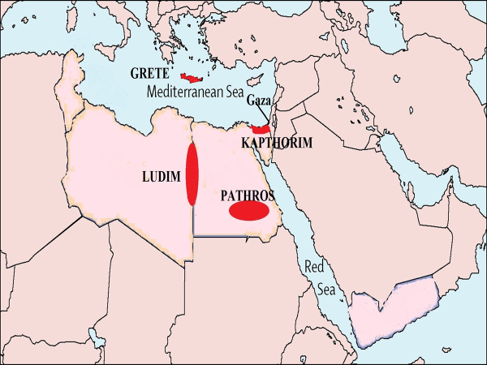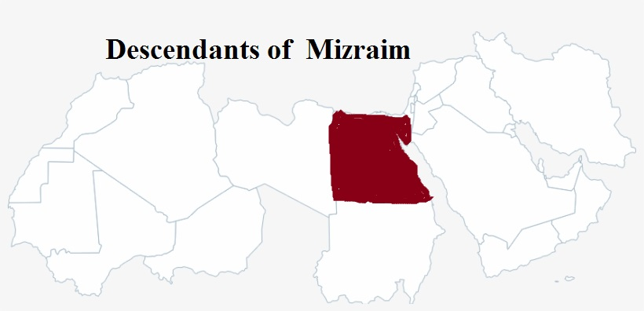

**fg;njhhpk**;: ,tdpd; re;jjpah; fg;Njhhpah;. ,th;fs; vfpg;jpd; fpof;F gFjpapy; cs;s fg;Njhhpy; FbNawpth;fs;. ,th;fs; ngauhy;jhd; me;j gFjp fg;Njhh; vd;W miof;fg;gl;lJ. ,J xU flw;fiu gl;lzk; (vNu:47:4). fg;Njhhpah;fs; vfpg;jpy; FbNawpajhy;jhd; vfpg;jpy; cs;s goikahd fpwp];jt rigahdJ Coptic Christians vd;W miof;fg;gl;lJ.

kp];uhaPkpd; re;jjpahpy; Mdhkpk;> nyfhgPk;> eg;J}fPk; vd;w %d;W re;jjpaiu jtpu kw;w ehd;F re;jjpaUk; Muk;gj;jpNy vfpg;J kw;Wk; vfpg;jpd; mUNfjhd; FbNawpapUe;jhh;fs; vd;W Ntjj;jpd; mbg;gilapNy ghh;j;Jtpl;Nlhk;. tpLgl;l %d;W Nfhj;jpuj;jhUk;$l vfpg;jpNyjhd; FbNawpdhh;fs; vd;gJ fpwp];jt mwpQh;fspd; fUj;jhf ,Uf;fpd;wJ. kp];uhaPkpd; nkhj;j re;jjpAk; vfpg;J kw;Wk; mij Rw;wp cs;s gFjpfspy; FbNawpdhh;fs;.

**G+j;:**

G+j;ijf; Fwpj;J tphpthf Ntjj;jpNy nfhLf;fg;gltpy;iy. G+j;jpd; re;jjpapdh; ypgpahtpYk; mjw;F Nkw;fhfTk; FbNawpdhh;fs;. ,th;fs; %yk; RUs; Kbia cila nts;is epw tlMg;gphpf;fh;fs; tpUj;jpaile;jhh;fs;. Mq;fpy Ntjhfkq;fspy; G+j; vd;gij gy ,lq;fspy; ypgpah vd;Nw nkhopngah;j;jpUf;fpd;whh;fs;. G+j;ij ypgpah vd;W nkhopngah;j;jpUg;gij kl;Lk; itj;J mth;fs; ypgpahtpy;jhd; ,Ue;jpUg;ghh;fs; vd;W $wptpl KbahJ. mij xU $Ljy; Mjhukhf Ntz;Lkhdhy; ehk; vLj;Jf;nfhs;syhk;. ,th;fs; gy ,lq;fspy; vj;jpNahg;gpah kw;Wk; vfpg;NjhL njhlh;Gilath;fshf nfhLf;fg;gl;bUg;gjhy; vfpg;jpw;Fk; mjw;F njw;fhd vj;jpNahg;gpahtpw;Fk; (vfpg;jpw;F njw;fpy; $\pd; re;jjpapdh; FbNawpa vy;yh gFjpfSk; Ntjhfk ghh;itapy; vj;jpNahg;gpahNt) mUNf cs;s (,uz;L Njrq;fisAk; vy;iyfshf nfhz;l) ypgpahNt ,th;fs; FbapUe;j Njrkhf ,Uf;fNtz;Lk; (vNu:46:9@ vNr:30:5@ 38:5@ eh$:3:9).

**fhdhd;:**

,td; fhkpd; filrp kfdhthd;. ,e;j re;jjpah; FbapUe;j fhdhd; NjrNk gpd;dh; Mgpufhkpd; re;jjpapdUf;F nfhLf;fg;gLfpd;wJ. ,th;fs; Nahh;jhd; Mw;wpd; ,UGwKk; FbapUe;jhh;fs;. rPNjhd;> Nfj;> VG+r;> Vk;Nkhh;> fph;fhrpah;> <tpah;> mh;fphpah;> rPepah;> mh;thjpah;> nrkhhpah;> fhkhj;jpah; vd;W 11 kfd;fis fhdhd; ngw;whd;.

**rPNjhd;:** fhdhdpd; %j;j kfd; rPNjhdhthd;. ,tdJ re;jjpaNu gpw;fhyj;jpy; kpfg;ngUk; flNyhbfshd gPdPrpah;fshf Mdhh;fs;. jPUitAk; ,th;fs; Rje;jhpj;J cyfk; KOtJk; fly; tzpfk; nra;jhh;fs;. ,tDf;F fhdhd; Njrj;jpd; tlf;Nf epyk; nfhLf;fg;gl;lJ. mJNt fhdhdpd; re;jjpahpd; tlvy;iyahFk;. fhdhd; Njrj;jpd; tlvy;iy rPNjhdpy; Muk;gpf;fpd;wJ. rPNjhDf;F; epahaj;jPh;g;G nfhLf;Fk;gb Njtd; ,];uNayh;fsplk; $wpdhh;. mJ MNrh; Nfhj;jpuj;jpw;F xJf;fg;gl;lJ (NahR:19:24-31). Mdhy; MNrh; Nfhj;jpuj;jhh; rPNjhdpah;fis Juj;jtpy;iy (epah:1:31). rPNjhdpah;fSila flTs; m];Nuhj;J (1uh[h:11:33). rhhPghj; tpjit ,e;j Ciu rhh;e;jtNs (1uh[h:17:9). ,th;fSila uh[;[pak; rhyNkhd; fhyj;jpy; (<uhk; uh[h) Gfo;ngw;W ,Ue;jJ. ,th;fSf;fhd epahaj;jPh;g;G NeGfhj;Ner;rh; %yk; Kjypy; nfhLf;fg;gl;lJ. mnyf;];rhz;luhy; jPU Kw;wpYk; mopf;fg;gl;lJ. mj;Jld; rPNjhdpahpd; MSif KbTf;F te;jJ. ,J ,g;NghJ nygdhd; Njrj;jpy; njd; gFjpapy; ,Uf;fpd;wJ.

**Nfj;:** Nfj;jpd; re;jjpapdh; Vj;jpauhth;. Vj;jpaUila epyKk; ,];uNaYf;F thf;Fjj;jk; nra;ag;gl;bUe;j epyNk (ahj;:3:8>17@13:5@23:23@). ,th;fsJ FbapUg;G kiyehlhFk; (vz;:13:29). Mgpufhk; ,e;j [hjpahhplNk rhuhis mlf;fk; nra;a fy;yiuia thq;fpdhd;. ,th;fSila FbapUg;ghdJ fhrhtpw;Fk; cg;Gf;flYf;Fk; ,ilNa ,Ue;jJ. ,th;fs; kpfg;nghpa uh[;[paj;ij fl;b vOg;gpdhh;fs;. ,th;fs; ,d;iwa ,];uNaypd; tlgFjpapypUe;J rphpah kw;Wk; JUf;fp tiu jq;fSila uh[;[paj;ij tphpTgLj;jpdhh;fs;. ,th;fs; Fjpiu G+l;ba ,Uk;G ujq;fis gad;gLj;jpdhh;fs;. fp.K.1200y; Vj;jpa uh[;[pakhdJ mopf;fg;gl;lJ. fhdhdpah;fspy; kpfg;ngUk; uh[;[paj;ij fl;b Mz;lth;fs; ,th;fNs. gr;Nrghspd; fztd; chpah ,t;tpdj;ij Nrh;e;jtNd (Vj;jpad;).

**vG+rpah;**: vUrNykpNy FbapUe;jhh;fs; (NahR:15:8). vG+rpaiuAk; ,];uNayh;fs; Kw;whf mopf;ftpy;iy (NahR:15:63). vUrNykpd; Mjp ngah; ,th;fs; ngahpNy vG+rp (NahR:18:28) vd;W miof;fg;gl;lJ. rPNahd; vd;Wk; miof;fg;gl;lJ. jhtPJ fhyj;jpy;jhd; vG+rp gpbf;fg;gl;L jhtPjpd; efukhdJ (2rhK:5:6>7).

**vk;Nkhhpah;:** Nahh;jhd; Mw;Wf;F fpof;Nf> mh;Ndhd; Mw;wpw;F tlf;Nf ,Ue;jhh;fs; (vz;:21:13). ahg;Nghf;F MW mth;fSila tl vy;iyahf ,Ue;jJ (vz;:21:24). vk;Nkhhpah;fSila mf;fpukkhdJ mth;fsJ tpf;fpuf MuhjidNa (1uh[h:21:26). MgpufhKf;F thf;Fjj;jk; nra;j fhyj;jpNyNa Njtd; Nyhj;jpw;F mtDf;fhd Njrj;ij nfhLj;Jtpl;lhh;. Mdhy; Vd; Mgpufhkpw;F kl;Lk; jhkjkhdJ? ,e;j vk;Nkhhpah;fSila ghtk; mg;NghJ epiwtilatpy;iy (Mjp:15:16). vk;Nkhhpah;fSila ghtk; epiwtilAk; tiuf;Fk; ,];uNayh;fs; vfpg;jpNy mbikfshf ,Uf;fNtz;bajpUe;jJ (fhj;Jf;nfhz;bUf;f Ntz;bajpUe;jJ). ghtk; epiwtilahj xU [hjpia Kw;wpYk; mopg;gjw;F Njtd; mePjpAs;sth; my;yNu.

**<tpah;**: vh;Nkhd; kiyabthuj;jpy; kp];gh vd;w gFjpapy; ,Ue;jhh;fs; (NahR:11:3@ epah:3:3). VtpaNu NahRthit tQ;rpj;j fpgpNahdpd; Fbfshth; (NahR:11:19).

**rPepah;:** ,th;fs; thrkhapUe;j ,lk; rPd; tdhe;jukhFk;. rPd; tdhe;juKk; fhdhd; Njrj;jpw;Fl;gl;l gFjpjhd;. vdNtjhd; NkhNr csT ghh;f;f mDg;gpa Ml;fs; “rPd; tdhe;jue;njhlq;fp> Mkhj;Jf;Fg; Nghfpw topahfpa Nunfhg;kl;Lk;> Njrj;ijr; Rw;wpg;ghh;j;J” te;jhh;fs; vd;W $wg;gl;bUf;fpd;wJ (vz;13:21). rPd; tdhe;jukhdJ fhNj]; mUNf ,Uf;fpd;wJ (vz;:20:1: 27:14). Vrpahd; Nfhghh; mUNf ,e;j tdhe;juk; ,Uf;fpd;wJ. mJ A+jhNfhj;jpuj;jhUf;fhd gq;fhFk; (NahR:15:1).

**nrkhhpah;:** nrkhhpah; thrkhapUe;j ,lkhdJ Ntjj;jpy; nrkuhapk; vd;W nfhLf;fg;gl;bUf;fpd;wJ. ,J ngQ;rkPd; Nfhj;jpuj;jhUf;F gq;fplg;gl;l ,lkhFk; (NahR:18:22). mJ ,];uNaYf;Fk; A+Njahtpw;Fk; vy;iyahf ,Uf;Fk; xU kiy gpuNjrkhFk; (2ehsh:13:4).

**fhkhj;jpah;:** ,th;fsJ re;jjpah; Mkhj;jpah;.,th;fs; FbapUe;j ,lk; Mkhj; vd;W miof;fg;gl;lJ. Mkhj; ,];uNaypd; tlvy;iyapy; ,Ue;jJ vd;W ehk; Vw;fdNt ghh;j;jpUf;fpd;Nwhk;. fhdhd; Njrj;ij csT ghh;f;fnrd;wth;fSk; rPd; tdhe;juk; njhlq;fp Mkhj;jpw;F NghFk; ghij tiu csT ghh;j;jhh;fs; (vz;:13:21). Vnddpy; rPd; tdhe;juk; fhdhd; Njrj;jpd; njd; vy;iyahfTk;> Mkhj; fhdhd; Njrj;jpd; tlvy;iyahfTk; ,Ue;jJ. mJ vh;Nkhd; kiyapd; mUNf ,Ue;jJ (NahR:13:5).

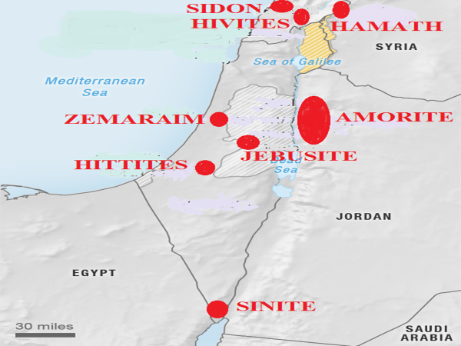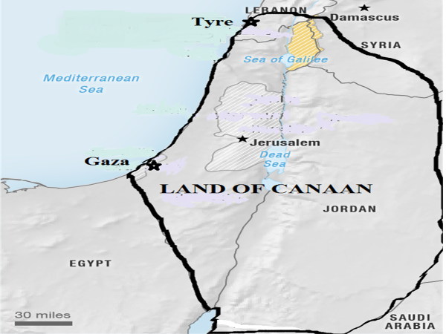

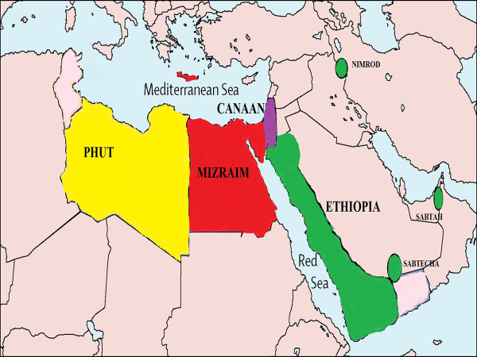

Njtd; thf;Fjj;jk; nra;j vy;yh ,lq;fisAk; ,];uNayh;fs; NahRth fhyj;jpNy ngw;Wtpl;lhh;fs; vd;W ehk; vz;zf;$lhJ. jhtPJ fhyj;jpy;jhd; vUrNyNk gpbf;fg;gl;lJ. rhyNkhd; fhyj;jpy;$l jPU uh[h jPUitAk;> rPNjhidAk;> vh;Nkhd; kw;Wk; yPgNdhdpd; gFjpfisAk; Mz;Lnfhz;bUe;jhd;. ,g;NghJk; ,];uNayh;fs; Njtd; mth;fSf;F thf;FnfhLj;j Njrq;fis Rje;jhpf;ftpy;iy. mth;fshy; Juj;jglhky; ,Ue;j [hjpah; vNkhhpah;> Vj;jpah;> nghprpah;> Vtpah;> vg+rpauhth; (1uh[h:9:20). ngyp];jpahTk;> rPNjhDk;$l kPjpahf tpl;Litf;fg;gl;bUe;jhh;fs; (epah:3:3). MdhYk; fhdhdpah; thrkhapUe;j mj;jid NjrKk; ngha;Aiuah Njtdhy; ,];uNayh;fSf;F thf;Fjj;jk; nra;ag;gl;bUg;gjhy; $batpiutpy; nkhj;j fhdhd; NjrKk; ,];uNayh;fSila trkhFk; (fhrh> Nkw;F fiu cl;gl).

fhdhdpah;fspd; Nkw;F vy;iy rPNjhd; Kjy; fhrh kl;Lk; ,Ue;jJ. njw;F vy;iy fhrhtpypUe;J NfuhUf;F te;J rhf;flypd; fpof;F gFjptiu ,Ue;jJ. fpof;F vy;iyahdJ NrhNjhk;> NfhNkhuh> mj;kh> nrNghaPk;> yhrh (,itfs; vy;yhk; Nahh;jhd; ejpapd; fpof;fpy; Mw;iw xl;b njw;F Kjy; tlf;F Nehf;fp thpirahf cs;s ehLfs;) Mfpa ehLfspd; fpof;F vy;iy topahf nry;fpd;wJ. ,J vh;Nkhd; kiy tiu ePz;lJ. fhdhdpaUila Njrk; vd;gJ ,d;iwa nygdhdpd; xU gFjp> rphpahtpd; njd;Nkw;F gFjp> ,];uNay;> fhrh> Nkw;F fiu> N[hh;lhdpd; xU gFjp Mfpait mlq;fpa gFjpahFk;. ,JNt Mgpufhkpd; re;jjpahd ,];uNay;> Vrh> ,];kNay;> Nfj;Juhs; kw;Wk; Nyhj;jpd; re;jjpfSf;F gq;fplg;gl;l nkhj;j ,lkhFk;.

ehk; ,Jtiu fhkpd; re;jjpah; Kjy; Kjypy; FbNawpa ,lj;ijf; Fwpj;J ghh;j;Jtpl;Nlhk;. mJ ,d;iwa ypgpah> vfpg;J> vj;jpNahg;gpah> ,];uNay;> fhrh> Nkw;F fiu> N[hh;ld;> rTjpmNugpahtpd; Nkw;F gFjp> Xkd;> Vkd;> mkPufk;> nygdhd;> <uhd;-<uhf;fpd; xU gFjp (mrPhpah) kw;Wk; rphpahtpd; xU rpy gFjpfs; Mfpait cs;slq;fpa gFjpahFk;.

**Nrkpd; re;jjpapdh;**

Nrkpw;F Vyhk;> m#h;> mh;gf;rhj;> Y}j;> Muhk; vd;w 5 kfd;fs; cz;L.

**Vyhk;:**

R+rhd; vd;gJ ngh;rpa uh[;[paj;jpd; jiyefuhFk;. ngh;rpah vd;gJ ,d;iwa <uhid Fwpf;Fk;. Nkjpa ngh;rpa uh[;[paj;jpd; uh[hthfpa mfh];NtU R+rhd; muz;kidapy; jdJ rpq;fhrdj;jpy; mkh;e;jpUe;jhd; vd;W $wg;gl;bUf;fpd;wJ. jiyefhpy;jhd; rpq;fhrdk; ,Uf;Fk;. vdNt Nkjpangh;rpa uh[;[paj;jpd; jiyefh; R+rhdhFk;. me;j $+rhdhdJ <uhdpy; ,Ue;jJ. jiyefuhfpa me;j R+rhdpNyjhd; jhdpNay;> neNfkpah> v];jh; MfpNahh; ,Ue;jpUf;fpd;whh;fs; (jhdp:8:2@neNf:1:1@v];j:1:2). Vyhk; Njrj;jpNyjhd; R+rhd; muz;kid ,Ue;jJ (jhdp:8:2) vd;Wk; $wg;gl;bUf;fpd;wJ. Vw;fdNt R+rhd; <uhdpypUe;jJ vd;W ghh;j;Njhk;. ,q;F R+rhd; VyhkpypUe;jJ vd;W ghh;f;fpd;Nwhk;. vdNt VyhKk;> <uhDk; xd;Nw. VyhNk Vyhkpah;fs; kw;Wk; ngh;rpah;fspd; jfg;gdhthd;. ,tdJ re;jjpapdh; <uhdpy; ilf;hP]; Mw;wq;fiuapd; njd; gFjpapYk;> ngh;rpa tisFlhtpd; tlfpof;F gFjpfspYk; FbNawpdhh;fs; vd;gij vy;NyhUk; Vw;Wf;nfhz;bUf;fpd;whh;fs;. VyhkpaH;fis (<uhdpah;fis> ngh;rpah;fis) rfy Njrj;jpw;Fs;Sk; rpjwg;gz;ZNtd; vd;W Njtd; $Wfpd;whh; (vNu:49:35-39). MdhYk; mg;gb rpjwbf;fg;gl;lth;fis kPz;Lk; Vyhkpw;F $l;b tUNtd; vd;w (rpiwapUg;G jpUk;Gjy;) cWjpiaAk; Njtd; mq;F nfhLf;fpd;whh;.

**mR+h**;: mLj;jjhf Nrkpd; xU Fkhudhd mR+hpd; re;jjpah; vq;F thrkhapUe;jhh;fs; vd;W ghh;g;Nghk;. ,td; Kjypy; rpneahh; Njrj;jpy;jhd; ,Ue;jpUf;fpd;whd;. ghNgy; NfhGuk; fl;lg;gl;l gpd;dUk; mR+Uk; mtdJ re;jjpapdUk; rpjwbf;fg;glhky; ghgpNyhdpNyjhd; ,Ue;jpUf;fpd;whh;fs;. mjhtJ ghNgYf;F mUfpy; ,lk;ngah;e;jpUf;fyhk;. Mdhy; rpneahh; Njrj;jpw;Fs;Nsjhd; ,Ue;jpUf;fpd;whh;fs;. ghNgy; NfhGuk; fl;lg;gLk; Kd;dh; rpneahh; Njrj;ij Mz;Lte;jJ epk;Nuhj;. Mjp:10:10y; “rpneahh; Njrj;jpYs;s ghNgy;> VNuf;> mf;fhj; fy;Nd vd;Dk; ,lq;fs; mtd; Mz;l uh[;aj;jpw;F Mjp];jhdq;fs;” vd;W $wg;gl;bUf;fpd;wJ. mjhtJ rpneahh; Njrj;jpy;jhd; mtdJ uh[;[pak; Muk;gkhdJ. “Mjp];jhdq;fs;” vd;why; mtdJ uh[;[pak; njhlq;fg;gl;l ,lk; vd;W mh;j;jk;. Mjp];jhdk; vd;W xd;W ,Ue;jhy; filrp ];jhdk; my;yJ ,uz;lhk; ];jhdk; vd;W xd;W ,Uf;fNtz;Lky;yth.rpneahh; Njrj;jpypUe;j epk;Nuhj;J ghNgy; NfhGuk; fl;lg;gl;l gpwF mq;NfapUe;J mrPhpahtpw;F Juj;jg;gl;bUf;fpd;whd;. epk;Nuhj;jpd; uh[;[paj;jpd; ,uz;lhk; ghfk; (,uz;lhk; ];jhdk;) mrPhpahtpy; Muk;gkhdJ. rpneahh; Njrkhfpa ghgpNyhdpypUe;J mrPhpahtpw;F Gwg;gl;L Ngha; mq;Nf gy gl;lzq;fis fl;b mtdJ uh[;[paj;jpd; ,uz;lhk; ghfj;ij epk;Nuhj;J Muk;gpj;jhd;. mtd; mrPhpahtpy; vd;ndd;d gl;lzq;fis fl;bdhd; vd;W Mjp:10:11>12y; $wg;gl;bUf;fpd;wJ. ,Jjhd; epk;Nuhj;jpd; uh[;[paj;jpd; ,uz;lhk; ];jhdk;;.rpneahhpypUe;J epk;Nuhj;J mrPhpah Gwg;gl;L nrd;whd; vd;W $wg;gl;bUf;fpd;wJ. Mdhy; mtd; rpneahhpypUe;J Gwg;gl;L nrd;wNghJ mjd; ngah; mrPhpah ,y;iy. Vnddpy; mg;NghJ mq;F ve;j CUk; ,y;iy. ,td; Ngha;jhd; mq;Nf gl;lzq;fis fl;Lfpd;whd;. mtd; me;j ,lq;fspy; gl;lzq;fis fl;ba gpwF mtdJ re;jjpauhy; me;j NjrkhdJ epk;Nuhj;J Njrk; vd;W miof;fg;gl;lJ. mrPhpahtpw;F Kjw; ngah; epk;Nuhj;J Njrk;jhd;. (kpfh:5:6). kPfh 5:6y; “mrPhpah Njrj;ijAk;> epk;Nuhjpd; Njrj;ijAk;” vd;W mJ ,uz;L Njrk; vd;gJNghy nfhLf;fg;gl;bUf;fpd;wJ. mjhtJ mrPhpa NjrKk;> epk;Nuhj;J NjrKk; xd;wpypUe;J xd;W khWgl;l Njrk; vd;gJNghy $wg;gl;bUf;fpd;wJ. mJ Ntjhfkj;jpd; xU nkhopeil. xNu Njrj;ij kPz;Lk; NtW xU ngahpy; miog;gJ vd;gJ Ntjhfk nkhopeilahFk;. vdNt ,uz;ilAk; ntt;NtW Njrq;fs; vd;W vz;zNtz;lhk;.

ghNgy; NfhGukhdJ tpf;fpuf Muhjidf;fhf fl;lg;gl;lJ (thdNridfis njhOJnfhs;SjYf;fhf) vd;W Vw;fdNt ehk; ghh;j;Njhk;. me;j tpf;fpuf Muhjidia jiyikNaw;W elj;jpaJ me;j Njrj;J uh[hthfpa epk;Nuhj;Jjhd;. epk;Nuhj;Jk; mtd; re;jjpaUk; rpneahh; Njrj;jpypUe;J Juj;jptplg;gl;lgpd;dh; te;j mrPhpathfpa epk;Nuhj;J Njrj;jpYk; tpf;fpuf Muhjid Nghd;w NjtDf;F tpNuhjkhd fhhpaq;fspy; <Lgl;L jq;fsJ mf;fpukj;ij epiwT nra;jhh;fs;. mg;NghJ Njtd; epk;Nuhj;jpw;Fk; mtdJ re;jjpaUf;Fk; epahaj;jPh;g;G nfhLf;f KbTnra;jhh;. epk;Nuhj;jpd; re;jpaUf;F epahaj;jPh;g;G nfhLf;f Njtd; gad;gLj;jpa fUtp ahh;? mR+h; kw;Wk; mtdJ re;jjpah;. mg;NghJ rpneahh; Njrj;jpypUe;j mR+h; kw;Wk; mtdJ re;jjpah; epk;Nuhj;J Njrj;jpd; kPJ gilnaLj;J nrd;W epk;Nuhj;jpd; re;jjpapdiu mq;NfapUe;J Juj;jpdhh;fs;. mq;Nf ,Ue;J Juj;jg;gl;l epk;Nuhj;J re;jjpapdh; vq;Nf nrd;whh;fs; vd;gij ehk; gpd;dh; ghh;g;Nghk;.epk;Nuhj;jpd; re;jjpapdiu epk;Nuhj;J Njrj;jpypUe;J Juj;jptpl;l mR+hpd; re;jjpah; me;j epk;Nuhj;J Njrj;jpNy FbNawpdhh;fs;. mJ KjNy me;j epk;Nuhj;J NjrkhdJ mrPhpah Njrk; vd;W miof;fg;gl;lJ. ,e;j mrPhpathdJ ,d;iwa ilf;hP]; Mw;wpd; tlf;F gFjpapy; ilf;hP]; Mw;wpd; ,UGwKk; ,Ue;jJ.

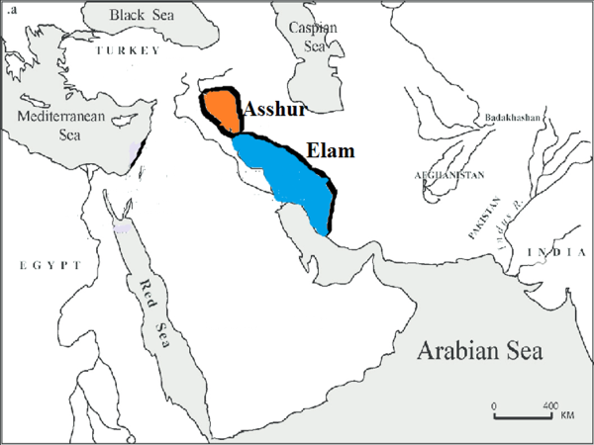 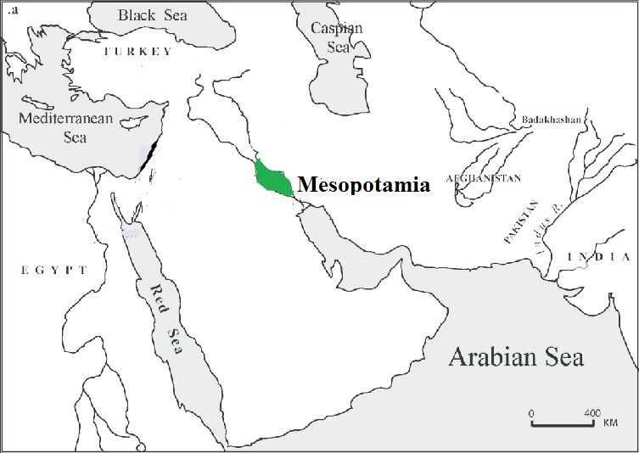

**Muhk;**

mLj;jjhf Nrkpd; ,d;dnkhU Fkhudhd Muhk; vq;Nf thrkhapUe;jhd; vd;gijf; Fwpj;J ghh;g;Nghk;. Muhk; vd;gJ Ntjj;jpNy rphpah vd;Wk; nkrgNlhkpah vd;Wk; nkhopngah;f;fg;gl;bUf;fpwJ. ,d;iwf;F rphpah vd;gJ ,];uNaYf;F tlfpof;F vy;iyapypUe;J JUf;fp tiu cs;s Njrkhf ,Uf;fpd;wJ. Ntjk; $Wk; rphpahtpw;Fk;> ,g;Nghija rphpahtpw;Fk; tpj;jpahrk; cz;L.

Mgpufhkpd; cwtpdh;fs; rphpah Njrj;jhh; mjhtJ Muhk; Njrj;jhh; vd;W miof;fg;gl;lhh;fs;. <rhf;F nuNgf;fhspd; kidtpia Fwpj;J $Wk;NghJ “rphpah Njrj;jhdhfpa ngj;JNtYf;Ff; Fkhuj;jp” vd;Wk; “rphpa Njrj;jhdhfpa yhghDf;Fr; rNfhjhpAkhths;” vd;Wk; Mjp:25:20y; $wg;gl;bUf;fpd;wJ. %y ghi\apNy ghh;j;jPh;fnsd;why; Muhkpadhfpa ngj;JNty;> Muhkpadhfpa yhghd; vd;Wjhd; mq;F $wg;gl;bUf;Fk;. rphpah vd;W nkhopngah;f;fg;gl;bUg;gJ %yghi\apNy Muhk; vd;Wjhd; ,Uf;Fk;. Mgpufhkpd; cwtpdhfs; ,Ue;j ,e;j Muhkhfpa rphpah vJ?

Mgpufhk; jdJ Copaf;fhudhd vypNarhplk; jdJ kfDf;F ngz;ghh;j;J tUk;gb $Wk;NghJ vd;d $Wfpd;whd;? “vd; Njrj;Jf;Fk; vd; ,dj;jhhplj;Jf;Fk; Ngha;> vd; Fkhudhfpa <rhf;Ff;Fg; ngz;nfhs;Ntd;” (Mjp:24:4) vd;W $wp jdJ Copafhudhfpa vypNariu vq;F mDg;Gfpd;whd;? “nknrhg;nghj;jhkpahtpNy ehNfhUila Chpy; Nrh;e;jhd;” vd;W Mjp:24:10y; $wg;gl;bUf;fpd;wJ. me;j nkrgNjhkpahjhd; rphpaNjrj;jhdhfpa ngj;jNtypd; Ch; (Mjp:24:24). me;j nkrgNlhkpahjhd; rphpa Njrj;jhdhfpa yhghdpd; Ch; (Mjp:24:29). ,jpypUe;J ehk; vd;d Ghpe;Jnfhs;syhk;. Mgpufhkpd; fhyj;jpy; rphpah vd;W miof;fg;gl;lJ nkrgNlhkpahNt. MgpufhKk; mtdJ cwtpdh;fSk; me;j rphpah Njrj;jhNu (nkrgNlhkpah Njrj;jhh;). me;j nkrgNlhkpahjhd; Muhkpd; re;jjpapdUf;Fk; thr];jykhf ,Ue;jJ. ,e;j nkrgNlhkpahNt Muhk; my;yJ rphpah MFk;.

,e;j nkrgNlhkpah vq;fpUe;jJ. ,d;iwf;F ,Uf;Fk; A+g;ul;B]; kw;Wk; ilf;hPRf;F ,ilg;gl;l gFjp KOtJk; nkrgNlhkpah vd;W vy;NyhUk; fUJfpd;whh;fs;. Mdhy; ,d;iwa A+g;ul;B]; kw;Wk; ilf;hPRf;F ,ilg;gl;l gFjp KOtJk; nkrgNlhkpah my;y. ,d;iwa A+g;ul;B]; kw;Wk; ilf;hPrpd; njd;gFjpapy; mitfSf;F ,ilg;gl;l gFjp kl;LNk Ntjhfk nkrgNlhkpahthFk;. nkrgNlhkpah vd;why; ,uz;L MWfSf;F ,ilg;gl;l gFjp. ,d;iwa A+g;ul;B]; kw;Wk; ilf;hP]; MWfSf;F ,ilg;gl;l gFjp (,uz;L MWfSk; ngh;rpa tisFlhtpy; NrUtjw;F Kd;dh; cs;s gFjp) nkrgNlhkpahthFk;. Ntjhfk fhyj;J Ig;gpuhj;J kw;Wk; ,njf;Nfy; Mfpatw;wpd; njd;gFjpAk;> ,d;iwa A+g;ul;B]; kw;Wk; ilf;hP]; ejpapd; njd;gFjpAk; xd;Nw.

,d;iwa A+g;ul;B]; kw;Wk; ilf;hPrpd; njd;gFjpapy; cs;sNj nkrgNlhkpah vd;gij ehk; ,d;DnkhU tifapYk; ep&gpf;fyhk;. MgpufhKk; mtdJ cwtpdh;fSk; rphpahtpy; (nkrgNlhkpahtpy;) tho;e;jhh;fs; vd;W ghh;j;Njhk;. MgpufhKk; mtdJ cwtpdh;fSk; ,Ue;j CuhdJ fy;Njah vd;W Mjp:11:31y; $wg;gl;bUf;fpd;wJ. nkrgNlhkpahTk; fy;NjahTk; xd;Nw (mg;:7:2-4). “nkrgNlhkpah ehl;by; ,Uf;Fk;NghJ” vd;W $wptpl;L mth;fs; mq;fpUe;J Gwg;gl;lij Fwpg;gpLk;NghJ “fy;Njah; Njrj;ijtpl;Lg; Gwg;gl;L” vd;W $wg;gl;bUf;fpd;wJ. ,jpypUe;j nkrgNlhkpahTk; fy;NjahTk; xd;Nw vd;gij ehk; Ghpe;Jnfhs;syhk;.

Muhk; (rphpah) vd;why; nkrgNlhkpah vd;Wk;> nkrgNlhkpah vd;why; fy;Nja Njrk; vd;Wk; ghh;j;Njhk;. ,g;NghJ fy;Njah Njrk; vq;fpUf;fpd;wJ vd;gij ehk; fz;Lgpbj;Jtpl;lhy; Muhk; vq;fpUe;jJ vd;gij fz;Lgpbj;Jtplyhk;. ghgpNyhdpah;fs;jhd; fy;Njah;fs; vd;W miof;fg;gl;lhh;fs; (2uh[h:25:1-4). ghgpNyhd; vd;gJ ,g;NghJ ,Uf;Fk; A+g;ul;B]; kw;Wk; ilf;hP]; Mw;wpd; njd;gFjpapy;jhd; ,Ue;jJ vd;W ekf;F njhpAk;. vdNt Ntjhfk nkrgNlhkpahTk;> Ntjhfk rphpahTk; ,JNt. Muhkpd; re;jjpah; ,e;j nkrgNlhkpahtpNyjhd; Kjypy; FbapUe;jhh;fs;.

ghNgy; NfhGuk; fl;lg;gl;l gpd;dh; rpneahh; (ghgpNyhd;) Njrj;jpypUe;j vy;NyhUk; Juj;jg;gl;lhh;fs;. MdhYk; Muhkpd; re;jjpaUk;> mR+hpd; re;jjpapdUk; ghgpNyhdhfpa rpneahh; Njrj;jpNyjhd; ,Ue;jhh;fs;. gpd;dh; epk;Nuhj;jpd; re;jjpapdiu Juj;Jtjw;F mR+hpd; re;jjpah; mrPhpah nrd;w gpwF Muhkpd; re;jjpapdh; kl;LNk ghgpNyhdpy; ,Ue;jhh;fs;.

Muhkpd; re;jjpah; gpd;dh; rpneahh; Njrj;jpypUe;J gutpdhh;fs;. NtjhfkhdJ jk];Fit Rw;wpapUe;j gFjpiaAk; rphpah mjhtJ Muhk; vd;W mioj;jJ (2rhK:8:5). tuyhw;wpYk; $l jk];Fit Rw;wpapUe;j gFjp Muhk; jk];F uh[;[pak; vd;Nw mwpag;gl;lJ. vdNt jk];Fit Rw;wpapUe;j gFjpAk; Muhkpd; re;jjpah; FbapUe;j gFjpNa. ,J Muhkpd; re;jjpapdh; FbapUe;j Njrj;jpd; tlf;F vy;iyahFk;.

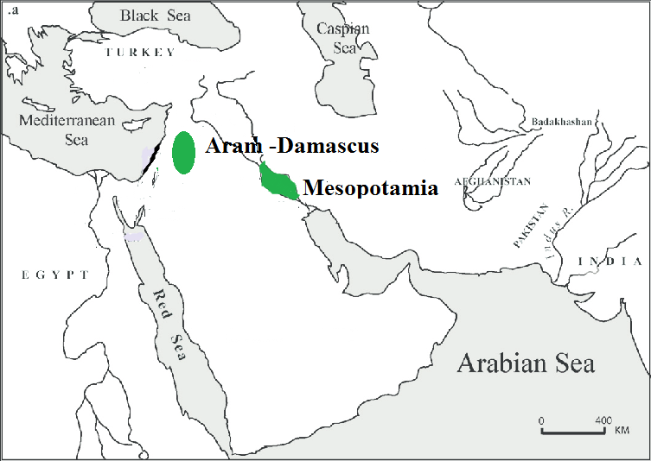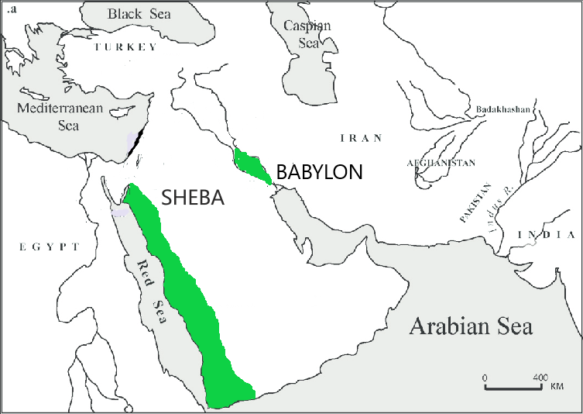

MuhKila njw;F vy;iyia ehk; mtdJ re;jjpfspy; xUtdhfpa Cj;]; vd;gtdJ FbapUg;G %ykhf fz;Lgpbf;fyhk;. MuhKila Fkhuh;fspy; xUtdhd Cj;]pd; re;jjpah; FbapUe;j NjrNk Cj;]; NjrkhFk;. NahG FbapUe;jJk; ,e;j Cj;]; Njrj;jpNyjhd; (NahG:1:1). ,J N\ghtpd; re;jjpapduhfpa rNgah; Njrj;jpw;F ntF mUfhf ,Ue;jJ (NahG:1:15). vdNtjhd; rNgah; mq;fpUe;J Cj;]; Njrj;jpw;F te;J nfhs;isapl;bUf;fpd;whh;fs;. ghgpNyhdpah;fshfpa fy;Njah;fSf;F mUfhfTk; me;j Cj;]; Njrk; ,Ue;jpUf;fpd;wJ (NahG:1:17). vdNtjhd; ghgpNyhdpah;fshfpa fy;Njah;fs; Cj;]; Njrj;jpw;F te;J nfhs;isapl;bUf;fpd;whh;fs;. mg;gbnad;why; Cj;]; NjrkhdJ N\ghtpw;Fk; ghgpNyhDf;Fk; (fy;Njahtpw;Fk;) mUNf ,Uf;fNtz;Lk;. Mdhy; ghgpNyhd; vd;gJ nkrgNlhkpahtpypUf;fpd;wJ. N\gh vd;gJ nrq;flypd; flw;fiuapy; NjjhDf;F njw;fhf njhlq;Ffpd;wJ vd;W Vw;fdNt ghh;j;Njhk;. Cj;]; NjrkhdJ vg;gb ,e;j ,uz;L Njrq;fSf;Fk; mUNf ,Uf;f KbAk;?

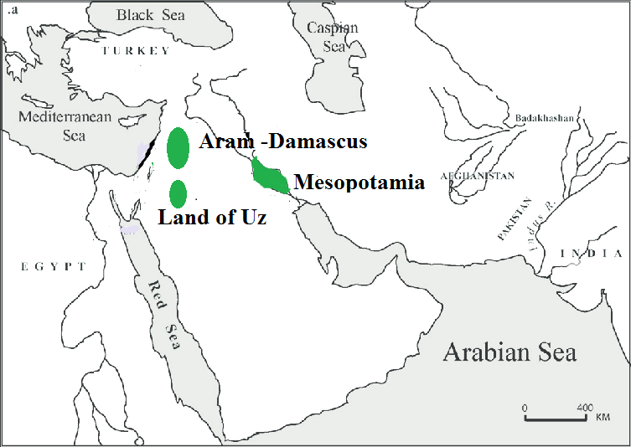 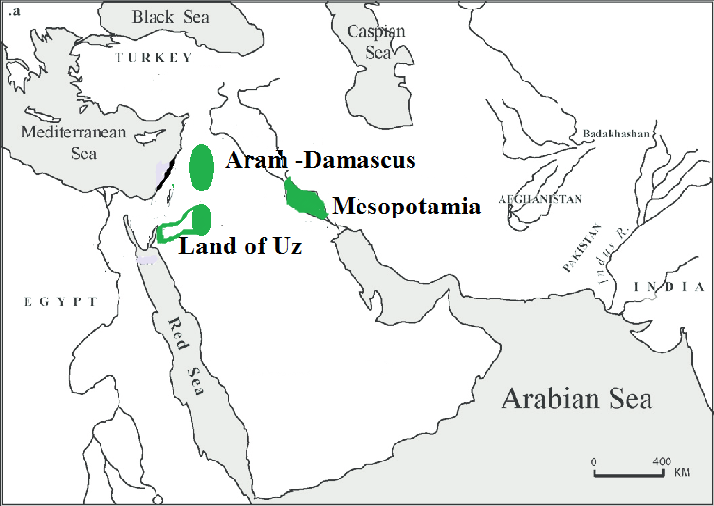

,uz;L Njrq;fSk; vjph; vjpNuay;yth ,Uf;fpd;wJ. mg;gbnad;why; Cj;]; NjrkhdJ ,uz;L Njrq;fSf;Fk; ,ilNa ,Uf;fNtz;Lk;. ,uz;Lf;Fk; ,ilapy; vd;whYk; mJ ghgpNyhDf;F mUNf ,Uf;Fkh? my;yJ N\ghtpw;F mUNf ,Uf;Fkh vd;gJ mLj;j Nfs;tp. tdhe;juj;jpypUe;J tPrpa fhw;W NahGtpd; tPl;il nehWf;fp mtdJ gps;isfis nfhd;wJ vd;W $wg;gl;bUf;fpd;wJ (NahG:1:19). Ntjhfkj;jpy; tdhe;juk; vd;W nkhl;ilahf nfhLf;fg;gl;bUe;jhy; mJ R+h; tdhe;juj;ijNa Fwpf;Fk;. vdNt Cj;]; Njrk; vd;gJ R+h; tdhe;juj;jpw;Fk; mUNf ,Ue;jpUf;fNtz;Lk;. ,e;j tpsf;fq;fspd; mbg;gilapy; ghh;j;jhy; Cj;]; re;jjpahpd; FbapUg;ghdJ rNgaUf;Fk; fy;NjaUf;Fk; eLthfTk;> R+h; tdhe;juj;jpw;F mUfpYk; ,Ue;jpUf;f Ntz;Lk;. ,e;j jftypd;gb ghh;j;jhy; Cj;]pd; re;jjpah; njw;Nf Mtpyh Njrk; tiuf;Fk; FbNawpapUe;jhh;fs; vd;gJ cWjpahfpd;wJ.

Gy:4:21y; Cj;]; Njrj;ij “Cj;];Njrthrpahfpa VNjhk; Fkhuj;jpNa” vd;W $wg;gl;bUf;fpd;wJ. Gyk;gy; vOjg;gl;lJ fp.K.6k; E}w;whz;byhFk;. me;j fhyj;jpy; Cj;]; NjrkhdJ VNjhikAk; cs;slf;fpajhf ,Ue;jpUf;fpd;wJ. vdNtjhd; Cj;]; Njrj;J ];jphp Gy:4:21y; “Cj;];Njrthrpahfpa VNjhk; Fkhuj;jpNa” vd;W $wg;gl;bUf;fpd;whs;. me;j fhyj;jpy; VNjhKf;F cl;gl;l xU Njrkhf Cj;]; Njrk; ,Ue;jpUf;fpd;wJ. ,jpypUe;Jk; Cj;]; NjrkhdJ VNjhKf;F mUNfAk; R+h; tdhe;juj;jpd; mUNfAk; ,Ue;jJ vd;gij ehk; cWjpnra;ag;gLj;jyhk;.

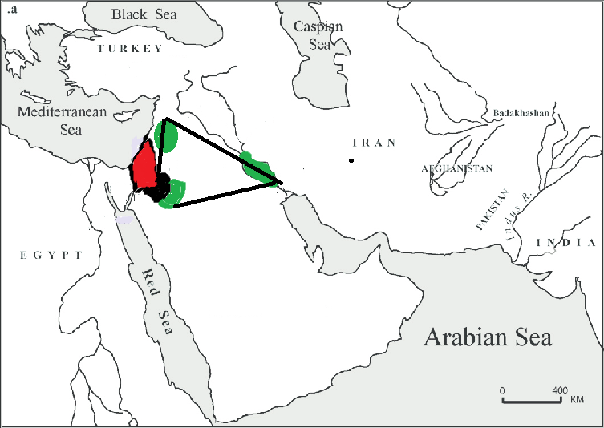 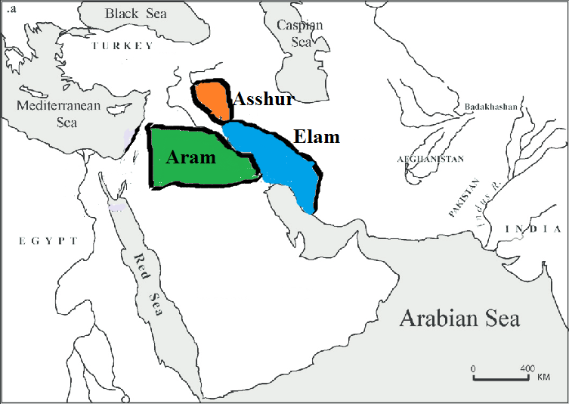

Muhkpw;F Cj;];> $y;> Nfj;njh; vd;W %d;W kfd;fs; cz;L (Mjp:10:23). mjpNy Cj;rpd; re;jjpah; ,e;j Cj;]; Njrj;jpy; ,Ue;jhh;fs;. $y; kw;Wk; Nfj;njh; MfpNahhpd; re;jjpah; vq;F ,Ue;jhh;fs; vd;W Ntj;jpy; $wg;gltpy;iy. Mdhy; mth;fspy; xUthpd; re;jjpah; nkrgNlhkpahtpYk;> xUthpd; re;jjpah; vh;Nkhd; kiyf;F mUNf jk];FtpYk; ,Ue;jpUf;fyhk; vd;gij ehk; Nkw;fz;l jfty;fs; %ykhf njhpe;Jnfhs;syhk;. MfNt Muhkpd; re;jjpapd; tlf;F vy;iy vh;Nkhd; kiy kw;Wk; jk];FthFk;. fpof;F vy;iy A+g;ul;B]; ilf;hP]; Mfpa MWfs; ,izAk; gFjpfshFk; (nkrgNlhkpah). Nkw;F vy;iy fhdhd; Njrk; kw;Wk; Mtpyh Njrq;fshFk;. mjd; njw;F vy;iy Cj;]; NjrkhFk;. ,e;j vy;iyfSf;F cl;gl;l nkhj;j NjrKk; Muhkpd; re;jpjpah;fSilNj.

**Muhkpd; MWfs; - Aram naharayim:** nkrgNlhkpah vd;w thh;j;ijNa gpw;fhyj;jpy; te;j thh;j;ijahFk;. mJ xU fpNuf;f thh;j;ij. mjd; mh;j;jk;jhd; MWfSf;F ,ilg;gl;l gFjp. Mdhy; nkrgNlhkpah vd;W nrhy;yg;gLk; thh;j;ijf;fhd vgpNua thh;j;ij Muhk; efuhapk; vd;Nw nfhLf;fg;gl;bUf;fpd;wJ. ,jd; mh;j;jNk Ntwhf ,Uf;fpd;wJ. Muhk; vd;why; Muhkpd; re;jjpah; FbapUe;j gFjpia Fwpf;Fk;. ehfhh; vd;why; MW vd;W mh;j;jk;. Muhkpd; re;jjpah; FbapUe;j gFjpapy; xba MWfNs Ntjj;jpy; Muhk; efuhapk; vd;W miof;fg;gl;ld. Muhkpd; re;jjpah; FbapUe;j ,e;j gFjpapy;jhd; Ntjhfk Ig;gpuhj;Jk;> ,njf;NfYk; Xbd. JUf;fpapy; cw;gj;jpahFk; ,d;iwa Ig;gpuhj;Jk;> ilf;hPRk; Ntjhfk Ig;gpuhj;J kw;Wk; ,njf;Nfy; my;y vd;gjw;F Muhk; efuhapk; vd;w thh;j;ijNa Mjhukhf ,Uf;fpd;wJ. Vnddpy; mitfs; ehk; Nkw;nrhd;d Muhkpd; re;jjpah; FbapUe;j gFjpapy; Xltpy;iy. gpw;fhyj;jpy; Ntjhfk Ig;gpuhj;Jk;> Ntjhfk ,jf;NfYk; kiwe;j gpwF mjpy; kPjkpUe;j njw;F gFjp MWk; mjw;F ,ilg;gl;l gFjpAk; kl;Lk; Muhk; efuhapk; vd;W miof;fg;gl;lJ. NgNyF fhyj;jpy; jhd; ,jf;Nfy; vh;Nkhdpy; cw;gj;jpahtJ jilgl;lJ. NgNyF NrkpypUe;J ehd;fhk; jiyKiwapdd;. Muhk; Nrkpd; Kjy; jiyKiwapddhthd;. MuhkpypUe;J %d;W jiyKiwf;F gpd;dh;jhd; NgNyF gpwe;jhd;. NgNyF fhyj;jpw;F Kd;dNu vh;Nkhd;> Cj;];> nkrgNlhkpah Mfpatw;iw vy;iyahf nfhz;l gFjpfSf;Fs; Muhkpd; re;jjpah; gutpajhy; me;j nkhj;j gFjpAk; Muhk; vd;Wk;> mq;F Xba Ntjhfk Ig;gpuhj;J kw;Wk; ,njf;Nfy; MWfSf;F Muhk; efuhaPk; (Muhkpd; MWfs;) vd;Wk; ngah; toq;fg;gl;lJ.

nrg;Ln[z;l vd;w fpNuf;f nkhopngah;g;gpd;NghJjhd; Muhk; efuhapk; vd;w vgpNua thh;j;ijf;F nkrgNlhkpah vd;w fpNuf;f thh;j;ij nfhLf;fg;gl;lJ. nkrgNlhkpa vd;why; fpNuf;f nkhopapy; MWfSf;F ,ilg;gl;l gFjp vd;W mh;j;jkhFk;. Ntjhfk Ig;gpuhj;J kw;Wk; ,njf;Nfy; Mfpa Mw;wpd; kPjKs;s gFjpfSf;F ,ilg;gl;l gFjp (,d;iwa Ig;gpuhj;J kw;Wk; ,njf;Nfypd; njd; gFjp) vd;w mh;j;jj;jpy; nkrgNlhkpah vd;w thh;j;ij nfhLf;fg;gl;lJ. Mdhy; ,d;W JUf;fpapy; cw;gj;jpahFk; nkhj;j Ig;gpuhj;J kw;Wk; ilf;hP]; Mw;wpw;F ,ilg;gl;l gFjpiaAk; nkrgNlhkpah vd;W $Wfpd;whh;fs;. Mdhy; Ntjhfkj;jpy; $wg;gLk; nkrgNlhkpah (Muhk; efuhapk;) vd;gJ Ntjhfk Ig;gpuhj;J kw;Wk; ilf;hP]; Mfpa ejpfspd; njw;F gFjpfSf;F ,ilg;gl;l gFjpia kl;LNk Fwpf;Fk;.

MgpufhikAk; mtdJ re;jjpiaAk; Ntjk; rphpad; vd;W miof;fpd;wJ vd;W ghh;j;Njhk;. Mdhy; mtd; Muhkpd; re;jjpad; my;y. mtd; Nrkpd; ,d;DnkhU kfdhd mh;gf;rhj;jpd; re;jjpahthd;. Mjp:11:10-27 trdj;ij gbj;jhy; mq;Nf mh;gf;rhj;jpypUe;J Mgpufhk; tiuf;Fkhd re;jjpah; gl;bay; nfhLf;fg;gl;bUf;fpd;wJ. mtDk; mtdJ tk;rj;jhUk; ,dj;jpd;gb Muhkpah;fs; mjhtJ rphpah;fs; my;y. mth;fs; tho;e;j ,lj;jpd;gb mth;fs; Muhkpah;fs;. Mgpufhkpd; re;jjpahpd; ,lk; Muhkpahpd; Njrj;jpw;F mUNfjhd; ,Ue;jJ. Mgpufhk; gpwg;gjw;F rpy fhyj;jpw;F Kd;dNuh my;yJ ntF fhyj;jpw;F Kd;dNuh mtdJ %jhijah; mUNf ,Ue;j jq;fsJ Njrj;ijtpl;L ,lk;ngah;e;J nkrgNlhkpahtpy; te;J FbNawpapUf;fpd;whh;fs;. mjdhy; Mgpufhkpd; re;jjpapdh; Muhkpah;fs; (rphpah;fs;) vd;W miof;fg;gl;lhh;fs;. Mgpufhk; ,dj;jpd;gb Muhkpad; vd;W miof;fg;gltpy;iy. tho;e;j ,lj;jpd; mbg;gilapy; Muhkpad; (rphpad;) vd;W miof;fg;gl;lhd;.

**Y}j;:**

Y}j;jpd; re;jjpapdh; Y}j;jpauhth;. Y}jpah;fs; jPUtpd; gilfspy; ,Ue;jhh;fs; (vNr:27:10). vdNt Y}j;jpah;fs; jPUTf;F kpfneUf;fkhfNt ,Ue;jpUg;ghh;fs;. Y}jpaiuf; Fwpj;J $Wk;NghJ ngh;rpaUk;> Y}jpaUk;> g+j;jpaUk; vd;W $wg;gl;bUf;fpd;wJ. Ntjj;jpy; fpof;fpypUe;J Nkw;F my;yJ Nkw;fpypUe;J fpof;fhf Chpd; ngah;fis $Wk; xUKiw gad;gLj;jg;gl;bUf;fpd;wJ. ,jd;gb ,e;j %d;W ,dj;jhUk; fpof;fpypUe;J Nkw;fhf $wg;gl;bUf;fpd;whh;fs;. mjdhy; Y}jpah;fs; ngh;rpah;fSf;Fk;> G+j;jpah;fSf;Fk; ,ilNajhd; ,Uf;fNtz;Lk;. ,th;fs; jPUtpw;F mUNf ,d;iwa nygdhdpd; tlgFjpapy; njhlq;fp mrPhpah tiuf;Fk; cs;s gFjpfspy; FbNawpapUf;fyhk; (,J G+j;jpw;Fk; ngh;rpahtpw;Fk; ,ilapy; ,Uf;fpd;wJ). rpyh; Y}j;jpah;fspd; FbapUg;ghdJ JUf;fpapd; Nkw;fpy; cs;s ypbah vd;W $Wfpd;whh;fs; (vNr:30:5). mJ jtwhd fUj;jhFk;. ypbah Njrj;jpd; Gfo;ngw;w uh[hthd Lydus vd;gtd; ngauhNyNa me;j Njrk; ypbah vd;W miof;fg;gl;lJ. mjw;Fk; Y}j;jpd; re;jjpaUf;Fk; ve;j rk;ge;jKk; ,y;iy.

**mh;gf;rhj;:**

mh;gf;rhj; ngahpy; ve;j NjrKk; ,y;iy. mg;gbnad;why; mh;;gf;rhj;jpd; thr];jyj;ij vg;gb fz;Lgpbg;gJ? mtdJ Fkhuh;fsJ ,Ug;gplj;ij fz;Lgpbg;gjd; %yk; mh;gf;rhj;jpd; thr];jyj;ij fz;Lgpbf;fyhk;. mh;gf;rhj; rhyhitAk;> rhy VNgiuAk;> VNgh; NgNyF> nahf;jhd; vd;W ,uz;L Fkhuh;fisAk; ngw;nwLj;jhd; vd;W Mjp:10:24>25 trdj;jpy; $wg;gl;bUf;fpd;wJ. mh;gf;rhj;jpd; kfd; rhyhtpd; ngahpYk; ve;j NjrKk; ,y;iy. rhyhtpd; xNu kfdhd VNghpd; ngahpYk; ve;j NjrKk; ,y;iy. VNghpd; ,uz;L kfd;fs;; ngahpy; VjhtJ Njrk; ,Uf;fpd;wjh vd;W ehk; mLj;jjhf ghh;f;fNtz;Lk;. NgNyiftpl nahf;jhid Fwpj;Nj Mjp:10k; mjpfhuj;jpNy mjpf jfty;fs; nfhLf;fg;gl;bUf;fpd;wd. vdNt Kjypy; nahf;jhd; vq;Nf FbapUe;jhd; vd;gijf;Fwpj;J ghh;g;Nghk;. ,tdJ FbapUg;ghdJ “Nkrh Jtf;fp> fpof;NfAs;s kiyahfpa nrg;ghUf;Fg; Nghfpw topkl;Lk; ,Ue;jJ” vd;W Mjp:10:30y; $wg;gl;bUf;fpd;wJ. mNugpa jPgfw;gj;jpy; fpof;Fg; gFjpapy; xNu xU kiy njhlh;jhd; ,Uf;fpd;wJ. me;j kiyj;njhluhdJ mkPufj;ijAk; (UAE), XkidAk; cs;slf;fpajhf ,Uf;fpd;wJ (Al-Hajar mountain). vdNt nahf;jhdpd; re;jjpahpd; FbapUg;gpd; fpof;F vy;iy vd;gJ mkPufk; kw;Wk; Xkdhf ,Uf;fNtz;Lk;. ,J nahf;jhDila re;jjpah; FbapUg;igf; Fwpj;J ekf;F fpilf;Fk; Kjy; jftyhf ,Uf;fpd;wJ. 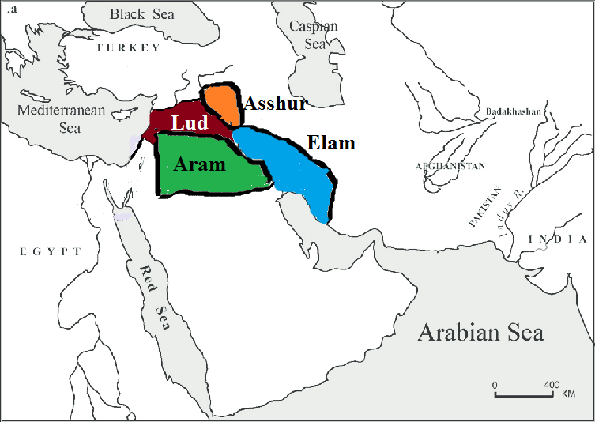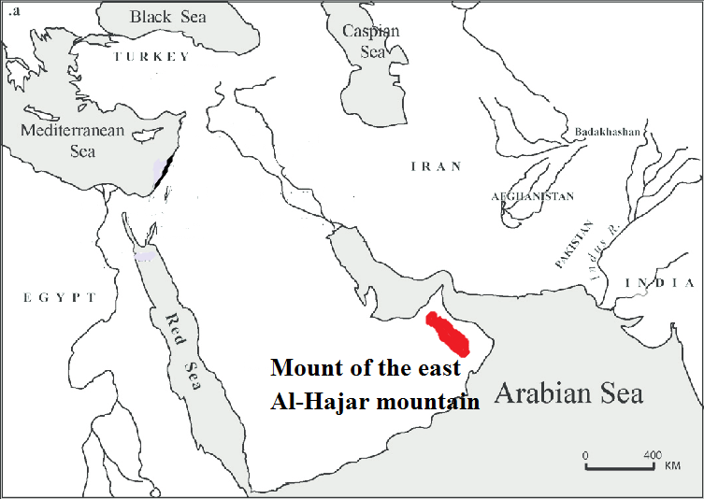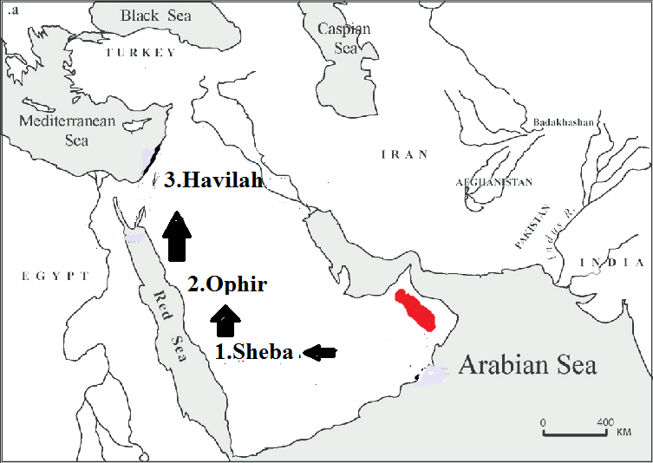

nahf;jhDila gps;isfspd; ngahpy; $\pd; re;jjpapYs;s ,uz;L gps;isfspd; ngah;fSk;> mth;fs; re;jjpah; FbapUe;j xU Chpd; ngaUk; ,Uf;fpd;wJ. Mjp:10:28>29y; N\gh> Xg;gPh;> Mtpyh vd;w me;j %d;W ngah;fs; nfhLf;fg;gl;bUf;fpd;wd. Vd; nahf;jhd; jdJ gps;isfSf;F $\pd; re;jjpapdh; rk;ge;jg;gl;l ngaiu itj;jhd;? nahf;jhDk; mtdJ re;jjpaUk; Kjypy; mNugpahtpd; njd; gFjpapy; FbapUe;jhh;fs;. mtdUNf N\gh Njrk; ,Ue;jJ. nahf;jhd; Kjypy; N\gh Njrj;ij ifg;gw;wpdhd;. N\gh Njrj;ij mtd; ifg;gw;Wk; NghJ ngw;w gps;isf;F N\gh vd;W ngah; itj;jhd;. mLj;jjhf tlf;F Nehf;fp efh;e;J Xg;gPiuAk; gpbj;jhd;. mg;NghJ gpwe;j Foe;ijf;F Xg;gPh; vd;W ngah; itj;jhd;. mLj;jjhf tlNkw;F jpirapy; efh;e;J Mtpyhit ifg;gw;wpdhd;. mg;NghJ gpwe;j mtdJ gps;isf;F Mtpyh vd;W ngah; itj;jhd;. ,e;j ifg;gwWjyhdJ xU jw;fhypfkhd fhhpakhfNt ,Ue;jpUf;Fk;. Vnddpy; nahf;jhDf;F gpd;dUk; Mtpyh Njrj;jpYk; fWg;gpdj;jhh; ,Ue;jhh;fs; vd;W ghh;j;jpUf;fpd;Nwhk;. N\gh Njrj;J uhzp N\gh Njrj;ijAk; Xg;gPiuAk; Mz;lhs; vd ghh;j;jpUf;fpd;Nwhk;. Nruh vd;w vj;jpNahg;gpa uh[h R+h; tdhe;ju gFjpapy; Mz;bUf;fpd;whd; vd;gijAk; ghh;j;jpUf;fpd;Nwhk;. vdNt nahf;jhd; N\gh> Xg;gPh;> Mtpyh Mfpa Njrq;fis ifg;gw;wpaJ xU jw;fhypf fhhpakhfNt ,Uf;fKbAk;. mtd; jdJ gps;isfSf;F ngah; itj;jjpy; xU xOq;F ,Uf;fpd;wJ. mtd; Kjypy; N\ghit ifg;gw;wpapUf;fpd;whd;. mLj;J Xg;gPiu ifg;gw;wp ,Uf;fpd;whd;. mLj;j Mtpyhit ifg;gw;wp ,Uf;fpd;whd;. mtd; ifg;gw;wpa Njrq;fspd; xOq;if itj;J ghh;f;Fk;NghJ mtd; N\ghtpw;F mUNfjhd; FbapUe;jpUf;f Ntz;Lk; vd;W njhpfpwJ. mjhtJ nahf;jhdpd; FbapUg;gpd; Nkw;F vy;iyahdJ N\ghtpd; FbapUg;gpd; fpof;fhf ,Ue;jpUf;f Ntz;Lk;. mtdJ Nkw;F vy;iy Nkrh vd;W nfhLf;fg;gl;bUf;fpd;wJ. me;j NkrhthdJ N\ghtpw;F fpof;Nf ,Ue;jpUf;fNtz;Lk;. vdNt nahf;jhdpd; re;jjpah; mNugpa jPgfw;gj;jpy; njd;gFjpapy;> N\ghtpw;F mLj;J FbapUe;jhh;fs;. ,e;j nahf;jhd;jhd; mNugpah;fSf;F je;ij vd;W miof;fg;gLfpd;whd;. ,tdpypUe;Nj mNugpa ,dk; cz;lhdJ.

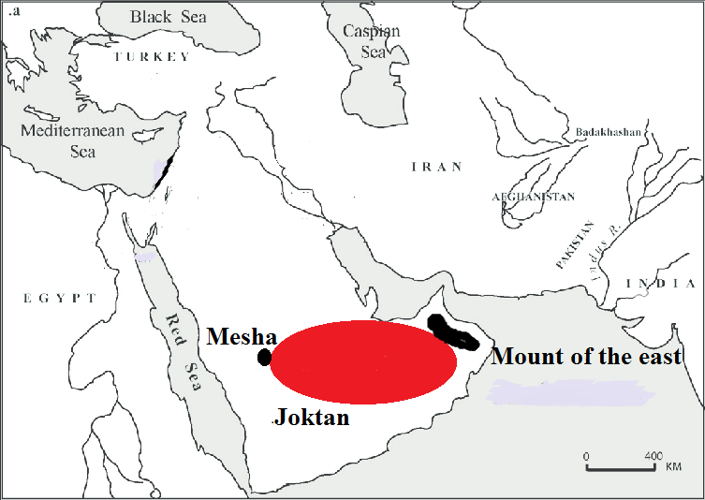 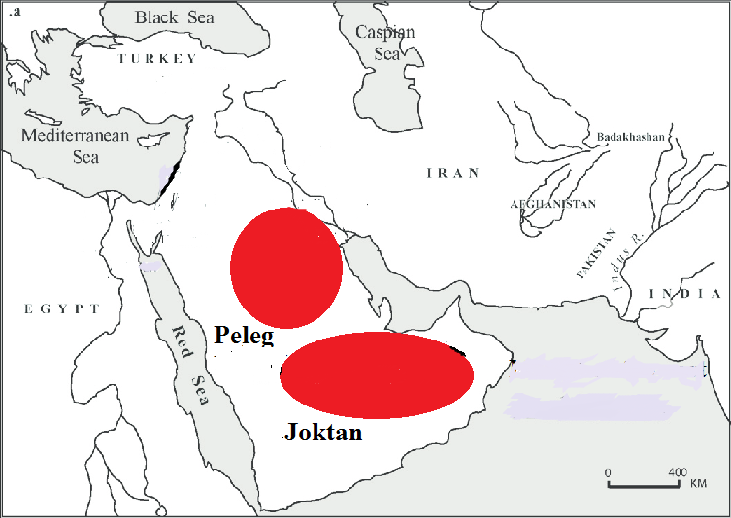

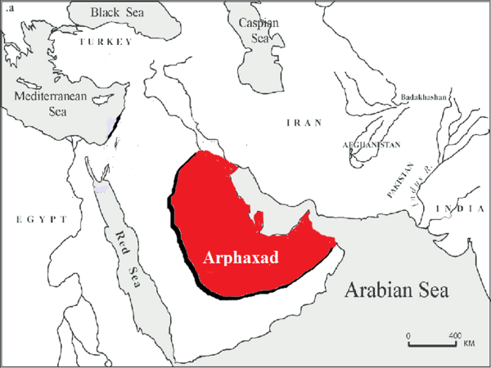 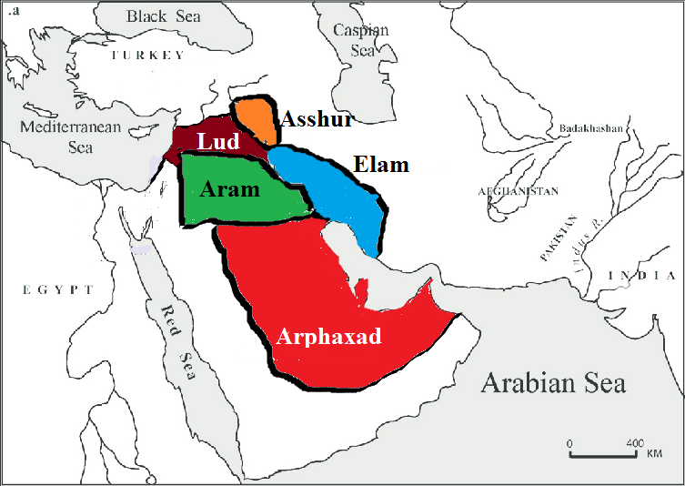

**NgNyF:** Muhkpd; re;jjpapdh; FbapUe;j gFjpf;F njw;fhfTk;> nahf;jhd; FbapUe;j gFjpf;F tlf;fhfTk;> R\pd; re;jjpahpd; FbapUg;gpw;F (vj;jpNahg;gpahtpw;F) Nkw;fhfTk; NgNyFtpd; FbapUg;G ,Ue;jpUf;f Ntz;Lk;. ,e;j NgNyFtpd; tk;rj;jpNyjhd; Mgpufhk; te;jhd;. ,e;j mgpufhk; nkrgNlhkpahtpNyjhd; FbapUe;jhd; vd;gij itj;J NgNyFtpd; re;jjpapdh; nkrgNlhkpahtpw;F mUNf (Nkw;nrhd;d vy;iyapy;) FbapUe;jpUg;ghh;fs; vd;gij ehk; cWjpnra;ayhk;. NgNyF> nahf;jhd; Mfpa ,UtUila FbapUg;Gk; Nre;jNj mh;gf;rhj;jpd; FbapUg;ghFk;. nahf;jhdpypUe;J mNugpah;fSk; NgNyFtpypUe;J ,];uNay; [dq;fSk; tpUj;jpaile;jhh;fs;. ,];uNayh;fSk;> mNugpah;fSk; xNu jfg;gDila gps;isfNs. mjhtJ mh;gf;rhj;jpd; gps;isfNs. Nrkpd; tk;rj;jhh; <uhd;> <uhf;> rphpah> nygdhd;> N[hh;ldpd;> Xkd;> Fitj;> If;fpa mkPufk; Mfpa gFjpfspy;; FbNawpdhh;fs;.

**ahNgj;jpd; re;jjpapdh;**

Nehthtpd; Fkhuh;fspy; %j;jtd; ahh;? ,isatd; ahh;? ehk; Nrk; fhk; ahNgj;J vd;W xU xOq;fpy; nghJthf Nehthtpd; Fkhuh;fis $Wfpd;Nwhk;. Mdhy; mJ rhpahd xOq;F fpilahJ. ahNgj;Jjhd; %j;jtd;. Mjp:10:21y; %j;jtdhfpa ahNgj;J vd;W $wg;gl;bUf;fpd;wJ. vdNt ahNgj;Jjhd; me;j %d;W Nghpy; %j;jtd;. ,isatd; ahh;? fhk; jhd; ,isatd;. ,J Fwpj;J Mjp:9:24y; $wg;gl;bUf;fpd;wJ. vd;d nrhy;yg;gl;bUf;fpwJ? “Nehth jpuhl;ir urj;jpd; ntwpnjspe;J tpopj;jNghJ> jd; ,isaFkhud; jdf;Fr; nra;jij mwpe;J” vd;W $wg;gl;bUf;fpd;wJ. Nehth jpuhl;ir urk; Fbj;J ntwpj;jpUe;jNghJ NehthtpDila eph;thzj;ij ghpahrk; nra;jJ fhk;jhd;. ,q;Nf me;j fhk;jhd; ,isatd; vd;W $wg;gl;bUf;fpd;wJ. mg;gbahdhy; Nehthtpd; Fkhuh;fspd; xOq;F vg;gb ,Uf;f Ntz;Lk;. ahNgj;J> Nrk;> fhk; vd;W jhd; ,Uf;fNtz;Lk;.

Njtd; ahNgj;jpw;F ,uz;L MrPh;thjq;fis nfhLj;jhh; vd;W Mjp:9:27y; $wg;gl;bUf;fpd;wJ. Kjy; MrPh;thjj;ij gpd;dh; ghh;g;Nghk;. Njtd; ahNgj;Jf;F nfhLj;j ,uz;lhtJ MrPh;thjk; vd;d? mtd; NrKila $lhuq;fspy; FbapUg;ghd; vd;gJ ahg;Ngj;Jf;F nfhLj;j ,uz;lhtJ MrPh;thjkhFk;. ,J jtwhd nkhopngah;g;ghFk;. ,e;j nkhopngah;g;gpd;gb ghh;j;jhy; ahg;Ngj;jpd; re;jjpapdh; Nrkpd; re;jjpapdh; FbapUe;j Njrq;fspy; FbapUg;ghh;fs; vd;w mh;j;jk; tUfpd;wJ. ehk; Vw;fdNt Nrkpd; $lhuj;ij Fwpj;J ghh;j;Jtpl;Nlhk;. Nrkpd; re;jjpah; mNugpa jPgfw;gk;> N[hh;ld;> nygdhd;> rphpah> <uhd> <uhf;;; Nghd;w gFjpfspy; FbNawpdhh;fs;. NrKila $lhuq;fspy; FbapUg;ghd; vd;gij NrkpDila thr];jyq;fspy; FbapUj;jy; vd;W ehk; Ghpe;Jnfhz;NlhNkahdhy; mJ jtwhd fUj;jhfNt ,Uf;fKbAk;. Vnddpy; Nrkpd; re;jjpah; FbNawpa Nkw;nrhd;d Njrq;fspy;> ahNgj;jpd; re;jjpah; ahUk; FbNawp ,Uf;ftpy;iy. mjdhy; NrKila $lhuq;fspy; FbapUj;jy; vd;gjd; rhpahd mh;j;jj;ij ehk; Kjypy; Ghpe;Jnfhs;s Ntz;Lk;.

Nrkpd; $lhuk; vd;gjpy; $lhuk; vd;gjw;F gad;gLj;jg;gl;bUf;fpd;w vgpNua thh;j;ij Ohel vd;gjhFk;. ,jw;F $lhuk; vd;w xU mh;j;jk; ,Ue;jhYk; me;j mh;j;jk; ,q;F nghUe;jhJ. Ohel vd;w thh;j;ijf;F strong concordance bibley; covering vd;W xU mh;j;jKk; nfhLf;fg;gl;bUf;fpd;wJ. covering vd;why; %bapUj;jy; vd;W mh;j;jkhFk;. ahj;:26:7y; me;j thh;j;ij covering vd;W mh;j;jjpy;jhd; gad;gLj;jg;gl;bUf;fpd;wJ. mjhtJ NkNy %bapUj;jy; vd;w mh;j;jj;jpy; mq;F nfhLf;fg;gl;bUf;fpd;wJ. Ml;L kapuhy; nra;ag;gl;l %L jpiufshdJ thr];jyj;jpd; NkNy %bapUf;Fk;gb nra;jy; vd;w mh;j;jj;jpNyjhd; mq;F Ohel vd;w thh;j;ij nfhLf;fg;gl;bUf;fpd;wJ (jkpopy; ,e;j ,lj;jpYk; Ohel vd;w me;j thh;j;ij $lhuk; vd;Wjhd; nkhopngah;fg;gl;bUf;fpd;wJ). covering upon the tabernacle vd;Wjhd; Mq;fpyj;jpNy nfhLf;fg;gl;bUf;fpd;wJ. jkpopy; ,e;j trdk; jtwhf nkhopngah;f;fg;gl;bUf;fpd;wJ. thr];jyk;jhd; $lhuk;. thr];jyj;jpw;F NkNyah $lhuk; ,Uf;Fk;? thr];jyj;jpw;F NkNy %Ljpiujhd; ,Uf;Fk;. mq;F vd;d nrhy;yg;gl;bUf;fpwJ vd;why; thr];jyj;jpw;F $iuahf %L jpiufis NghLk;gb $wg;gl;bUf;fpwJ. mJ me;j trdj;jpd; gpd; gFjpia ghh;j;jhy; GhpAk;. gpd; gFjpapy; thr];jyj;jpd; %L jpiufis Fwpj;Jjhd; $wg;gl;bUf;fpd;wJ. ahj;:26:7MdJ “thr];jyj;jpd;Nky; %Lk;gb Ml;Lkapuhy; gjpndhU %Ljpiufis cz;Lgz;Zthahf” vd;Wjhd; nkhopngah;f;fg;gl;bUf;f Ntz;Lk;. $lhuk; vd;gjw;F gjpyhf %Ljy; vd;w thh;j;ijNa mq;F nghUj;jkhfTk; ,Uf;Fk;.

,jd;gbMjp:9:27d; rhpahd mh;j;jkhdJ vg;gb ,Uf;fNtz;Lnkd;why; “mtd; Nrik NkNy %bagb FbapUg;ghd;” my;yJ “Nrkpw;F Nkw;$iuahf FbapUg;ghd;” my;yJ “Nrkpw;F %lhq;fha; FbUg;ghd;” vd;Wjhd; ,Uf;fNtz;Lk;. mjd;gb Nrkpd; re;jjpah; FbapUe;j nygdhd;> mugpa jPgfw;gk;> rphpah> <uhd;> <uhf;> Mg;fhdp];jhd;> ghfp];jhd; Mfpatw;iw %bagbNa ahNgj;jpd; re;jjpah; ,Ue;;jhh;fs;. mth;fSf;F xU %L jpiuahf> mth;fSf;F $iuahf %bagb ,Ue;jhh;fs;. Nrkpd; $iuapy;jhd; ahg;Ngj;jpd; re;jjpah; Kjy; Kjypy; FbNawpdhh;fs;.

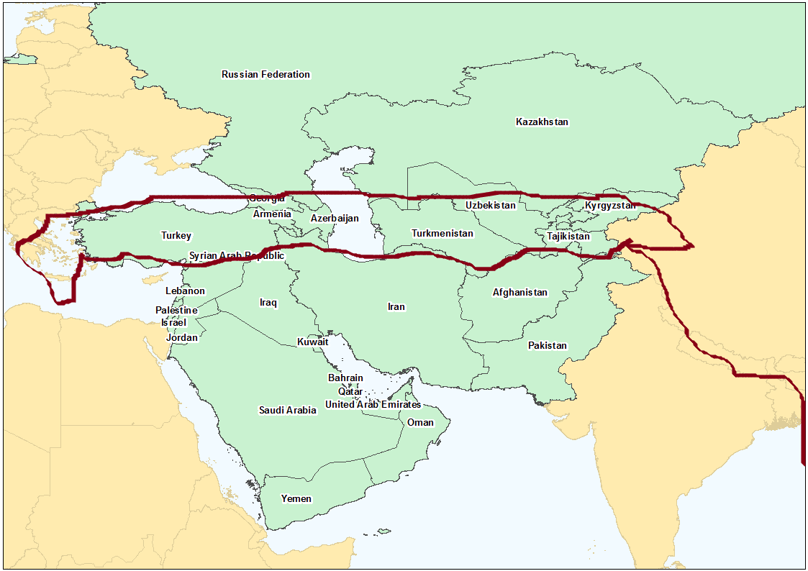

,Jjhd; Njtd; ahNgj;jpw;F nfhLj;j ,uz;lhtJ MrPh;thjk;. ,jpNy vd;d mrPh;thjk; ,Uf;fpd;wJ vd;W ePq;fs; Nfl;fyhk;. mth;fis jhz;b Nrkpd; re;jjpapdh; tlf;Nf gutKbahJ vd;gJjhd; me;j mrPh;thjk;. Nrkpd; re;jjpapdh; $iuia gpr;rpfpl;L NkNy NghfKbahJ. me;j MrpH;thjj;jpw;F Vw;g Nrkpd; re;jjpapdUila gutyhdJ tlf;F Nehf;fp nry;yNt ,y;iy. ,d;DnkhU mrPh;thjKk; ,jpNy mlq;fpapUf;fpd;wJ. Nrk; vg;NghJk; %j;jtdhfpa ahNgj;Jf;F fPo;gl;ltdhfNt ,Ug;ghd; vd;gJk; me;j mrPh;thjj;jpy; mlq;fpapUf;fpd;wJ. ghgpNyhdpah;> mrPhpah; Nghd;w Nrkpd; re;jjpapdNu ahNgj;jpd; re;jjpapdhpd; Njrj;jpNy xU rpW gFjpia kl;LNk Mz;lhh;fs;. kw;wgb ngUk;ghyhd rkaq;fspy; ahNgj;jpd; re;jjpapdh;jhd; Nrkpd; re;jjpapdiu Mz;bUf;fpd;whh;fs;. Nrkpd; re;jjpapd; mth;fSf;F fPo;gl;Nl ,Ue;jpUf;fpd;whh;fs;. ,g;NghJk; Nrkpd; re;jjpapdh; ahNgj;jpw;F fPo;gl;Nl ,Uf;fpd;whh;fs;.

ahNgj;jpd; re;jjpah; Kjy;Kjypy; Njhuhakhf ve;j ,lq;fspy; FbapUe;jhh;fs; vd;W ghh;j;Jtpl;Nlhk;. mth;fs; Nrkpd; re;jjpf;F Nkyhf mth;fSf;F xU %lhq;fhf> xU Nkw;$iuahf (Nrkpd; re;jjpapdUf;F tlf;fhf) ,Ue;jhh;fs;. Nrkpw;fhd ,e;j Nkw;$iuapy; ahg;Ngj;jpd; Fkhuh;fs; xt;nthUtUk; jdpj;jdpahf vq;F FbapUe;jhh;fs; vd;W ,g;NghJ ghh;g;Nghk;. ahg;Ngj;jpd; Fkhuh;fs; vj;jid Ngh; vd;Wk; mth;fSila ngah; vd;dntd;Wk; Mjp:10:2y; $wg;gl;bUf;fpd;wJ. mtDf;F nkhj;jk; VO kfd;fs; ,Ue;jhh;fs;. Nfhkh;> khNfhF> khjha;> ahthd;> J}ghy;> NkNrf;F> jPuh]; vd;gth;fNs mth;fs;. ,th;fspy; ekf;F ed;F njhpe;jth;fs; FbapUe;j ,lj;ij Kjypy; ghh;g;Nghk;.

**ahthd;:**

Kjypy; ahthidf; Fwpj;J ghh;g;Nghk;. jhdpNay; 8k; mjpfhuj;jpy; ,uz;L nfhk;gfis cila Ml;Lf;flh Fwpj;J $wg;gl;bUf;fpd;wJ. me;j ,uz;L nfhk;Gila Ml;Lf;flh Nkjpangh;rpa uh[;[pak; vd;W jhdp:8:20y; $wg;gl;bUf;fpd;wJ. mLj;jjhf Nkw;Nf ,Ue;J xU nts;shl;Lflh tUtjhf $wg;gl;bUf;fpwJ? me;j nts;shl;Lflh vJ? khkd;dd; mnyf;rhz;lUila fpNuf;f rhk;uh[;[pak;. 21k;trdj;jpNy mJ nfhLf;fg;gl;bUf;fpd;wJ. me;j fpNuf;fk; vd;gjw;fhd %y nkhopia ghh;j;jhy; ahthd; vd;Wjhd; ,Uf;Fk;. jhdp:10:20@ rf:9:13 Mfpatw;wpy; fpNuf;fk; vd;W nfhLf;fg;gl;bUf;Fk; thh;j;ijapd; %y nkhopia ghh;j;jhYk; ahthd; vd;WjhdpUf;Fk;. mg;gbnad;why; ahthdpd; re;jjpah; fpNuf;fj;jpy; FbNawpdhh;fs; vd;W ehk; Ghpe;Jnfhs;syhk;. fpNuf;fKk; rhpahf ehk; Kd;dh; Fwpj;j Nrkpd; $iuapy;jhd; tUfpd;wJ.

rq;ffhy jkpo; ,yf;fpaq;fspy; fpNuf;f Njrj;jhh; atdh;fs; vd;Nw miof;fg;gLfpd;whh;fs;. rq;f fhyj;jpy; fpNuf;fh;fs; jkpo;ehl;Lld; fly; tzpfj; njhlh;gpy; ,Ue;jhh;fs;. tzpfj;jpdpkpj;jk; ahthdpd; re;jjpah; rpyh; jkpo;ehl;bNyNa jq;fptpl;lhh;fs;. mth;fs; jkpo;ehl;by; FbapUe;j ,lk;; atd FbapUg;G vd;W miof;fg;gl;lJ. mg;gb jkpofj;jpy; FbNawpa atdh;fs; ghz;ba kd;ddpd; gilfspy;$l Nghh; tPuh;fshf Nrh;e;jpUf;fpd;whh;fs;. ghz;ba kd;dh;fsplk; atd gilgphpT vd;W xU jdp gilgphpNt ,Ue;jpUf;fpd;wJ. tuyhw;W ehtyhrphpah; rhz;by;ad; $l atd uhzp vd;W xU ehty; vOjpapUf;fpd;whh;. ahthdpd; re;jjpapduhd fpNuf;fh;fNs jopoh;fshy; atdh;fs; vd;W miof;fg;gl;lhh;fs;.

xhprhtpy; `j;jpf; Fk;gh (Hattigumpha) vd;w ,lj;jpy; fz;nlLf;fg;gl;l fp.K.,uz;lhk; E}w;whz;il Nrh;e;j fy;ntl;bYk; (gpuhfpUjnkhop fy;ntl;L) atdh;fs; vd;Nw fpNuf;fh;fs; miof;fg;gl;bUf;fpd;whh;fs;. ,njy;yhk; atdh;fs; vd;why; fpNuf;fh;fs; vd;gjw;fhd ,e;jpa Mjhuq;fshFk;.

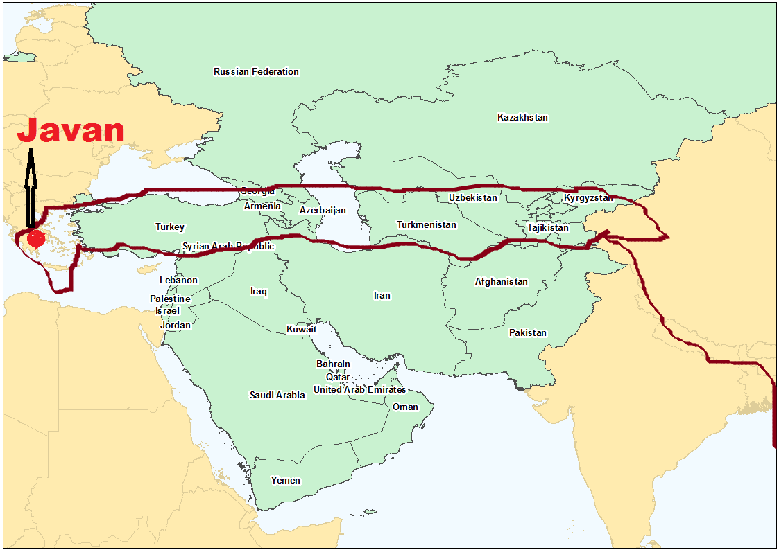 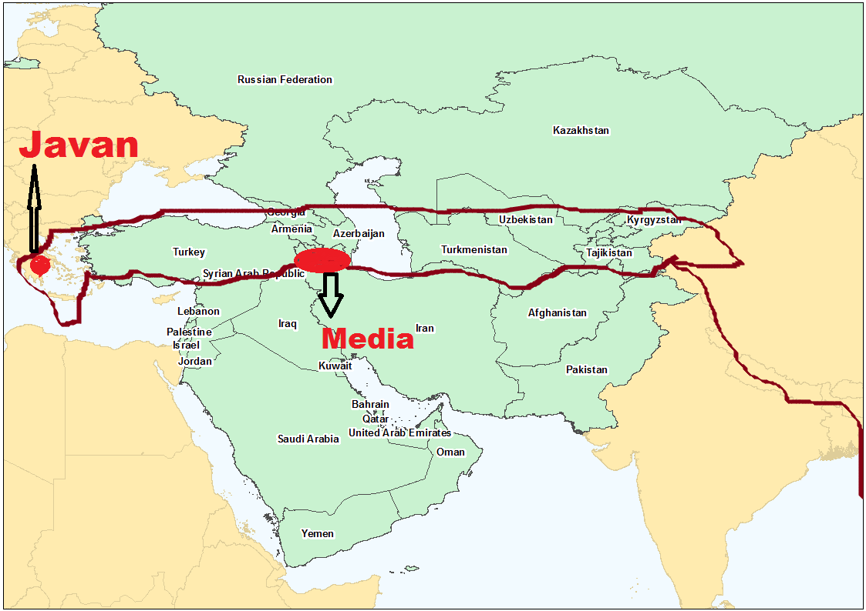

**khjha;:**

mLj;jjhf ehk; ghh;f;fg;Nghfpd;w ahNgj;jpd; re;jjpapd; FbapUg;ghdJ khjha; vd;gtDila FbapUg;ghFk;. khjha; vd;why; Nkjpah. Mk; Nkjpa NjrNk khjhapd; re;jjpah; FbapUe;j NjrkhFk;. Nkjpah vd;gJ vg;NghJk; ngh;rpahTld; Nrh;j;J Nkhjpa - ngh;rpah vd;Nw Ntjj;jpy; nfhLf;fg;gl;bUf;fpd;wJ. Ntjhfkj;jpy; cs;s xU nkhop eilia ehk; Ghpe;Jnfhs;s Ntz;Lk;. ,uz;L Ch;fs; ngah;fis vg;NghJk; Nrh;j;J> Nrh;j;J nfhLj;jpUe;jhy; mJ mUfUNf ,Uf;Fk; Ch;> my;yJ mUfUNf ,Uf;Fk; Njrk; vd;W mh;j;jkhFk;. jPU>rPNjhd; vd;w mUfUfhd Njrq;fSk; mbf;fb Nrh;j;J nfhLf;fg;gl;bUf;Fk;. NrhNjhk;> nfhkhuh vd;w Njrq;fSk; Nrh;j;J nfhLf;fg;gl;bUf;Fk; fhuzk; mitfSk; mUfUNf cs;s efukhFk;. mNjNghy NkjpahthdJ vg;NghJk; ngh;rpahTlNd Nrh;j;J nfhLf;fg;gl;bUf;Fk;. fhuzk; ngh;rpahit xl;b Nkjpah ,Ue;jJ. ngh;rpah vd;gJ ,d;iwa <uhdhFk;. ,d;iwa <uhdpd; tlNkw;F gFjpapNyNa Nkjpah ,Ue;jJ. mjhtJ fh];gpad; flYf;F njw;Nf <uhid xl;bagb Nkjpah ,Ue;jJ. ,e;j NkjpahTk; ehk; Vw;fdNt tiue;j Nrkpd; $iuapy;jhd; ,Uf;fpd;wJ.

**Nfhkhh;:**

mLj;jjhf ahNgj;jpd; Kjy; kfdhd Nfhkhhpd; re;jjpapdh; vq;F FbapUe;jhh;fs; vd;W ghh;g;Nghk;. Nfhkhhpd; FbapUg;G vq;fpUf;fpd;wJ vd;W Ntjj;jpy; njspthf nfhLf;fg;gltpy;iy. Mdhy; mtDila kfd;fs; FbapUe;j ,lk; Fwpj;J rpy jfty;fs; Ntjj;jpNy nfhLf;fg;gl;bUf;fpd;wJ. mtDf;F m];fpdh];> hpg;ghj;J> njhfh;kh vd;w %d;W kfd;fs; nfhLf;fg;gl;bUf;fpd;whh;fs;. ,th;fs; %d;WNgUila ,Ug;gplj;ij fz;Lgpbg;gjd; %yk; Nfhkhhpd; re;jjpah; vq;Nf FbapUe;jhh;fs; vd;gij ehk; fz;Lgpbj;Jtplyhk;.

**m];fpdh];:** m];fpdh]; muuhj; vd;w Njrj;Jld; Nrh;j;J nfhLf;fg;gl;bUf;fpd;wJ (vNu:51:27). vdNt m];fpdh]pd; re;jjpah; FbapUe;j gFjpahdJ muhuj; Njrj;jpw;F mUfpNyNa ,Uf;fNtz;Lk;. muuhj; Njrk; vd;why; Mh;kPdpa Njrk;. ,J mwpQh;fs; vy;NyhUk; Vw;Wf;nfhz;l fhhpak;jhd;. Nehthtpd; [yg;gpusak; Fwpj;J tpthpf;Fk;NghJ ehk; Vw;fdNt ,ij Fwpj;J ghh;j;jpUf;fpd;Nwhk;. vdNt m];fpdh]pd; re;jjpah; Mh;kPdpahtpw;F mUfpYs;s Mn[h;ig[hdpy; FbNawpapUf;fyhk;.

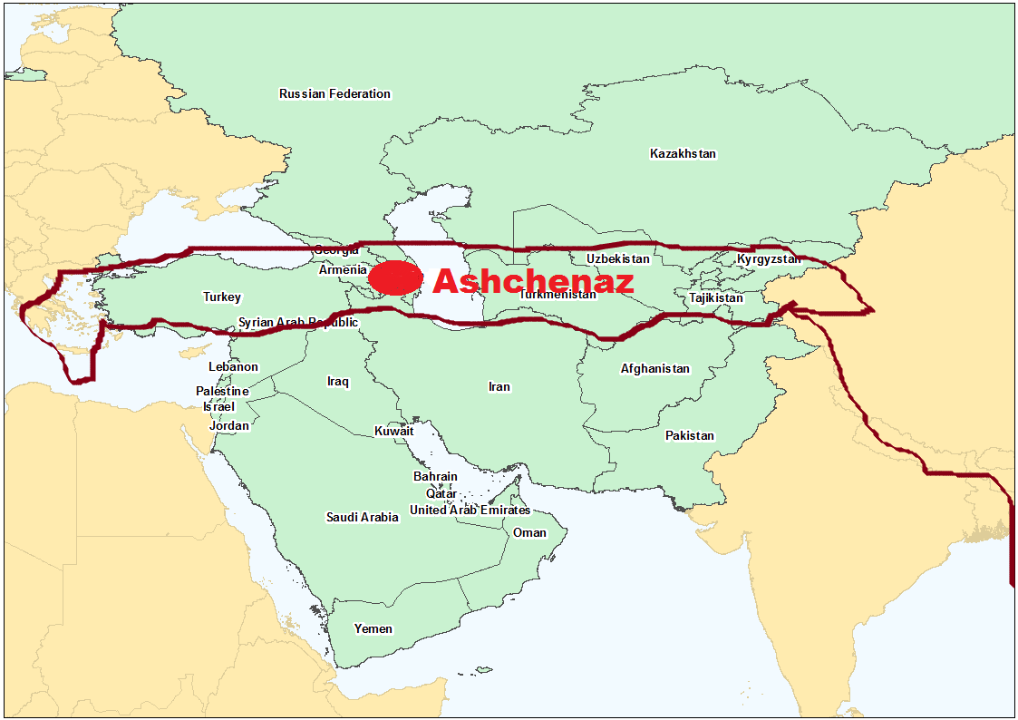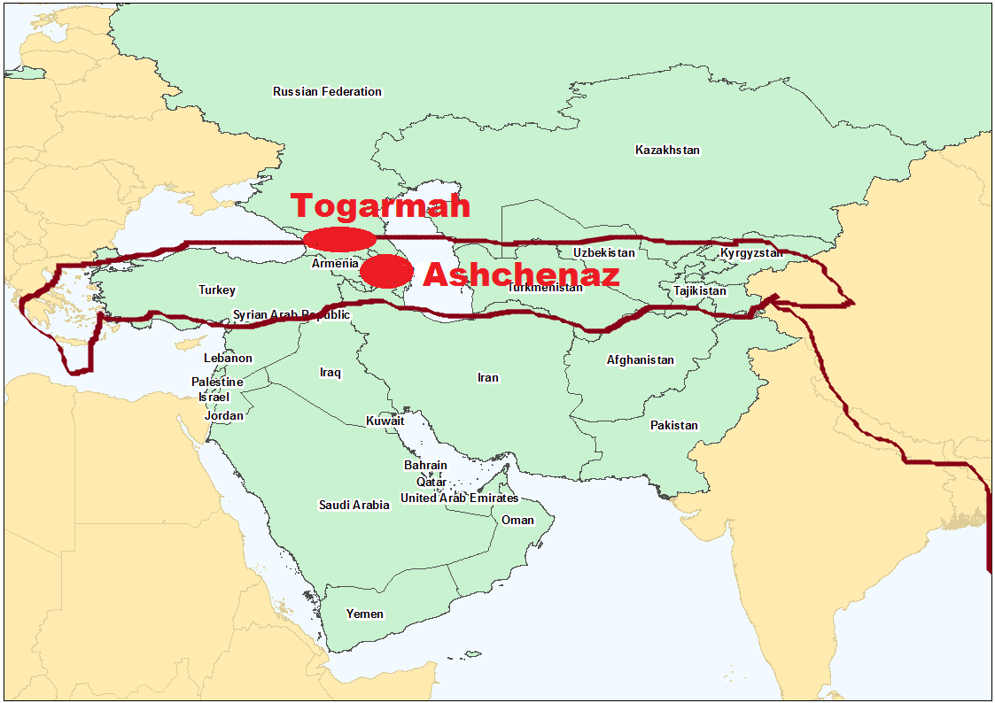

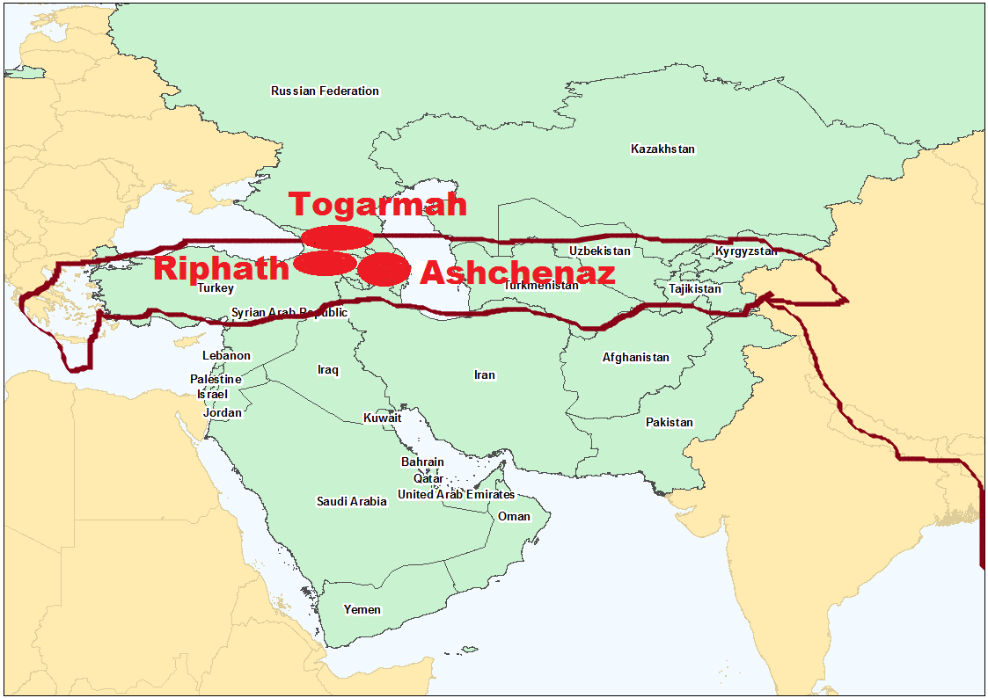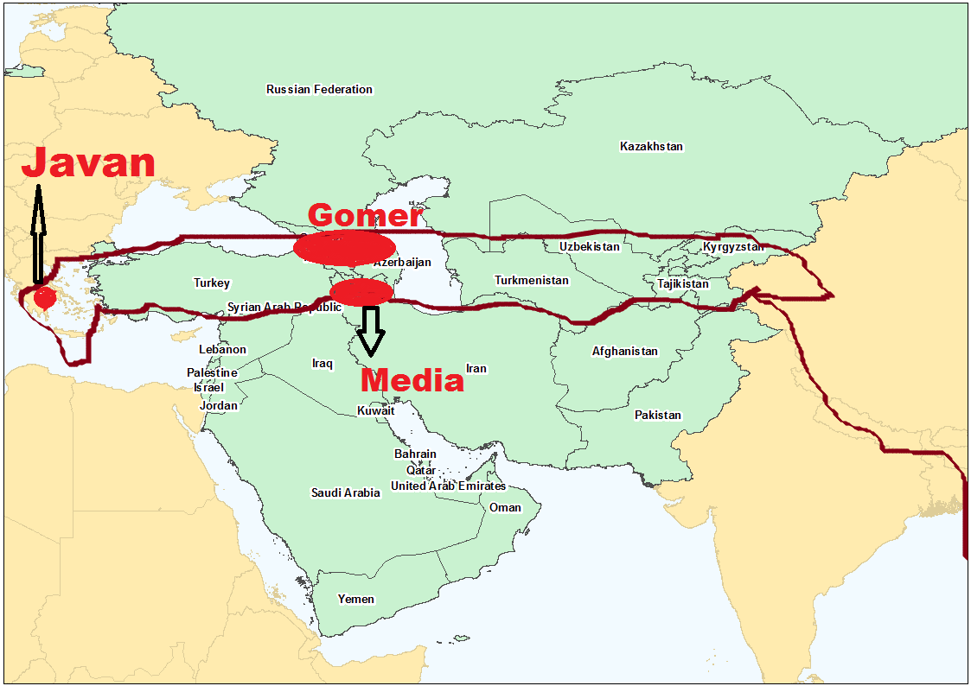

**njhfh;kh:** Nfhkhhpd; ,d;DnkhU kfdpd; ngah; njhfh;kh. ,td; Fjpiufis jPU Njrj;jpw;F nfhz;L te;J tzpfk; nra;jhd; vd;W $wg;gl;bUf;fpd;wJ (vNr:27:14). Kjy; Kjypy; Fjpiufis gof;fg;gLj;jpa gFjp fh];gpad; flYf;Fk; fUq;flYf;Fk; ,ilNa cs;s ];Nlgp Gy;ntsp (steppe grassland) vd;gJ cWjpnra;ag;gl;bUf;fpd;wJ. vdNt fh];gpad; flYf;Fk; fUq;flYf;Fk; ,ilNa cs;s ];Nlgp Gy;ntspapy; m];fpdh]Pf;F mUfpNy njhfh;khtpd; re;jjpah; FbNawp ,Ug;ghh;fs;.

jPU vd;gJ ,d;iwa nygdhdpy; ,Uf;fpd;wJ. ,d;W mJ nygdhd; epyg;gug;Gld; ,ize;J ,Uf;fpd;wJ. mnyf;rhz;lhpd; fhyj;jpw;F Kd;dh; mJ xU jdpj;j jPthfNt ,Ue;jJ. mnyf;rhz;lh; jPU jPtpw;F kz;zpdhyhd xU ghyj;ij mikj;J me;j jPit gpbj;jhd;. mJ Kjy; mJ nygdhdhNdhL ,ize;j xU epyg;gug;ghfNt ,Ue;J tUfpd;wJ. vNrf;fpNay; fhyj;jpy; mJ jPthfj;jhd; ,Ue;jJ. njhfh;kh Njrj;jhh; jPU jPtpw;F Fjpiuia fg;gypNyjhd; nfhz;Lte;jpUf;fNtz;Lk;. fg;gypNy nfhz;Lte;J tzpfk; nra;jpUg;gjhy; jPUtpw;F fg;gy; Nghf;Ftuj;J elf;Fk; tpjkhf xU flw;fiuNahuNk njhfh;kh Njrk; ,Ue;jpUf;f Ntz;Lk;. mg;gb ghh;j;jhy; fh];gpad; flYf;Fk;> fUq;flYf;Fk; ,ilg;gl;l flw;fiu gFjpahd [hh;[pahtpy; ,th;fs; FbNawpapUf;fyhk;. mJjhd; ];nlgp Gy;ntspg;gFjpapYk; ,Uf;fpwJ. m];fpdh]; FbapUe;j Mh;kPdpahtpw;F mUfhfTk; cs;sJ. [hh;[pahtpy; ,Ue;Jnfhz;L fUq;fly; topahf jPU jPtpw;F fg;gypy; Fjpiufis ,th;fs; nfhz;L te;jpUg;ghh;fs;. njhfh;kh tljpirapy; ,Uf;fpd;whd; vd;W vNr:38:6y; $wg;gl;bUg;gJk; ,jw;F ,zf;fkhfNt ,Uf;fpd;wJ.

**hpg;ghj;J:** Nfhkhhpd; ,d;DnkhU kfdhd hpg;ghj;Jtpd; ,Ug;gplk; Fwpj;J Ntjj;jpNy ve;j jftYk; nfhLf;fg;gltpy;iy. Nfhkhhpd; xU kfd; m[h;ig[hdpYk; xU kfd; [hh;;[pahtpYk; FbNawpapUe;jjhy; ,d;DnkhU kfd; me;j ,uz;L Njrq;fSf;Fk; mUNf cs;s Mh;kPdpahtpy; FbNawpapUf;f tha;g;G ,Uf;fpd;wJ. vdNt Nfhkhhpd; FbNaw;wkhdJ MhpkPdpah> M[h;ig[hd;> [hh;[pah Mfpatw;iw cs;slf;fpa gFjpahFk;. mjhtJ fUq;flYf;Fk;> fh];gpad; flYf;Fk; ,ilg;gl;l gFjpapy; Nfhkhhpd; re;jjpah; FbapUe;jhh;fs;.

**NkNrf;F:**

,th;fSk; jPU vd;w jPTld; fly; thzpfk; nra;jpUf;fpd;whh;fs; (vNr:27:13). vdNt jPUtpw;F tUtjw;F Vw;w xU flw;fiuapy; mth;fs; ,Ue;jpUf;f Ntz;Lk;. mth;fs; ve;j flw;fiu Njrj;jpy; ,Ue;jhh;fs; vd;gij vg;gb cWjp nra;tJ? rq;:120:5y; jhtPJ jhd; NkNrf;fpNy rQ;rhpj;jjhf $Wfpd;whd;. rQ;rhpj;jy; vd;gJ guNjrpaha; miye;J jphpjyhFk;. jhtPJ xUNghJk; NkNrf;fpNy rQ;rhpf;ftpy;iy. rq;:120 MdJ ,];uNayh;fs; rpiwgl;LNgha; guNjrpfshf rQ;rhpf;fg;NghtJ Fwpj;J jhtPJ Kd;dNu $Wk; jPh;f;fjhprdkhFk;.

A+jh;fs; ghgpNyhDf;F rpiwgl;L Nghdhh;fs;. mg;gbahdhy; ,e;j NkNrf; ghgpNyhdpNy ,Ue;jpUf;f tha;g;gpUf;fpd;wjh? fz;bg;ghf ,y;iy. Vnddpy; ghgpNyhdhdJ Nrkpd; $lhuk;. mq;Nf ahg;Ngj;jpd; re;jjpah; FbapUf;f KbahJ. Nrkpd; $iuapy;jhd; ,Uf;f KbAk;. vdNt NkNrf;fpNy rQ;rhpj;jJ A+jh Nfhj;jpuj;jhuhf ,Uf;f tha;g;gpy;iy. A+jh;fis jtpu Vida gj;J Nfhj;jpuj;jhUk; mrPhpa uh[hthy; rpiwahff;nfhz;L Nghfg;gl;lhh;fs;. mth;fis mrPhpa uh[h vq;Nf Fbakh;j;jpdhd;? mth;fs; vq;Nf guNjrpfshf rQ;rhpj;jhh;fs;? 2uh[h:17:6y; “MyhfpYk; MNghhpYk; Nkjpahpd; gl;lzq;fspYk; FbNaw;wpdhd;” vd;W $wg;gl;bUf;fpd;wJ. MyhFk;. MNgUk; Nkjpahtpd; mUNf ,Ue;j gl;lzq;fs; vd;gij ,e;j trdq;fs; %yk; njhpe;Jnfhs;syhk;. ,e;j gj;J Nfhj;jpuj;jhh;jhd; NkNrf;fpNy guNjrpfshf rQ;rhpj;jhpj;jpUf;f Ntz;Lk;. mth;fs; rQ;rhpj;j ,lk; NkjpahtpYk;> Nkjpahtpw;F mUfpYk; (MyhF> MNgh;) ,Ue;jJ.

ekf;F NkNrf;F Fwpj;J ,g;NghJ ,uz;L jfty;fs; fpilf;fg;ngw;wpUf;fpd;wd. vd;ndd;d jfty;fs; mJ? jPUtpw;F tzpfk; nra;Ak; mstpw;F NkNrf;fpd; re;jjpah; flw;fiuapNy ,Ue;jpUf;f Ntz;Lk;. Nkjpahtpw;F mUNf (10 Nfhj;jpuj;jhh; rQ;rhpj;j gFjp) ,Ue;jpUf;f Ntz;Lk;. ,e;j ,uz;L jfty;fisAk; nghUj;jp ghh;j;jhy; NkNrf;fhdJ fUq;flYf;Fk; Nkjpahtpw;Fk; ,ilNajhd; ,Ue;jpUf;f Ntz;Lk;.

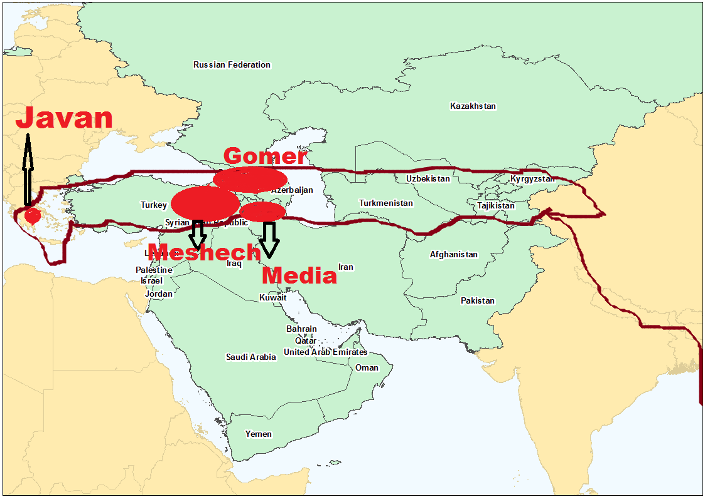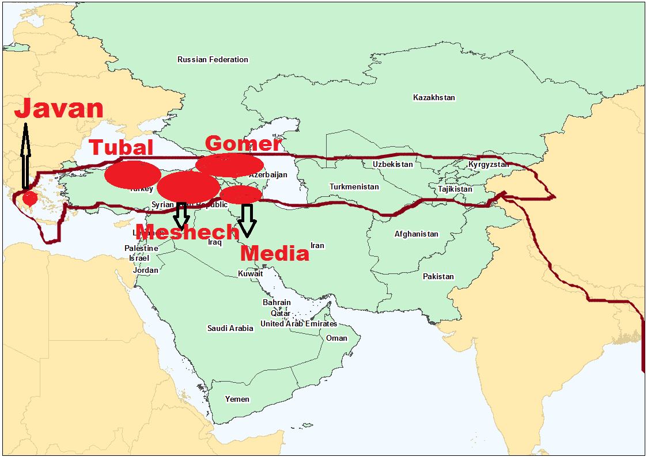

**J}ghy;:**

J}ghy; vg;NghJk; NkNrf; J}ghy; vd;W NkNrf;Fld; Nrh;j;Nj $wg;gLfpd;whd;. vdNt ,th;fs; NkNrf;fpd; re;jjpah; FbNawpa Njrj;jpd; mUfpy; FbNawpapUf;f Ntz;Lk;. ,th;fSk; jPUTld; tzpf njhlh;G itj;jpUe;jjhh;fs; vd;W vNr:27:13y; $wg;gl;bUf;fpd;wJ. J}ghiyf; Fwpj;J ,e;j ,uz;L jfty;fs;jhd;; ekf;F fpilj;jpUf;fpd;wJ. xd;W mth;fs; NkNrf;Ff;F mUfhf ,Uf;f Ntz;Lk;. mLj;jjhf jPUTld; tzpfk; nra;a Vw;wgb flw;fiuapNy ,Ue;jpUf;f Ntz;Lk;. NkNrf;Fk; fUq;fly; mUNf ,Ue;jjhy; ,th;fSk; fUq;fly; mUNf NkNrf;fpw;F mUfhf (Nkw;fhf) ,Ue;jpUf;f Ntz;Lk;.

**khNfhF:**

mLj;jjhf khNfhFitf; Fwpj;J ghh;g;Nghk;. NkNrf; J}ghy; [hjpapd; jiyik mjpgjp (vNr:38:2) vd;W khNfhFitf; Fwpj;J $wg;gl;bUf;fpd;wJ. NkNrf;> J}ghypd; mjpgjp vd;why; vd;d? xNu ,lj;jpy; my;yJ xNu Njrj;jpy; xd;Wf;Fk; Nkw;gl;l ,dq;fs; ,Uf;Fk;NghJ me;j ,dq;fSf;Fs; ve;j ,dkhdJ mjpfhukpf;f> MSik kpf;f ,dkhf ,Uf;fpd;wNjh me;j ,dNk jiyik mjpgjp my;yJ jiytd; vd;W Ntjj;jpNy $wg;gLk;. A+jh> ngQ;rkPd; Nfhj;jpuq;fs; ,ize;J cUthdJjhd; A+Njah vd;w ,dkhFk;. me;j ,uz;L Nfhj;jpuj;jhUs; A+jh Nfhj;jpukhdJ mjpfhukpf;fjhf> MSik kpf;f ,dkhf ,Ue;jjhy; ngQ;rkPd; Nfhj;jpuj;jpd; mjpgjp my;yJ jiytd; vd;gJ A+jh Nfhj;jpukhFk;. mJNghyNt NkNrf;> J}ghy; [hjpapd; jiyik mjpgjp vd;why; NkNrf;> J}ghy;> khNfhF MfpNahh; ,ize;J xNu ,dkhdhh;fs;. vg;gb ngQ;rkPDk;> A+jhTk; Nrh;e;J A+jh;fs; cz;lhdhh;fNsh mJNghy NkNrf;> J}ghy;> khNfhF Nrh;e;j xNu ,dkhdhh;fs;. mth;fs; mth;fsJ jiyikj;Jt ,dkhd (mjpfhukpf;f> MSikkpf;f) khNfhF ngauhy; miof;fg;gl;lhh;fs;. mth;fs; ,Ue;j ,lk; nkhj;jKk; khNfhF Njrk; vd;W miof;fg;gl;lJ.

vdNt khNfhFtpd; re;jjpah; NkNrf; J}ghy; MfpNahh; ,Uf;Fk; mNj Njrj;jpy; mth;fSf;F mUNfjhd; ,Uf;fNtz;Lk;. NkNrf; J}ghy; ve;j Njrj;jpypUe;jhh;fs;? JUf;fpapy;. mg;gbahdhy; khNfhFTk; JUf;fpapy;jhd; ,Uf;fNtz;Lk;. JUf;fpapy; ve;j ,lk; kPjkhf ,Uf;fpd;wJ? njd; gFjpapy; jhd; ,lkhdJ kPjkhf ,Uf;fpd;wJ. vdNt JUf;fpapd; njd; gFjpapy;jhd; khNfhF FbapUe;jpUf;f Ntz;Lk;. khNfhFtpd; re;jjpah; FbapUe;j gFjp kl;Lky;yhky; nkhj;j JUf;fpAk; Nrh;e;J khNfhF Njrk; vd;Nw miof;fg;gl;lJ. vNr:38>39 kw;Wk; ntsp:20 Mfpatw;wpy; $wg;gl;bUf;Fk; NfhF khNfhF vd;gJ ,e;j JUf;fpiaj;jhd; Fwpf;fpd;wJ. ,e;j JUf;fpjhd; gpw;fhyj;jpNy ,];uNaYf;F vjpuhf cyf ehLfis jiyikNaw;W tUk;. ,ij Fwpj;J gpd;dh; tphpthf ehk; ghh;g;Nghk;. khNfhFtpd; kfdJ ngauhdJ NfhF vd;W ,Ue;jpUf;fyhk;.

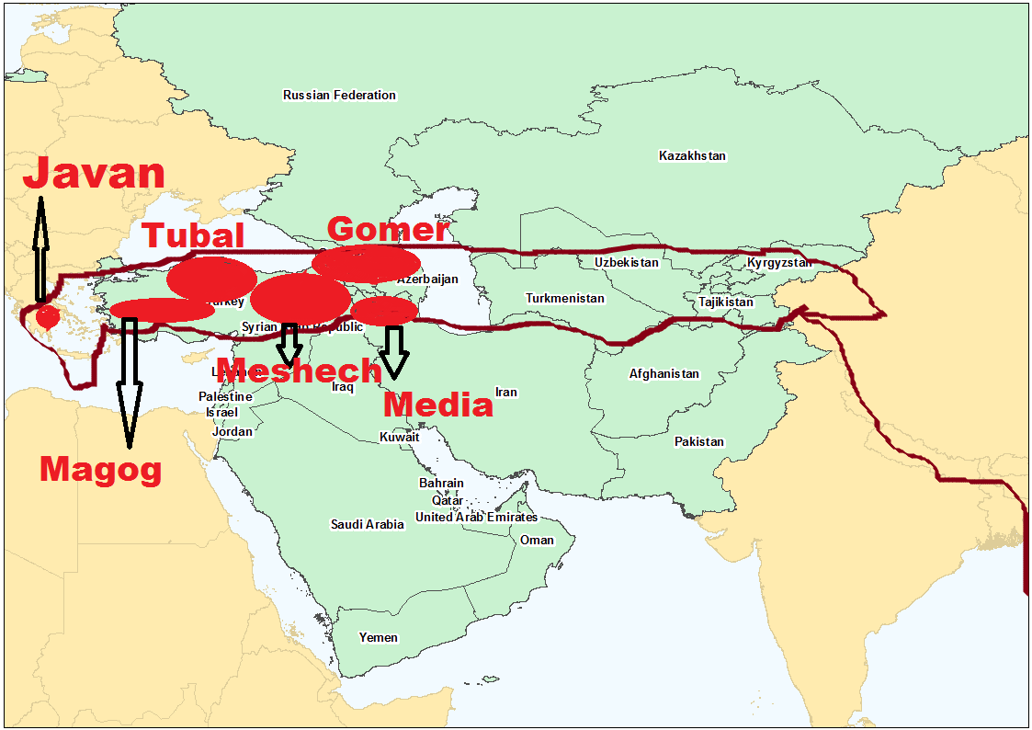 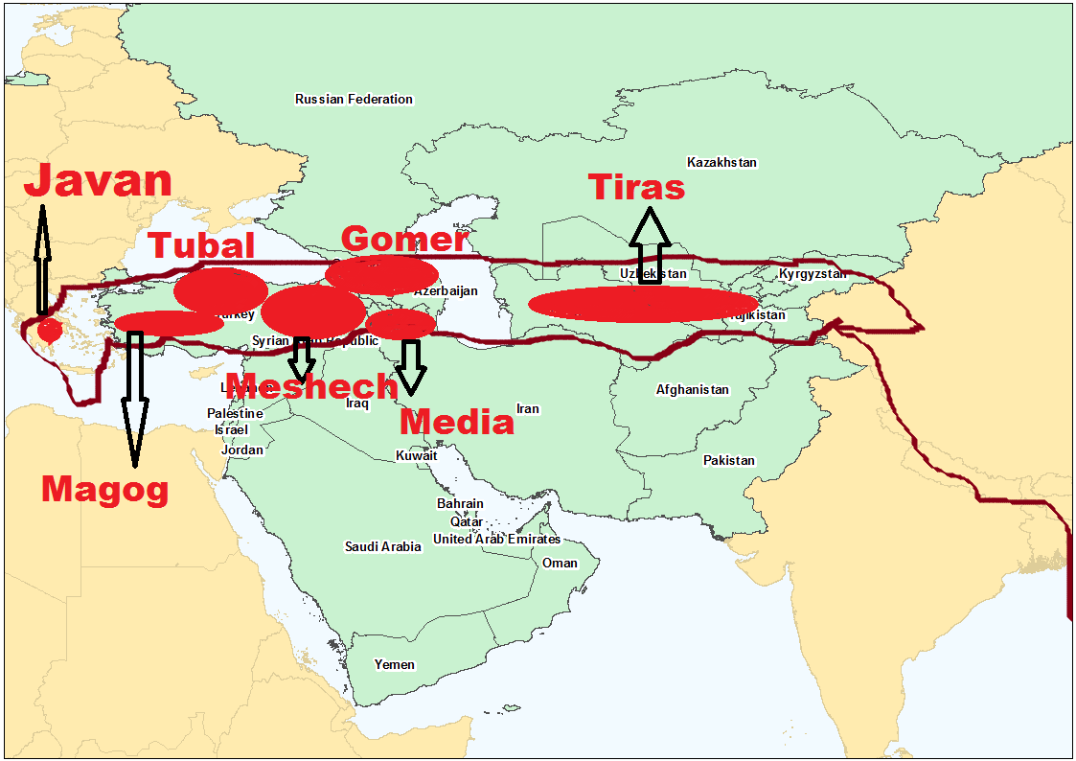

**jPuh];:**

,d;Dk; ahNgj;jpd; re;jjpapy; jPuh]pd; re;jjpah;; kl;Lk; vq;Nf FbapUe;jhh;fs; vd;W ehk; ghh;f;f Ntz;bajpUf;fpd;wJ. ,tidf; Fwpj;J Ntjj;jpy; ve;j jftYk; ,y;iy. mg;gbnad;why; ,e;j jPuh]pd; re;jjpapdh; FbapUe;j ,lj;ij ehk; vg;gb fz;Lgpbg;gJ? ehk; Vw;fdNt ahNgj;J Nrkpw;F $iuaha; thrkhapUg;ghd; vd;w ghh;j;Njhk;. me;j Nrkpd; $iutiuglj;jpy; ve;j ,lk; ,d;dKk; epiwtilahky; ,ilntsp ,Uf;fpd;wJ? fh];gpad; flYf;F fpof;Nf Nrkpw;F $iu ,y;yhky; ,Uf;fpd;wJ. mg;gb vd;why; jPuhrpd; re;jjpah; fh];gPad; flYf;F fpof;Nf c];ngfp];jhd;> Jh;f;nkdpj;];jhd;> fph;fp];jhd;> j[fp];jhd; Nghd;w Njrq;fspy; FbNawpath;fshfNt ,Uf;f tha;g;Gz;L.

,g;NghJ ahg;Ngj;jpd; 7 kfd;fspd; re;jjpaUk; FbNawpa ,lj;ij fz;Lgpbj;Jtpl;Nlhk;. ahg;Ngj;Jila re;jjpah; fpNuf;fk;> JUf;fp> Mh;kPdpah> M[h;ig[hd;> [hh;[pah> tlNkw;F <uhd;> c];ngfp];jhd;> fph;fp];jhd;> Jh;f;nkdp];jhd; Mfpa gFjpfspy; Kjypy; FbNawpdh;.

**kf;fs; ,dg;guty;**

ghNgy; NfhGukhdJ fl;lg;gl;l gpd;dh; kDf;Fyk; rpjwbf;fg;gl;lJ. mg;NghJ Nehthtpd; %d;W kfd;fspd; re;jjpAk; vq;F thrkhapUe;jhh;fs; vd;W Ntj trdj;jpd; %ykhf Muha;e;J ghh;j;Njhk;. kj;jpa fpof;F kw;Wk; mij Rw;wpAs;s INuhg;gpa> Mg;gphpf;f> Mrpa gFjpfspy;jhd; Kjy; Kjypy; Nehthtpd; re;jjpah; gutpdhh;fs;. mjd; gpd;dh; mth;fs; mq;fpUe;J nfhQ;rk; nfhQ;rkhf cyfk; KOtJk; gutj;njhlq;fpdhh;fs;. my;yJ rpjwbf;fg;gl;lhh;fs;. Nehthtpd; re;jjpah; cyfk; KOtJk; guTjyhdJ vt;thW ele;jJ vd;gij ,g;NghJ ehk; Ntj trdj;ijf; nfhz;L Muha;e;J ghh;g;Nghk;.

**fhkpd; re;jjpapdhpd; guty;**

**$\; re;jjpapdh;:**

ghNgy; NfhGuk; fl;lg;gl;L kf;fs; ,dthhpahf gphpe;j rpy Mz;Lfspy; Nkw;nfhz;L kdpj gutypy; ve;j khw;wKk; epfotpy;iy. fp.K.2200 Nghy; vj;jpNahg;gpah;fspd; Kjy; ,lg;ngah;T ele;jJ. $\pd; re;jjpaNu (vj;jpNahg;gpah;fs;) Kjypy; Juj;jg;gl;lhh;fs;. mth;fs; xt;nthU re;jjpauhf Juj;jg;gl;lhh;fs;. $\pd; re;jjpah; Vd; Juj;jg;gl;lhh;fs;. mjw;F NtjMjhuk; VjhtJ ,Uf;fpd;wjh?“*,];uNty; Gj;jpuNu> ePq;fs; vdf;F vj;jpNahg;gpahpd; Gj;jpuiug;Nghy; ,Uf;fpwPh;fs; my;yNth vd;W fh;j;jh; nrhy;Yfpwhh*;” (mNkh:9:7). ***,***e;j jPh;f;fjhprdkhdJ Njtd; MNkh]; jPh;f;fjhprpapd; %ykhf ,];uNaYf;F (10 Nfhj;jpuj;jhUf;F) $wpajhFk;. MNkh]; fhyj;jpy; ,];uNaypd; uh[hthf ,Ue;jtd; naNuhngahkhthd;. mtd; kpfg;nghpa tpf;fpuf Muhjidf;fhudhf ,Ue;jhd; (1uh[h:14:9). mtd; tpf;fpuf Muhjidfhudhf ,Ue;jNjhly;yhky; jdJ Njrj;jhiuAk; tpf;fpuf Muhjidfhuh;fshf khw;wpapUe;jhd;. ,e;j tpf;fpuf Muhjidahy; mf;fpukk; epiwtile;j ,];uNay; Njrj;ijjhd; Njtd; vj;jpNahg;gpahTld; xg;gpLfpd;whh;. Mk; ,];uNay; Njrk; vt;thW tpf;fpuf Muhjidahy; epuk;gpapUe;jNjh mNjNghy Kd;dh; $\pd; NjrKk; tpf;fpuf Muhjidahy; epuk;gpapUe;jJ. vdNt vj;jpNahg;gpah;fis ($\pd; re;jjpaiu) ntWj;jJNghy Njtd; ,];uNayh;fisAk; ntWj;jpUf;fpd;whh;. ,];uNayh;fis mth;fsJ Njrj;jpypUe;J rpjwbj;jJNghy tpf;fpuf Muhjidapy; %o;fpapUe;j $\pd; re;jjpaiu mth;fSf;F FbNaw nfhLj;j ,lj;jpypUe;J Njtd; Juj;jpdhh;. vj;jpNahg;gpah;fs; mth;fsJ tpf;fpuf Muhjidapd; fhuzkhfNt mth;fSf;F nfhLf;fg;gl;l ,lj;jpypUe;J Njtd; Juj;jpdhh; vd;gij tpf;fpuf Muhjidapy; epiwTw;wpUe;j ,];uNayh;fis mth;fSf;F nfhLj;jpUe;j Njrj;ijtpl;L Njtd; Juj;jpaij xg;gpl;L $wpajd; %ykhf ehk; Ghpe;Jnfhs;syhk;.

$\pd; kfd;fshd rg;jh kw;Wk; rg;jpjh MfpNahUila ngahpy; ve;j NjrKk; ,y;iy. fhuzk; mth;fs; xd;W my;yJ ,uz;L jiyKiw tUk; Kd;dNu mth;fSf;F nfhLf;fg;gl;l ,lj;jpypUe;J Juj;jg;gl;bUf;fpd;whh;fs; vd;W ehk; Vw;fdNt ghh;j;Njhk;. rg;jh rg;jpjh MfpNahh; N\ghtpw;F fpof;fhf mNugpa jPgfw;gj;jpd; njw;F fiuapy; FbapUe;jhh;fs; vd;W ghh;j;Njhk;. ,th;fNs $\pd; re;jjpahpy; tpf;fpuf Muhjidapy; Ngh;ngw;wth;fshf ,Ue;jpUf;fNtz;Lk;. vdNtjhd; Njtd; ,th;fis ,th;fSf;F nfhLj;j Njrj;jpypUe;J ntFtpiutpy; Juj;jpapUf;fpd;whh;. jhq;fs; FbapUe;j Njrj;jpw;F jq;fSila jfg;gDila ngaiu itf;Fk; Kd;dNu Juj;jg;gl;lhh;fs;. mth;fs; jq;fSila jfg;gdJ ngaiu itj;jpUe;jhy; me;j ngah; fz;bg;ghf NkhNr fhyk;tiuf;FkhtJ epiyj;jpUf;Fk;. $\pd; kw;w re;jjpah; nganuy;yhk; mq;Fs;s Ch;fSf;F ,Uf;Fk;NghJ rg;jh kw;Wk; rg;jpfhtpd; ngauh;fspy; ve;j CUk; ,y;iy vd;gjpypUe;J ,th;fNs $\pd; re;jjpahpy; tpf;fpuf Muhjidapd; Cw;Wf;fz; vd;gJk;> mth;fsJ gpjhf;fspd; ngah;fis jhq;fs; FbapUe;j ,lj;jpw;F ngauhf itf;Fk; Kd;dNu Juj;jg;gl;lhh;fs; vd;gJk; cWjpahfpd;wJ.

Njtd; xU [hjpahiu Juj;Jtjw;F kw;nwhU [hjpahiuNa gad;gLj;Jthh;. mg;gbahdhy; rg;jh kw;Wk; rg;jpfhtpd; re;jjpapdiu ahiuf;nfhz;L Juj;jpapUg;ghh;? rg;jh> rg;jpjh MfpNahh; mq;Nf FbapUe;jNghJ $\pd; re;jjpapdiuj; jtpu mNugpa jPgfw;gj;jpy; NtW ahUNk FbNawtpy;iy (nahf;jhdpd; re;jjpah; gy tUlq;fs; fopj;Nj mq;F te;J FbNawpdhh;fs;). Njtd; mth;fis Juj;Jtjw;F fz;bg;ghf mth;fSf;F mUfhf ,Ue;j $\pd; re;jjpauhfpa N\ghit kl;LNk gad;gLj;jpapUf;f Ntz;Lk;. N\ghit jtpu NtW ahUk; mg;NghJ me;j mNugpa jPgfw;gj;jpy; mth;fSf;F mUfhf ,y;iy.

**rg;jpfh:** N\ghtpw;F mUfpy; ,Ue;jth;fs; rg;jpfhtpd; re;jjpapduhth;. mth;fisjhd; N\gh Kjypy; Juj;jpapUf;f KbAk;. ,th;fs; njw;F Nehf;fp efh;e;J Mg;gphpf;fhtpw;Fs; rfhuh ghiytdj;jpd; njw;F gFjpf;Fs; Eioe;jhh;fs;. ,th;fs; rfhu ghiytdj;jpd; njd;gFjpf;Fs; Eioe;jjhy; ehfhPf cyfpypUe;J gphpf;fg;gl;L ehfhPfkw;w kdpjh;fshfp Nghdhh;fs;. ,th;fs; %ykhfNt rfhuhtpd; njw;F gFjpapy; cs;s vy;yh fWg;gpdj;jhUf;Fk; tpUj;jpaile;jhh;fs;. ,th;fs; rfhuhtpw;F njw;Nf khl;bf;nfhz;ljhy; cyfj;jhNuhL njhlh;G ,y;yhky; ehfhPf tsh;r;rp milahky; Nghdhh;fs;. ehfhPfkw;w Mg;gphpf;f MjpkdpjdpypUe;J vy;yh cyf kdpjh;fSk; Njhd;wpdhh;fs;; vd;gJ kdpj Qhdkhd ghpzhkf; nfhs;if. Mdhy; ehfhPfkhd $\pd; re;jjpNa kdpjh;fNshL njhlh;gpy;yhky; Nghdjhy; ehfhPfkw;w Mg;gphpf;f goq;Fbahdhh;fs; vd;gJ Ntjhfk nfhs;if. mJNt NjtQhdk;. Njtid tpRthrpg;gth;fs; kdpj Qhdkhd ,e;j ghpzhknfhs;ifia fz;bg;ghf Vw;Wf;nfhs;sNt KbahJ. NkYk; ,d;iwa khDltpay; mwpQh;fs; vy;yhk; Mg;gphpf;fhtpy;jhd; kdpj ,dk; Njhd;wpaJ> mq;fpUe;Jjhd; cyfj;jpd; vy;yh gFjpfSf;Fk; gutpaJ vd;W $Wfpd;whh;fs;. Njtd; Qhdpfspd; Qhdj;ij klikahf;f ty;yth;. ,th;fSila out of Africa TheoryahdJ NghypahdJ> ngha;ahdJ vd;W Njtd; ntF tpiutpy; mth;fSf;F Ghpar;nra;thh;. out of Africa TheoryahdJ ghpzhk nfhs;if mbg;gilapyhdJ. Ntjhfkj;jpd;gb Kjy; kdpj guty; ghgpNyhdpypUe;Nj Vw;gl;lJ. mLj;j kdpj gutyhdJ mNugpa jPgfw;gj;jpypUe;J Vw;gl;lJ. vdNt Ntjhfkk; $Wk; kdpj guty; nfhs;ifahdJ out of Arabia (or out of Mesopotamia) MFk;. out of Africa Theory my;y. cyfNk Vw;Ws;s out of Africa TheoryahdJ NghypahdJ. Ntjhfkj;jpw;F vjpuhdJ.

mLj;jjhf ekf;F xU Nfs;tp voNtz;Lk;. mNugpa jPgfw;gj;ijAk;> Mg;gphpf;fhitAk; nrq;fly; gphpf;fpd;wNj. ,e;j nrq;fliy rg;jpfhtpd; re;jjpapdh; vt;thW fle;J Mg;gphpf;fhtpw;Fs; nrd;wpUg;ghh;fs;? nrq;fliy flf;f NjtDila [dq;fshf ,Ue;j ,];uNayh;fSf;Nf NjtDila ty;yik Njitg;gl;lNj. mg;gbapUf;f NjtDila tpNuhjpfshd rg;jpfhtpd; re;jjpah; vt;thW nrq;fliy Njt xj;jhir ,y;yhky; fle;jpUg;ghh;fs;? ,J rhpahd Nfs;tpjhd;. Mdhy; rNfhjuh;fNs rg;jpjh Juj;jgLk; fhyj;jpy; Mg;gphpf;fhNthL mNugpah epyg;gug;ghy; ,ize;Nj ,Ue;jd. Mg;gphpf;fhtpw;Fk;> mNugpahtpw;Fk; ,ilNa nrq;fly; mg;NghJ ,y;iy. fPNfhd; MWjhd; Xbf;nfhz;bUe;jJ. vdNt mth;fs; mg;NghJ fliy flf;fNtz;ba mtrpak; ,Uf;ftpy;iy. fPNfhd; Mw;iwjhd; fle;Jnrd;whh;fs;. rg;jpfhtpd; re;jjpauJ ,lg;ngah;rpahdJ NgNyFtpd; fhyj;jpw;F Kd;dNu ele;Jtpl;lJ vd;gij Mjp:10:25 ekf;F czh;j;Jfpd;wJ (G+kp gFf;fg;gLtjw;F Kd;dh;).

**Nrgh:** fPNfhd; Mw;wpd; Nkw;F fiuapy; Nrghtpd; re;jjpah; jq;fpdh; vd;W ehk; Vw;fdNt ghh;j;Njhk;. mth;fs; rfhuh ghiytdj;jpy; vfpg;J> ypgpahtpw;F njw;fhf fpof;fpypUe;J Nkw;F Nehf;fp gutpdhh;fs;. ,th;fs; %yNk tl Mg;gphpf;f fWg;gpdj;jhh; tpUj;jpaile;jhh;fs;. ,e;j Nrghtpd; re;jjpah; %ykhfNt $+lhdpy; nfh;kh (kerma) ehfhPfk; Njhd;wpaJ. ,e;j ehfhPfkhdJ ,g;Nghija R+lhdpy; fp.K.2200y; ,Ue;J fp.K.1500 tiu ,Ue;jJ vd;W tuyhw;whsh;fshy; ep&gpf;fg;gl;LkpUf;fpd;wJ. rg;jpfhtpd; re;jjpapdh; rfhuhtpd; njw;Nf gutpdhh;fs;.

**rg;jh:** rg;jpfhtpd; re;jjpah; Juj;jptplg;gl;l gpd;dh; N\ghtpd; re;jjpauhy; rg;jhtpd; re;jjpah; Juj;jg;gl;lhh;fs;. N\ghtpd; re;jjpapduhy; ,th;fs; Juj;jg;gl;lNghJ vq;Nf nrd;wpUf;f tha;g;G ,Uf;fpd;wJ? rg;jhtpd; re;jjpapdh; ngh;rpa tisFlh fliy xl;b tlf;F Nehf;fp gpuahzk; gz;zpapUf;f KbahJ. Vnddpy; nkrgNlhkpahtpy; mg;NghJ kpfg;nghpa ehfhPfj;jpdh; (Nrkpd; re;jjpapdh;) ,Ue;Jnfhz;bUe;jhh;fs;;. vdNt ,th;fs; <uhDf;F njw;fhf flw;fiu Xukhf nrd;W ghfp];jhdpd; rpe;J rkntspia mile;jpUf;f Ntz;Lk;. mNugpahtpd; njd; gFjpapypUe;J ,th;fs; vt;thW <uhDf;Fs; Eioe;jpUf;f KbAk;? Mg;gphpf;fhTk; mNugpahTk; ,ize;jpUe;jJNghyNt mf;fhyj;jpy; (NgNyF fhyj;jpw;F Kd;dh;) mNugpahTk;> <uhDk;$l ,ize;Njjhd; ,Ue;jd. me;j fhyj;jpy; mNugpa jPgfw;gj;jpw;Fk;> <uhDf;Fk; ,ilNa Ntjhfk igNrhd;> Ig;gpuhj;J> ,njf;Nfy; Mfpa %d;W mWfSk; ,ize;J xNu Mwhf Xbf;nfhz;bUe;jJ. me;j Mw;iw mth;fs; vspjhf fle;J <uhDf;Fs; Eioe;jhh;fs;. mth;fs; <uhdpd; flw;fiu topahf ghfp];jhd; te;J rpe;J rkntspapy; FbNawpdhh;fs;. ,e;j rg;jhtpd; re;jjpapdNu rpe;J rkntsp ehfhPfj;ij Muk;gpj;J itj;j Muk;g fhy jpuhtplh;fshth; (Proto-Dravidians).

rg;jhtpd; re;jjpapdh; rpe;Jrkntspf;F te;jhh;fs; vd;W vg;gb cWjpahff; $Wfpd;wPh;fs; vd;W xU Nfs;tp vOtJ ,aw;ifNa. rg;jhtpd**;** re;jjpah;jhd**;** rpe;J rkntspf;F te;jhh;fs; vd;gjw;F Ntjhfkj;jpw;F ntspNa xU Mjhuj;ij ehk; ghh;g;Nghk;. nrsuh\;buk; (Zoroastrianism) vd;w kjkhdJ ngh;rpah;fs; (Vyhkpah;fshy;) gpd;gw;wg;gl;l xU kjkhFk;. ,th;fSila nkhop mnt];jpa nkhop (Avestan language). ,th;fSila Gdpj E}yhdJ zentd Avesta. ,e;j E}ypy; rpe;J rkntsp gFjpia gw;wp Fwpg;gpLk;NghJ rg;jh rpe;J (Sapta sindu) vd;W vOjg;gl;bUf;fpd;wJ. rg;jh rpe;J vd;gJ ngh;rpah;fSila (mnt];jpa) nkhop thh;j;ijahFk;. rg;jhtpd; re;jjpah; rpe;J gFjpfspy; FbNawpajhy;jhd; me;j gFjpia nrsuh\;buh;fs; rg;jh rpe;J vd;W mioj;jhh;fs;. mjw;F rg;jhtpd; re;jjpapdh; FbapUe;j rpe;J gFjp vd;W mh;j;jkhFk;.

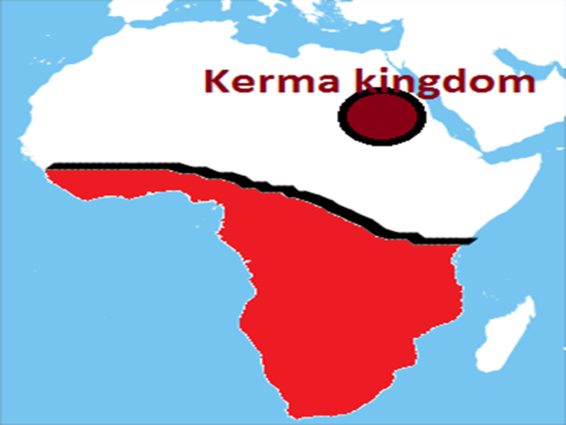 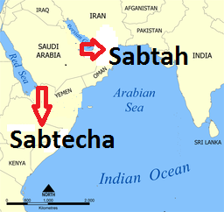

rk];fpUjj;jpy; vOjg;gl;l Kjy; Ntjkhd hpf;Ntjj;jpYk; gQ;rhg; gFjpahdJ rg;jh rpe;J vd;W miof;fg;gl;lJ. ,e;j thh;j;ijia hpf;NtjkhdJ mnt];jpad; nkhopapypUe;Nj vLj;jJ. xU Chpd; ngah; ,d;DnkhU nkhopapypUe;j vLj;jhy; mij mg;gbNajhd; gad;gLj;j Ntz;Lk;. mNjNghy hpf;Ntjj;jpYk; mnt];jpa nkhopapy; Fwpg;gpl;lgb mg;gbNa rg;jh rpe;J vd;W gad;gLj;jpdh;. mdhy; rk];fpUjj;jpy; rg;jh vd;why; VO vd;W mh;j;jKk; cz;L (rg;j hp\p> rg;j ];tuq;fs; vd;nwy;yhk; rk];fpUjj;jpy; $Wfpd;whh;fNs). vdNt mij VO ejpfs; XLk; gFjp vd;W gpd; te;jth;fs; jtwhf Ghpe;Jnfhz;lhh;fs;. hpf;Ntjk; vOjg;gl;lNghJ rhpahfj;jhd; vOjg;gl;lJ. Mdhy; gpd; te;jth;fs; mij VO MWfs; XLk; gFjp vd;W jtwhf Ghpe;Jnfhz;Ltpl;lhh;fs;. gQ;rhg; vd;gJ vg;gb VO MWfs; XLk; gFjpahf ,Uf;fKbAk;. Ie;J ejpfs; XLtjhy;jhd; mjw;F gQ;rhg; vd;W ngaNu te;jJ. ,th;fs; vd;d nrhy;fpd;whh;fs; vd;why;> Kd;dh; ru];tjp vd;w xU ejp mq;F XbaJ vd;W $Wfpd;whh;fs;. me;j ru];tjp ejp XbaJ cz;ik vd;W itj;Jf;nfhz;lhNy MW MWfs; jhNd tUfpwJ. mJ vg;gb VO ejp Xba gFjp vd;W miof;fg;gl KbAk;. rg;jh rpe;J vd;w thh;j;ij rpe;j rkntspia Fwpf;fNt gad;gLj;jg;gl;lJ vd;gij ehk; hpf; Ntjj;jpypUe;Jk; Ghpe;Jnfhs;syhk;. rg;jhit VO vd;W mh;j;jg;gLj;Jtij ehk; Gwf;fzpj;Jtplyhk;. Vnddpy; me;j gFjpapy; vg;gb NjbdhYk; VO MW ,y;iy.

rpe;J rkntspapy; FbNawpa rg;jhtpd; re;jjpah; ,kakiyapd; topahf rPdhtpd; tlfpof;F gFjp tiu nrd;whh;fs;. mq;fpUe;J njd; fpof;fhrpa ehLfspy; gutp M];jpNuypah tiu nrd;whh;fs;. ,e;j FbNaw;wk; vy;yhNk NgNyFtpd; fhyj;jpw;F Kd;dh; mjhtJ G+kp gFf;fg;gLtjw;F Kd;dh; ele;J Kbe;jJ. rPdhtiu nrd;w fWg;gpdj;jhh; vy;yhUk; mg;gbNa njw;F Nehf;fp jpUk;gptpltpy;iy. xU rpyh; kl;Lk; njw;F Nehf;fp M];jpNuypah tiuf;Fk; nrd;whh;fs;. xU $l;lj;jhh; rPdhtpNyNa jq;fptpl;lhh;fs;.

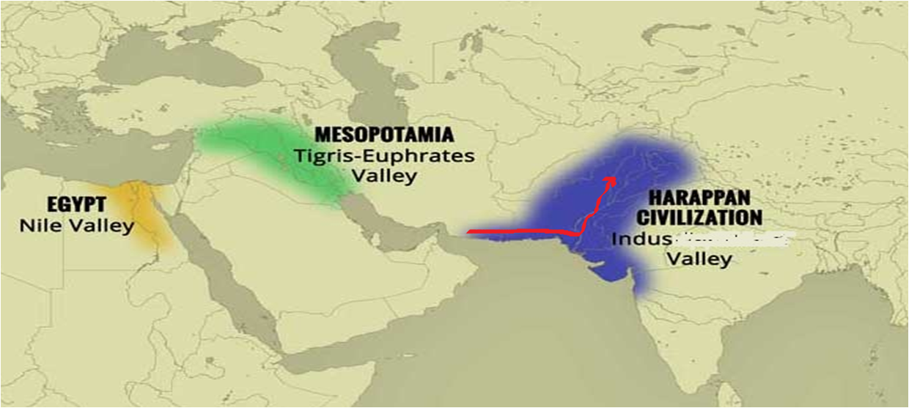 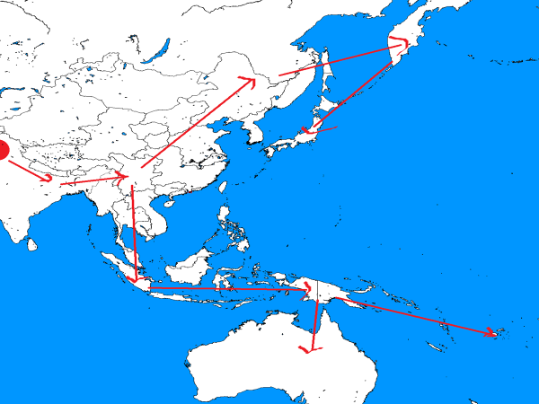

rPdhit Mz;l Xia Dynasty (1900-1700 BC), Shang/Yin Dynasty (1700-1050 BC) ,itnay;yhk; fWg;gh; rhk;uh[;[paNk. rPdhit Mz;l %d;whk; uh[;[pakhd Zhou Dynasty jhd; ahg;Ngj;jpd; re;jjpah; rhk;uh[;[pakhFk;. mjw;F Kd;tiu fWg;gh;fNs rPdhit Mz;Lnfhz;bUe;jhh;fs; vd;gJ tuyhW.

gpypg;igd;rpYk; fWg;G ,d kf;fs; Mjpthrpfshf ,g;NghJk; ,Ue;J tUfpd;whh;fs;. ek;k Chpy; vg;gb Mjpthrp kf;fs; njhiyJ}u kiyg;ghq;fhd gFjpfspy; ,Ug;ghh;fNsh mg;gbNa gpypg;igd;rpd; njhiyJ}u kiyg;ghq;fhd gFjpfspy; ,e;j fWg;G goq;Fb kf;fs; ,g;NghJk; tho;e;Jnfhz;bUf;fpd;whh;fs;. 30f;Fk; Nkw;gl;l fWg;G ,df;FOf;fs; gpypg;igd;rpy; ,g;NghJk; tho;e;Jnfhz;bUf;fpd;whh;fs;.

jha;yhe;jpy; nrhw;g mstpy; fWg;G ,dj;jhh; ,Uf;fpd;whh;fs;. Rkhh; 300 Ngh;jhd; ,Ug;gjhf $Wfpd;whh;fs;. ,th;fis **Maniq people** vd;W miof;fpd;whh;fs;.

kNyrpahtpy**;** nrkhq; (Semang) kw;Wk; gNlf; (Batek) vd;w ,uz;L fWg;G ,df;FOf;fs; ,Uf;fpd;whh;fs;

me;jkhdpYs;s nrd;bndy; jPTfspy; ,d;Wk; ntsp cyfj;NjhL njhlh;G ,y;yhky; fWg;gpdj;jhh; ,Uf;fpd;whh;fs;. ,th;fis jtpu njw;F me;jkhdpy; Xq;Nf (Onge) kw;Wk; [huth]; (Jarawa) vd;w ,uz;L fWg;G ,df;FOf;fs; ,Uf;fpd;whh;fs;.

,e;NjhNdrpahtpw;F fpof;fhfTk;> gpypg;igd;Rf;F njw;fhfTk; M];jpNuypahtpw;F tlf;fhfTk; ,Uf;Fk; gFjpia nkyNdrpah vd;W miog;ghh;fs;. ,e;j gFjpfspy; cs;s rg;jhtpd; re;jjpapdiu nkyNdrpah;fs; vd;W $Wthh;fs;. rg;jhtpd; re;jjpauhd ,e;j nkyNdrpah;fs; gg;Gth ePA+fpdpah> gp[p jPTfspy; Mjpf;fk; nrYj;jf;$bath;fshf ,Uf;fpd;whh;fs;. kw;w gFjpfspnyy;yhk; Fiwthd vz;zpf;ifapy; Mjpthrpfshf njhiyJ}u gFjpfspy; xU FOtpduhfNt ,Uf;fpd;whh;fs;. Mdhy; ,q;Nfh (gg;Gth ePA+fpdpah> gp[p jPTfspy;) mth;fs;jhd; ngUk;ghd;ik ,dkhf ,Ue;J jq;fis jhq;fNs Msf;$bath;fshf ,Uf;fpd;whh;fs;.

,g;gbahf rpe;J rkntspapypUe;J nrd;w rg;jhtpd; re;jjpah; fpof;F Mrpah> njw;F Mrpah> njd; fpof;F Mrpah kw;Wk; nkyNdrpah vd;W nrhy;yf;$ba gFjpfspYk; gutpdhh;fs;. M];jpNuypahtpYk; gutpdh;. Mdhy; rg;jhtpd; re;jjpapdhpy; xU $l;lj;jhh; rpe;J rkntspapNyNa jq;fptpl;lhh;fs;. rpe;J gFjpapy; jq;fpath;fspy; xU $l;lj;jhh; ,e;jpahtw;Fs; gutpdhh;fs;.

rpe;J rkntspapy; ,Ue;j rg;jhtpd; re;jjpaNu ,e;jpahtpw;Fs; gutpdhh;fs; vd;gjw;F VjhtJ Mjhuk; ,Uf;fpd;wjh vd;W ePq;fs; Nfl;fyhk;. `hpahdhtpy; cs;s uhf;fp`h;`p (Rakhigarhi) vd;w ,lj;jpy; 4000 Mz;LfSf;F Kw;gl;l xU ngz;zpd; b.vd;.V. khjphp fpilj;jpUf;fpd;;;;;;;;;;;;;;;;;;;;wJ. 4000 tUlj;jpw;F Ke;ja b.vd.V khjphp vd;why; vd;d mh;j;jk;? rpe;J rkntsp fhyj;J b.vd;.V vd;W mh;j;jkhFk;. me;j b.vd;.V. ,g;NghJ njd;dpe;jpahtpd; jopo;ehl;bYs;s ,Ush; vd;w goq;Fbapdhpd; b.vd;.V.Ald; xj;JNghfpd;wJ vd;W tpQ;QhdG+h;tkhf ep&gpj;jpUf;fpd;whh;fs;. vdNt rpe;J gFjpapy; ,Ue;j rg;jhtpd; re;jjpapdh; jkpo;ehL tiu gutpapUf;fpd;whh;fs; vd;gJ ,jd; %yk; cWjpahfpd;wJ. MdhYk; xU gFjp rg;jhtpd; re;jjpapdh; mjd; gpwFk; rpe;J rkntspg; gFjpapNyNa ,Ue;jhh;fs;.

**epk;Nuhj;J:** ,Jtiu $\pd; MW re;jjpaUs; rg;jh> rg;jpfh> Nrgh vd;w %d;W re;jjpapdUila guty; Fwpj;J ghh;j;Njhk;. mjw;fLj;J $\pd; re;jjpahpy; epk;Nuhj;jpd; re;jjpah; Juj;jg;gl;lhh;fs;. ,tdJ re;jjpah; mrPhpahtpw;F epk;Nuhj;J Njrk; vd;w ngah; itj;j gpwFjhd; Juj;jg;gl;bUf;fpd;whh;fs;. vdNt ,th;fs; rg;jh kw;Wk; rg;jpfh MfpNahUf;F gpd;dh;jhd; Juj;jg;gl;bUf;fpd;whh;fs;. NgNyF fhyj;jpw;F gpwF (G+kp gFf;fg;gl;l gpwF) ,th;fs; Juj;jg;gl;bUf;fyhk;. mR+hpd; re;jjpauhy; mth;fs; tpf;fpuf Muhjidapd; epkpj;jkhf mrPhpahtpypUe;J Juj;jg;gl;lhh;fs; vd;Wk; ghh;j;Njhk;. mrPhpahtpy; Juj;jg;gl;l mth;fs; vq;Nf nrd;wpUf;f tha;g;G ,Uf;fpd;wJ? mtdJ re;jjpahpd; tlf;Nf ahg;Ngj;J re;jjpapdh; ,Ue;jhh;fs;. njw;Nf Vyhkpah;fs; ,Ue;jhh;fs;. vdNt mR+hpd; re;jjpauhy; mq;fpUe;J Juj;jg;gLk;NghJ mth;fshy; tlf;F gFjpf;Fk; nrd;wpUf;f KbahJ. njw;F gFjpf;Fk; nrd;wpUf;f KbahJ. fpof;fhfj;jhd; mth;fs; gazpj;jpUf;f Ntz;Lk;. fpof;F Nehf;fp efh;e;J Nghyd; fztha; topahf rpe;J rkntspia mile;jhh;fs;. rg;jhtpd; re;jjpaUf;F mLj;J rpe;J rkntspf;F te;j ,uz;lhtJ $\pd; re;jjpah; ,th;fNs. fl;llq;fs; fl;LtjpYk;> efuq;fs; fl;LtjpYk; Njh;e;j epk;Nuhj;jpd; re;jjpapduhy; rpe;J rkntsp ehfhPfkhdJ kpfTk; nrOikaile;jJ. rpe;J rkntsp ehfhPfj;jpd; cz;ikahd nrhe;jfhuh;fs; epk;Nuhj;jpd; re;jjpapdNu. mth;fs; Vw;fdNt ghgpNyhd;> epdpNt Nghd;w nghpa efuq;fis fl;ba mDgtk; cs;sth;fs; Mjhyhy; mNj mDgtj;ij nfhz;L khngUk; rpe;J rkntsp ehfhPfj;ij cUthf;fpdhh;fs;.

rpe;J rkntspf;F te;j epk;Nuhj;jpd; re;jjpapdh; mq;F kPjkhf ,Ue;j rg;jhtpd; re;jjpapdiu mq;fpUe;J Juj;jpdhh;fs;. epk;Nuhj;jpd; re;jjpapduhy; Juj;jg;gl;l rg;jhtpd; re;jjpah; rpyh; fq;if rkntspf;Fk;> rpyh; kj;jpa> fpof;F kw;Wk; njw;F ,e;jpahtpw;Fk; nrd;whh;fs;. rg;jhtpd; re;jjpapdNu ,d;W ,e;jpahtpd; njw;F> kj;jpa> tlf;F> fpof;F gFjpfspYs;s kiytho; kf;fs; kw;Wk; G+h;t Fbfshth;.

rg;jhtpd; re;jjpah; Juj;jg;gl;l gpd;dh; rpe;J rkntspapy; epk;Nuhj;jpd; re;jjpah; kl;LNk tho;e;Jnfhz;bUe;jhh;fs;. vg;gTNk xU ,df;$l;lk; nkhj;jkhf gpuahzKk; gz;zhJ. mNjNghy nkhj;jkhf xNu ,lj;jpYk; ,Uf;fhJ. rg;jhtpd; re;jjpapdhpy; xU gphptpdh; gphpe;J ,kakiy topahf nrd;W Mrpah KOtJk; gutpaJ Nghy rpe;J rkntspapy; ,Ue;j epk;Nuhj;J re;jjpahpy; xU $l;lj;jhh; ,e;jpahtpd; njw;F Nehf;fp efh;e;J Fkhpf;fz;lk; tiu nrd;W mq;NfNa epue;jukhf jq;fpdh;. Fkhpf;fz;lk; vd;wTld; mJ ,d;iwa Fkhpf;fz;l Mh;tyh;fs; $WtJNghy mJ M];jpNuypahitAk;> klfh];fiuak; ,izj;J ,Ue;j xU fz;lky;y. jopo;ehl;ilAk; ,yq;ifiaAk; ,izj;jpUe;j xU rpW epyg;gug;Ng me;j Fkhpf;fz;lkhFk;. NgNyF fhyj;jpw;F gpwFk; jkpo;ehLk; ,yq;ifAk; ,ize;Nj ,Ue;jJ. gpw;fhyq;fspy; flw;Nfhspdhy;jhd; Fkhpf;fz;lk; mope;jJ vd;W jopo; ,yf;fpaq;fs; $Wfpd;wd. ,d;iwa ehfg;gl;bdk;> uhkehjGuk;> Jj;Jf;Fb> jpUney;Ntyp> fd;dpahFkhp Mfpa epyg;gFjpfis ,yq;ifNahL ,izj;J ,Ue;jNj me;j Fkhpf;fz;lkhFk;. fd;dpahFkhpf;F njw;fhfTk; nfhQ;rk; epyg;gug;G ,Ue;jpUf;fyhk;.

njd; ,e;jpah te;j epk;Nuhj;jpd; re;jjpapdUk; Vw;fdNt njd; ,e;jpah te;jpUe;j rg;jhtpd; re;jjpapdUk; ,ize;Nj jpuhtpl ,dk; cUthdJ. rg;jhTk;> epk;Nuhj;Jk; ,uz;L ,dq;fshf ,Ue;jhYk; ,uz;LNgUf;Fk; xNu jfg;gd; vd;gjhy; ,uz;LNgUk; $\pd; re;jjpapdNu. mg;gbnad;why; jkpoh;fshfpa ehk; ahh;? epk;Nuhj;J kw;Wk; rg;jhtpd; fyg;gpdhy; cz;lhd $\pd; re;jjpaNu ehk;. ,g;NghJ njhpfpwjh njd; ,e;jpahtpy; Vd; NfhGuq;fs; mjpfkhf ,Uf;fpd;wJ> tpf;fpufq;fs; mjpfkhf ,Uf;fpd;wJ vd;W. ,e;j NfhGuq;fSk; tpf;fpufq;fSNk ehk; epk;Nuhj;jpd; re;jjpah; vd;gjw;fhd ,d;DnkhU Mjhuq;fshf ,Uf;fpd;wJ.

rpe;J rkntspapy; ,Ue;j epk;Nuhj;jpd; re;jjpah; njd; ,e;jpah KOtJk; Fwpg;ghf jopofj;jpy; gutpdhh;fs; vd;gjw;F NtW vd;d Mjhuk; ,Uf;fpd;wJ> fPobapy; fz;Lgpbf;fg;gl;l ghidNahl;L fPuy; vOj;Jf;fSk;> rpe;J rkntspapy; fpilf;fg;gl;l fPuy; vOj;Jf;fSk; xd;WNgyNt ,U;fpd;wJ. vdNt rpe;J rkntspapy; fPuy; vOj;Jf;fis cz;lhf;fpa epk;Nuhj;jpd; re;jjpauhy;jhd; jkpo;ehl;by; vOj;Jf;fs; cz;lhf;fg;gl;lJ vd;gJk;> ,uz;L ehfhPfKk; epk;Nuhj;jpd; ehfhPfNk vd;gJk; cWjpnra;ag;gLfpd;wJ.

rpe;J rkntspapy; FbNawpapUe;j kw;w epk;Nuhj;jpd; re;jjpah; nfhQ;rk; fhyj;jpw;F gpwF mUfpy; ,Ue;j Vyhkpah;fshy; ,e;jpahtpw;Fs; Juj;jg;gl;lhh;fs;. mjd; gpwF rpe;J gFjpfspy; Vyhkpah;fs; FbNawpdhh;fs;. ,e;j Vyhkpah;fNs Mhpah;fs;. rpe;J rkntspf;F rg;jh kw;Wk; epk;Nuhj;jpd; re;jjpaUf;F mLj;J %d;whtjhf te;jth;fNs Vyhkpah;fs; (<uhdpah;fs; - Mhpah;fs;).

Vyhkpah;fshy; Juj;jg;gl;l epk;Nuhj;jpd; re;jjpah; tlf;F> kj;jpa kw;Wk; fpof;F ,e;jpahtpw;Fs; gutpdhh;fs;. ,th;fs; Vw;fdNt tlf;F kj;jpa kw;Wk; fpof;F ,e;jpahtpy; ,Ue;j rg;jhtpd; re;jjpapdNuhL fye;jhh;fs;. ,d;Wk;$l Xhprh> kj;jpa gpuNj\;> [hh;fz;l;> rl;B\;fh;> gPfhh;> cj;jugpuNj\;> Nkw;F tq;fk; Nghd;w khepy kf;fspy; cs;s gpw;gLj;jg;gl;l> jho;j;jg;gl;l> kiytho; kf;fs; njd; ,e;jpa jpuhtplh;fspd; rhaiy xl;bNa fhzg;gLtjd; fhuzKk; mJNtahFk;. Mkhk; rNfhjuh;fNs mth;fSk; ek;ikNghyNt $\pd; re;jjpapdh;jhd;. tl ,e;jpah;fs; vy;NyhiuAk; ehd; $wtpy;iy. tl ,e;jpahtpy; cs;s goq;Fb kw;Wk; Mjpthrp kf;fs; midtUk; kw;Wk; rpy tl ,e;jpa gpw;gLj;jg;gl;l r%fj;jhh; $\pd; re;jjpaNu. nkhop NtWgLtjhy; mth;fs; NtW ,dk; vd;W ehk; vz;zNtz;lhk;.

vfpg;jpw;F njw;Nf cs;s Mg;gphpf;fhit Njtd; $\pd; re;jjpf;F nfhLj;jJNghy Nkw;F ,e;jpah jtph;j;J ,e;jpahtpd; kw;w vy;yh gFjpfisAk; Njtd; $\pd; re;jjpf;Nf nfhLj;jhh;. vdNt Ntjhfk ghh;itapy; ,e;jpahitAk; $\; Njrk; vd;W miof;fyhk;. ,t;thuhf rpe;J rkntspapy; Kjypy; FbNawpa rg;jhtpd; re;jjpaUk;> mLj;J FbNawpa epk;Nuhj;jpd; re;jjpaUk; ,e;jpahtpw;Fs; Juj;jg;gl;lhh;fs;. rg;jhtpd; re;jjpapdh; ,e;jpahtpw;F ntspNa fpof;F> njd;fpof;F> njw;F Mrpa kw;Wk; Xrpahdpf; gFjpfspYk; gutpdhh;fs;. Mdhy; epk;Nuhj;jpd; re;jjpapdh; ,e;jpahtpw;Fs; kl;LNk gutpdh;.

rpe;J rkntspapNyNa jq;fpapUe;j epk;Nuhj;jpd; re;jjpapdh; Vyhkpah;fspd; tUifapd;NghJ ,e;jpahtpw;Fs; Juj;jg;gl;lhh;fs; vd;W ghh;j;Njhk;. mg;NghJ epk;Nuhj;jpd; re;jjpapdhpy; rpyh; kl;Lk; jhq;fs; FbapUe;j rpe;Jtpw;F mUNf ,Ue;j ghfp];jhdpYs;s gYrp];jhd;> <uhd;> Jh;f;nkdp];jhd; Nghd;w ehLfspy; cs;s gFjpfSf;F jg;gp Xb mq;NfNa ,Ue;Jtpl;lhh;fs;. mth;fNs gpuhFa; ,dj;jhh; (Brahui) vd;W ,d;W miof;fg;gLfpd;whh;fs;. ,th;fSk; jpuhtplh;fs; vd;W ,d;iwa khDltpay; ty;Ydh;fs; $Wfpd;whh;fs;. ,th;fs; NgRk; nkhopahd gpuhFa; nkhopAk; jpuhtpl FLk;g nkhopjhd; vd;W nkhopapay; ty;Yzh;fs; ep&gpj;jpUf;fpd;whh;fs;. jpuhtpl nkhop FLk;gk; vd;W ePq;fs; $Fspy; Njbdhy; tiuglj;jpy; ghf;fp];jhdpYk; xU gFjp fhl;lg;gLk;. mJNt gpuhFa; ,dkf;fs; thOk;gFjp MFk;. ,jpypUe;J ekf;F vd;d njhpfpwJ. ,d;W ehk; NgRk; jpuhtpl nkhopfshdJ rg;jhtpd; re;jjpapypUe;J te;jjy;y. mJ epk;Nuhj;jpd; re;jjpahplkpUe;J te;jJ vd;gJ mjd; %yk; ekf;F cWjpahfpd;wJ. jkpo; vOj;Jf;fSk; epk;Nuhj;J re;jjpapd; fPuy; vOj;Jf;fspypUe;J te;jitNa (fPob Mjhuk;).

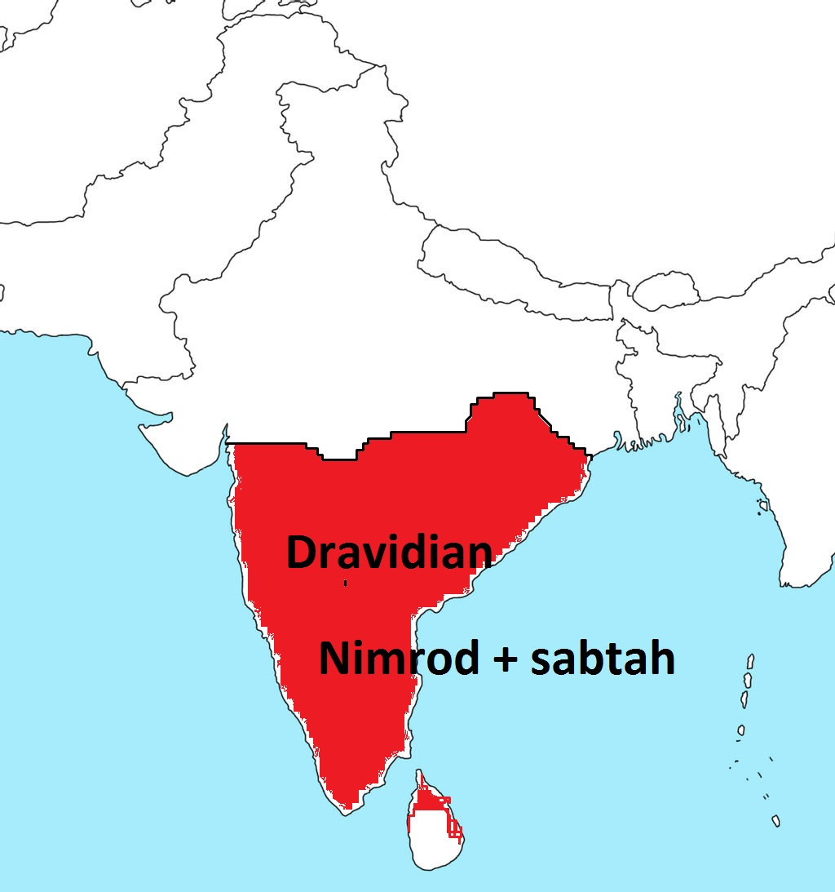 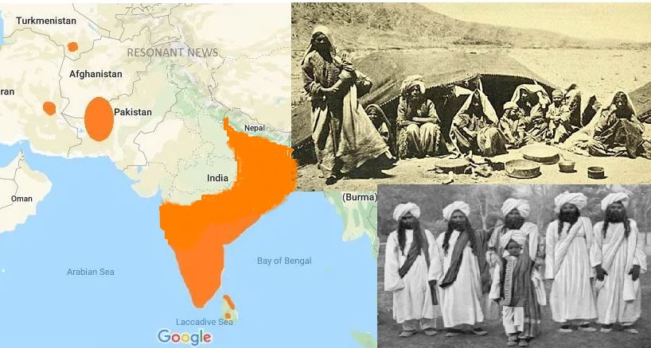

epk;Nuhj;jpd; re;jjpah; vd;d epwk;? $\pd; re;jjpah;fshf mth;fs; ,Ug;gjhy; mth;fSk; fWg;G epwj;jth;fsh? epk;Nuhj;jpd; re;jjpapdhpd; epwj;ij ehk; fz;Lgpbf;f KbAkh? mth;fs; $\pd; re;jjpahjyhy; fWg;G epwj;jth;fs; vd;W ehk; nrhy;yptpl KbahJ. $\pd; re;jjpapy; fWg;G Kjy; gpuTz; tiuapyhd epwj;jhh; ,Ue;jhh;fs; vd;W ehk; Vw;fdNt ghh;j;Njhk;. ghfp];jhd; gFjpfspy; ,Uf;Fk; ,e;j gpuhFa; ,dj;jhh; rg;jhtpd; re;jjpaUld; fyf;fhj epk;Nuhj;jpd; re;jjpapduhth;. ,e;jpahtpw;Fs; te;j epk;Nuhj;jpd; re;jjpapdh; kl;LNk rg;jhtpd; re;jjpapdNuhL fye;jhh;fs;. gpuhFa; ,dkf;fs; rpe;J gFjpapNyNa ,Ue;Jtpl;ljhy; rg;jhtpd; re;jjpaNuhL fyf;fhky; jq;fsJ nrhe;j epwj;ij fhj;Jf;nfhz;lhh;fs;. mjdhNy gpuhFa; ,dj;jhUila epwNk epk;Nuhj;J re;jjpahpd; cz;ikahd epwkhFk;. gpuhFa; ,dj;jhh; vd;d epwk;? brown vd;W nrhy;yyhk;. ,jpypUe;J epk;Nuhj;jpd; re;jjpapdh; gpuhFa; ,dj;jhiug; NghyNt gpuTz; epwj;jhh; vd;gJ cWjpahfpd;wJ. mjdhy;jhd; epk;Nuhj;jpd; re;jjpAk;> rg;jhtpd; re;jjpAk; fye;J cUthd jpuhtplh;fspy; ,d;W fWg;G Kjy; gpuTz; tiuahd epwq;fs; ,Uf;fpd;whh;fs;.

Fkhpf;fz;lk; te;j epk;Nuhj;jpd; re;jjpahpd; xU $l;lj;jhh; mq;NfNa epue;jukhf jq;fptpl;lhh;fs;. Vw;fdNt nkhop mth;fsplkpUe;jJ. vOj;J tbtkpUe;jJ. mwpTk;> Mw;wYk; ,Ue;jJ. fiy fyhr;rhukpUe;jJ. vdNt ngUk; ehfhPfj;ij Fkhpf;fz;lj;jpy; ];jhgpj;jhh;fs;. mJNt ghz;ba ehfhPfk; my;yJ jopo; ehfhPfkhFk;. ,JNt $\pd; ehd;fhtJ nghpa ehfhPfkhFk; (Kjy; ehfhPfk; ghgpNyhdpd; epk;Nuhj;J ehfhPfk;> ,uz;lhk; ehfhPfk; R+lhdpd; nfh;kh – kerma ehfhPfk;> %d;whtJ ehfhPfk; rpe;J rkntsp ehfhPfk;). ghz;ba my;yJ jkpo; ehfhPfkhdJ rpe;J rkntsp ehfhPfj;jpd; ePl;rpNa. ghz;ba ehfhPfkhdJ fp.K.2000j;jpy; ];jhgpf;fg;gl;lJ. mth;fs; jq;fSila nkhopia tsh;g;gjpYk;> fiyfis tsh;gjpYk; ngUk;gq;fhw;wpdhh;fs;. fly;Nfhspdhy; me;j fz;lk; mopaNt mth;fs; jpUney;Ntyp> J}j;Jf;fb> ,uhkehjGuj;ij Nehf;fp efh;e;jhh;fs;. rpyh; ,yq;ifapy; jq;fptpl;lhh;fs;. mth;fNs ,d;iwa ,yq;ifapd; G+h;t Fbfshf ,Uf;fpd;whh;fs;. jpUney;Ntypapd; Mjpr;rey;Y}hpy; 3800 (fp.K.1800) Mz;LfSf;F Kw;gl;l vYk;G$Lfs; fz;Lgpbf;fg;gl;bUf;fpd;wd. gpd;dh; mth;fs; mq;fpUe;J kJiuf;F ,lk;ngah;e;jhh;fs;.

**uhkh>Mtpyh:** $\pd; MW kfd;fspd; re;;jjpahpy; rg;jh> rg;jpjh> Nrgh> epk;Nuhj;J Mfpa ehd;F re;jjpaUila guty; Fwpj;J ehk; ,Jtiuf;Fk; ghh;j;Njhk;. uhkh Mtpyh MfpNahNu kPjKs;s $\pd; re;jjpauhth;. $\pd; ,e;j ,uz;L re;jjpah; ,Ue;j ,lk;jhd; NkhNr fhyj;jpy; vj;jpNahg;gpah vd;W miof;fg;gl;lJ. ,th;fSila FbapUg;ghdJ fhdhd; Njrj;jpd; njd; Gwj;jpy; Muk;gpj;J ,d;iwa Vkd; Njrk; tiuf;Fk; ,Ue;jJ. ,th;fs; gpw;fhyq;fspy; xUtNuhL xUth; fye;J xNu ,dkhfptpl;lhh;fs;. Mrh fhyj;jpNy ,e;j vj;jpNahg;gpah;fs; kPz;Lk; ngyd;nfhs;sKbahjgbf;F Kwpabj;jhd; vd;W Ntjj;jpNy $wg;gl;bUf;fpd;wJ. mjpypUe;J $\pd; re;jjpah; ngyd; Fiwe;J nfhz;Nl te;jJ. mNugpah;fSila gyk; mNugpahtpy; mjpfhpj;Jf;nfhz;Nl te;jJ. mjdhy; mNugpahtpd; Nkw;F fiuapy; ,Ue;j uhkh kw;Wk; Mtpyhtpd; re;jjpah; nfhQ;rk; nfhQ;rkhf mNugpahtpd; njw;F Nehf;fp js;sg;gl;L ,Wjpapy; Vkd;> XkDf;Fs; milf;fg;gl;Ltpl;lhh;fs;. mjd; gpwF me;j Njrj;jpypUe;j mNugpah;fSld; (nahf;jhdpd; re;jjpaUld;) mth;fs; fye;Jtpl;lhh;fs;. ,t;thwhf uhkh kw;Wk; Mtpyhtpd; re;jjpapdh; ,y;yhkNyNa Ngha;tpl;lhh;fs;. $\pd; re;jjpahpy; kw;w ehd;F re;jjpapdUk; ed;F gutpapUf;f uhkh kw;Wk; Mtpyhtpd; re;jjpapdh; kl;Lk;; kiwe;Jtpl;lhh;fs;. MdhYk; ,d;Wk; Xkd; VkdpYs;s mNugpah;fSila b.vd;.Vit ghpNrhjid nra;jhy; mjpNy $\pd; re;jjpah; (uhkh> Mtpyh) [Pd;fSk; fye;jpUg;gJ ekf;F njhpatUk;.

$\pd; re;jjpapdh; Mg;gphpf;fh Kjy; M];jpNuypah tiu gutpdh;. ,th;fs; FbNaWtjw;nfd;Nw Njtd; Mg;gphpf;fh fz;lj;ijAk;> ,e;jpa Jiz fz;lj;ijAk;> njd;fpof;fhrpa ehLfisAk;> fpof;fhrpa ehLfisAk;> Xrpahdpf; ehLfisAk; fhypahf itj;jpUe;jhh;.

**fhdhdpd; re;jjpah;:**

fhkpd; re;jjpahpy; mLj;jjhf ehk; fhdhdpd; re;jjpahpd; guty; Fwpj;J ghh;g;Nghk;. fhdhdpah;fs; ,uhl;rjh;fs; (vz;:13:33@cgh:9:2@2:20) vd;W Ntjk; $Wfpd;wJ. fhkpd; re;jjpadhfpa epk;Nuhj;J guhf;fpukrhypahf ,Ue;jhd;. vdNt mtdplk; [yg;gpusaj;jpw;F Ke;ja thdJ}jh;fSila [Pd;fs; ,Ue;jJ vd;W Kd;dh; ghh;j;Njhk;. me;j thdJ}jh;fSila [PdhdJ fhkpd; kidtpapd; %yk; epk;Nuhj;jpw;F flj;jg;gl;lJ vd;w ghh;j;Njhk;. fhkpd; kidtp %ykhf epk;Nuhj;jpw;F nrd;w thdJ}jh;fSila [PdhdJ fhkpd; re;jjpapy; fhdhDf;Fk; fhkpd; kidtp %ykhf mjpfkhf flj;jg;gl;lJ. vdNt fhdhdpah;fSk; uhl;rjh;fshfTk;> guhf;fukrhypfshfTk; ,Ue;jhh;fs;. mjdhy;jhd; fhdhd; NjrkhdJ ,uhl;rjUila NjrkhfNt fUjg;gl;lJ.

“fhdhdpahpd; tk;rj;jhh; vq;Fk; gutpdhh;fs;” vd;W Mjp:10:18y; nfhLf;fg;gl;bUf;fpd;wJ. Kjypy; mth;fs; Vrh fhyj;jpy; Juj;jg;gl;lhh;fs; (cgh:2:20>21). ,J Rkhh; fp.K.1850k; tUlj;jpy; ele;jJ. mjd; gpwF kp];uhaPkpd; tk;rj;jhuhd fg;Njhhpah; “MNrhPk; njhlq;fp Mrh kl;Lk;” (fhrh kl;Lk;) ,Ue;j fhdhdpaiu Juj;jpdhh;fs; (cgh:2:22). ,];uNayh;fs; fhdhd; Njrj;jpd; kPJ gilnaLj;jNghJ fhdhdpah;fs; Juj;jg;gl;lhh;fs; (fp.K.1450). fhdhdpah;fspy; gykhd uh[;[pak; Vj;jpa uh[;[pakhFk;. fhdhdpd; re;jjpauhfp Vj;jpah; (Hittities) kpfg;nghpa rhk;uh[;[pakhf ,Ue;jhh;fs;. mth;fsJ uh[;[paj;jpd; fhykhdJ (fp.K.1600-1180). Vj;jpah;fs; fp.K.1180y; rpjwbf;fg;gl;ljd; %ykhf fhdhdpahpd; mLj;j guty; (INuhg;ghtpw;Fs;) Vw;gl;bUf;Fk;. fhdhdpd; ,d;ndhU re;jjpauhd rPNjhdpah; (jPUit Mz;lth;fs;) rhyNkhd; fhyj;jpy; Gfo;ngw;W ,Ue;jhh;fs; (<uhk; uh[h). jPU mnyf;rhz;lh; fhyj;jpy; mopf;fg;gLk; tiuf;Fk; mth;fs; mq;F ,Ue;jhh;fs;. gpd;dh; mUfpYs;s ,lq;fSf;F rpjwbf;fg;gl;lhh;fs;. ,th;fs; ,d;iwa nygdhd;> rphpah> mNugpah> N[hh;ld;> vfpg;J> JUf;fp> <uhd; Nghd;w ehLfspy; gutpapUf;fyhk;. ,];uNaypy; 3700 tUlj;jpw;F Ke;ja vYk;Gf;$L fz;Lgpbf;fg;gl;bUf;fpwJ. 3700 Mz;LfSf;F Kd;dh; mq;F fhdhdpah;fNs tho;e;jhh;fs;. vdNt me;j vYk;Gf;$lhdJ fhdhdpah;fSila vYk;Gf;$Ljhd;. me;j vYk;Gf;$l;bypUe;J vLf;fg;gl;l b.vd;.V. khjphpia ghpNrhjpj;jjpy; mJ ,d;W nygdhdpy; thOk; kf;fSila b.vd;.V.Tld; xj;jpUg;gij ep&gpj;jpUf;fpd;whh;fs;. ,d;W nygdhdpy; thOk; 90 rjtpfpj kf;fs; fhdhdpah;fNs. rphpahtpYk; ngUk;ghyhdth;fs; fhdhdpah;fshfNt ,Uf;fpd;whh;fs;.

fhdhdpd; xU kfdhd rPNjdpah;fs; (gPdprpah;fs;) kpfr;rpwe;j flNyhbfshf ,Ue;jjhy; kj;jpajiuf;fly; flw;fiu efuq;fs; vq;Fk; gutpapUg;ghh;fs; (njw;F INuhg;gh kw;wk; tlf;F Mg;gphpf;fh). NkYk; J}u Mrpa ehLfSf;F tzpfk;nra;Ak; nghUl;L vfpg;J> vj;jpNahg;gpah gFjpfspYk; FbNawpapUg;ghh;fs;.

2500 tUlq;fSf;F Kw;gl;l gPdPrpah;fSila b.vd;.V.I Muha;e;jNghJ> mJ INuhg;ghtpd; tuyhw;W fhyj;jpw;F Ke;ja G+h;tFbfSila b.vd;.VAld; xj;jpUg;gJ njhpfpd;wJ. vdNt fhdhdpah;fs; (gPdPrpah;fs;) Vrh fhyj;jpw;F Kd;dNu INuhg;ghtpw;F nrd;wpUf;fyhk; vd;W njhpatUfpd;wJ. NkYk; JUf;fpia Mz;l Kjy; uh[;[paNk Vj;jpa uh[;[pak;jhd;. vdNt JUf;fp topahf efhPfkile;j Vj;jpah;fs; fp.K.1800y; INuhg;ghtpw;F nrd;wpUf;fyhk;. JUf;fpah;fSlDk; Vj;jpah;fs; fye;jpUf;fyhk;. ,d;iwa INuhg;gpa r%fj;jpy; ,e;j ,uz;L fhdhdpd; re;jjpapdUk; (gPdPrpah;> Vj;jpah;) fz;bg;ghf fye;jpUg;ghh;fs;. mjdhNyjhd; “fhdhdpahpd; tk;rj;jhh; vq;Fk; gutpdhh;fs;” vd;W Ntjj;jpy; nfhLf;fg;gl;bUf;fpd;wJ. Mdhy; ,d;W mth;fs; nygdhdpy; ,Ug;gJ kl;LNk ep&gpf;fg;gl;bUf;fpd;wJ.

**fhdhDf;F nfhLj;j rhgk; (Mjp:9:25-27):** Nehth fhdhDf;F vd;d rhgq;fis nfhLj;jhd;? “jd; rNfhjuhplj;jpy; mbikfSf;F mbikahapUg;ghd;” vd;gJ Njtd; fhdhDf;F nfhLj;j Kjy; rhgk;. fhdhdpd; re;jjpah; xt;nthUtUk; jq;fsJ rNfhjuh;fSf;F mbikfshf ,Ug;ghh;fs; vd;gNj mjd; tpsf;fkhFk;. fhdhdpah;fsplk; xw;Wik ,y;yhjjhy; jq;fSf;Fs; Nghhpl;L> jq;fsJ rNfhju ,dq;fis mbikf;nfhs;thh;fs;. mjd;gbNa ele;jJ. fhdhdpahpd; rNfhju ,dkhd vfpg;jpa ,dKk; mth;fis mbiknfhz;lJ. Mgpufhk; fhyj;jpNy$l vfpg;Jjhd; fhdhid Mz;Lnfhz;bUe;jJ.

“fhdhd; mtDf;F (Nrkpw;F) mbikahapUg;ghd;” vd;gJ mLj;j rhgkhFk;. Nrkpd; re;jjpahd ,];uNayh;fs; fhhdpah;fis mopj;jhh;fs;. kPjkhapUe;jth;fs; ,];uNayf;F mbikahf fPo;gl;L ,Ue;jhh;fs;. fhdhdpah;fs; FbapUe;j NrhNjhk;> NfhNkhuhit Nyhj;jpd; re;jjpapdh; Rje;jhpj;Jf;nfhz;lhh;fs;. NkYk; Nrkpd; re;jjpahd ,];kNaYk;> VNjhkpaUk;$l fhdhd; Njrj;ij Rje;jhpj;Jf;nfhz;lhh;fs;. ,jd; %yk; fhdhd; Nrkpw;F mbikahf ,Ug;ghd; vd;w jPh;f;fjhprdk; epiwNtwpaJ. fhdhdpahpy; filrp tiu Mz;Lnfhz;bUe;jJ rPNjhdpah;fshd jPU uh[;[paNk. ghgpNyhd; uh[;[pakhd Nrkpd; re;jjpah; mth;fisAk; mbik nfhz;lhh;fs;.

“fhdhd; mtDf;F (ahNgj;jpw;F) mbikahf ,Ug;ghd;” vd;gJ fhdhDf;F nfhLf;fg;gl;l %d;whtJ rhgkhFk;. fpNuf;f> Nuhk NguuRfs; vy;yhNk ahNgj;jpDila re;jjpapdUila uh[;[paq;fshFk;. ,th;fSk; fhdhdpah;fis mbiknfhz;lhh;fs;. mnyf;rhz;lh;jhd; filrp fhdhDila uh[;[pakhfpa jPU uh[;[paj;jpd; kPjpapUe;j gFjpahd jPU jPit mopj;J fhdhdpa uh[;[paj;ij Kw;wpYk; mopj;Jg;Nghl;lhd;. ahNgj;jpd; kw;nwhU uh[;[pakhd xl;lkhd; uh[;[pak; ,d;iwa nygdhdpy; ,Uf;Fk; fhdhdpah;fis mbiknfhz;lhh;fs;. ,g;gbahf Nehth fhdhDf;F nfhLj;j rhgk; epiwNtwpaJ.

**Nehthtpd; Vd; fhdhid rgpj;jhh;?** jtW nra;jJ fhk;. Mdhy; Nehth fhik rgpf;fhky; mtdJ filrp kfdhfpa fhdhid Vd; rgpf;fpd;whh;? NehthtpDila rhgkhdJ jdpg;gl;l xU kdpjdhfpa NehthtpDila rhgky;y. mJ NjtDila rhgk;. Njtd; Nehth %yk; fhdhid rgpj;jhh;. Nehth jtW nra;j fhikAk; rgpf;ftpy;iy. mtdJ %j;j kfdhd $i\Ak; rgpf;ftpy;iy. khwhf fhdhid (fhkpd; ,isa kfd;) Vd; rgpf;fpd;whh;? Ntjk; fhik milahsg;gLj;Jk;NghJ fhdhDila jfg;gd; vd;Wjhd; milahsg;gLj;Jfpd;wJ (Mjp:9:18>22). fhdhdpah;fs; epk;Nuhj;ijg; NghyNt Nfhl;il fl;b efuq;fis mikg;gjpy; Ngh;ngw;wth;fs;. fhdhd; Njrj;jpy; NahRth tUk;NghJ gy fhdhdpa [hjpah; gyj;jNfhl;il fl;b tho;e;jpUe;jhh;fs;. xU uh[;[pak; ];jhgpf;f Nfhl;il fl;Ljy; mtrpak;. fhdhdpd; re;jjpah; %ykhfNt fhk; kfpikailthd; vd;gjhy; Njtd; fhdhid rgpj;jpUg;ghh;. fhkpd; kfpikahd fhdhid rgpg;gjd; %yk; fhkpw;F jz;lid nfhLf;f Njtd; epidj;jpUf;fyhk;.

Njtd; fhdhid rgpg;gjpy; xH; Mo;e;j mh;j;jk; ,Ue;jpUf;Fk; vd;Nw Nahrpf;fj; Njhd;Wfpd;wJ. fhdhdpah;fs; vy;NyhUk; ,uhl;rj [hjpahf ,Ue;jhh;fs; (vz;:13:33@ cgh:9:2). ,uhl;rj jd;ik vd;gJ thdJ}jh;fspd; fyg;gpdj;jhy; kl;LNk tuKbAk;. fhkpd; kidtpapd; [Pd;fspy; thdJ}jh;fspd; [Pd; mjpfkhf ,Ue;jJ. mJ fhdhDf;F flj;jg;gl;lJ. vdNt fhdhdpah; thdJ}jh;fspd; fyg;gpdj;jth;fshf (uhl;rjh;fshf) ,Ue;jhh;fs;. Njtd; vy;yh thdJ}jh;fspd; fyg;gpdj;jhiuAk; [yg;gpusaj;jpd; %yk; Vw;fdNt mopj;Jtpl;lhh;. Mdhy; Nehthtpd; kidtp %yk;> fhdhd; %yk;> mtdJ re;jjpf;F thdJ}jh;fspd; [Pd; guthjgbf;F fhdhid rgpj;jpUf;fyhk; (,J xU mDkhdNk).

**kp];uhaPk;:**

kDf;Fyk; gphpe;jjpypUe;J xNu ,lj;jpy; ,Uf;Fk; xU rpy [df;$l;lq;fspy; vfpg;jpaUk; xUth;. xNu ,lj;jpy; 4000 tUlq;fshf tho;e;J te;jjhy; mth;fs; ehfhPfj;jpd; cr;rj;ij njhl;lhh;fs;. mnyf;];hz;lh; ,e;j Njrj;ij gpbf;Fk;tiu 31 uh[;[paq;fs; vfpg;ij Mz;bUf;fpd;wJ (mjpy; njw;fpyike;j $\pd; uh[;[paKk; mlq;Fk;). kp];uhaPkpd; re;jjpapdh; nghpa mstpy; guttpy;iy. vfpg;ij Rw;wpapUe;j ypgpah> fhdhd; Mfpa Njrq;fspy; gutpdhh;fs;.

**G+j;:**

G+j;ijf; Fwpj;J Ntjj;jpy; mjpfkhf nfhLf;fg;gltpy;iy. ypgpah kw;Wk; mjw;F Nkw;fhf cs;s nkhj;j tl Mg;gphpf;f gFjpfspy; ,th;fs; gutpapUf;fyhk;. Fwpg;ghf ypgpah> my;[Phpah> Jdprpah> nkhuhf;Nfh Nghd;w gFjpfspy; ,th;fs; gutpapUf;fyhk;.

**Nrkpd; re;jjpapdhpd; guty;:**

Nrkpw;F 5 kfd;fs; ,Ue;jhh;fs;. ,th;fs; ahUk; ahNgj;ij kPwp tlf;Nf Nghftpy;iy. Vnddpy; ahNgj;J Nrkpw;F $iuahf ,Ue;jhh;fs; vd;W ehk; Vw;fdNt ghh;j;Jtpl;Nlhk;.

**Vyhk;:** VyhNk Nrkpd; re;jjpahpy; fpof;fpy; ,Ue;jtdhthd;. mtdpd; re;jjpapdNu Mg;fhdp];jhd;> ghfp];jhd;> Nkw;F ,e;jpah Mfpa ,lj;jpy; gutpdhh;fs;. ,th;fSila nkhop mt];jpa nkhopahFk; (Avestan). ,e;j Vyhkpah;fs; ,e;jpahtpd; Nkw;F gFjptiu gutpdhh;fs;. ,e;jpahtpd; Nkw;F gFjpfspYs;s rj;jphpa ,dkhdJ ,e;j Vyhkpah;fNs. NtjKk; Vyhkpah;fs; kpfr;rpwe;j tpy;tPuh;fs; vd;W $wpapUf;fpd;wJ (vNu:49:35). Njtd; Vyhik rpjwbg;Ngd; vd;W $wpapUf;fpd;whh;. MdhYk; Vyhkpd; rpiwapUg;G filrp ehl;fspy; jpUg;gg;gLk; vd;W Njtd; $Wfpd;whh; (vNu:49:39). ,jpypUe;J Mg;fhdp];jhd;> ghfp];jhd;> ,e;jpahtpd; Nkw;F gFjpapy; cs;s vy;yh Vyhkpd; re;jjpaUk; kPz;Lk; <uhdpy; Nrh;f;fg;gl tha;g;G ,Uf;fpd;wJ vd;W njhpfpd;wJ.

**mh;gf;rhj;:** Vyhkpw;F gpwF nghpa mstpy; gutpa Nrkpd; re;jjpah; mh;gf;rhj;jpd; re;jjpaNu.,tdJ re;jjpaNu ,];uNayh;fs; (NgNyFtpd; re;jjpah;). ,th;fs; fhdhdpah;fis Juj;jp fhdhd; Njrj;ij Rje;jhpj;Jf;nfhz;lhh;fs;.

nahf;jhDk; mh;gf;rhj;jpd; re;jjpapdNd. ,td; NgNyFtpd; rNfhjud;. nahf;jhDila ngauhdJ kpfTk; Fwpg;gpl;L Mjp:10:25y; $wg;gl;bUf;fpd;wJ. xU Kf;fpa ghj;jpuj;jpd; rNfhjud;> rNfhjhp> my;yJ jhapd; ngah; Ntjj;jpy; nfhLf;fg;gl;bUf;fpd;wJ vd;why; mth;fSila gq;F NjtDf;F MjuthfNth my;yJ NjtDf;F vjpuhfNth Kf;fpakhdjhf ,Uf;Fk; vd;gJ Ntjhfk tpjpahFk;. mNjNghy nahf;jhDk; Kf;fpa ghj;jpuk;jhd;. ,tNd mNugpah;fspd; je;ij Mthd;. mjhtJ ,td; %ykhfNt mNugpa ,dk; cz;lhdJ. ,tdJ re;jjpaNu mNugpa jPgfw;gj;jpd; ngUk;ghyhd gFjpfis Mf;fpukpj;jhh;fs;.

**RNkhpa ehfhPfk;:** RNkhpa ehfhPfkhdJ Nrkpd; re;jjpapdUila ehfhPfkhFk;. Nrk; vd;w thh;j;ijapypUe;Nj RNkh; vd;w thh;j;ij te;jJ. ,e;j RNkhpa ehfhPfkhdJ nkrgNlhkpahit rhh;e;jJ. me;j ,lj;jpy;jhd; Kjy; Kjypy; muhuj; Njrj;jpypUe;J te;j nkhj;j kDf;FyKk; jq;fpdhh;fs;. mg;NghJ mth;fSf;F epk;Nuhj;J uh[hthf ,Ue;jhd;. ghNgy; NfhGuk; fl;lg;gl;l gpwF Nehthtpd; re;jjpah; rpjwbf;fg;gl;lhh;fs;. mg;NghJ ,q;F ,Ue;jth;fs; Muhkpd; re;jjpah;fNs. Muhkpd; re;jjpaNu RNkhpa ehfhPfj;ij njhlq;fp itj;jth;fs;. rpneahh; Njrk; ,th;fsJ fl;Lg;ghl;by;jhd; ,Ue;jJ. epk;Nuhj;jpw;F gpwF nghpa uh[;[paj;ij Njhw;Wtpj;jth;fs; ,th;fNs. ,e;j uh[;[pakhdJ mf;fhbad; uh[;[pak; (Akkadian kingdom) vd;W miof;fg;gl;lJ. mf;fhbad; uh[;[paj;jpw;F Ntjhfk ngah; Muhkpa uh[;[pakhFk; (Muhkpd; re;jjpauhy; Njhw;Wtpf;fg;gl;ljhy;). ,e;j uh[;[paj;jpd; Kf;fpa uh[h rhh;Nfhdhthd;. ,e;j uh[;[pakhdJ fp.K.2334-2154 tiu ,Ue;jJ. mf;fhba (Muhkpa) uh[;[paj;jpw;F gpwF mR+h; tk;rj;jhhpd; mrPhpa rhk;uh[;[pak; vOe;jJ. ,jd; fhyk; fp.K.2154 Kjy; fp.K.538 tiu ,Ue;jJ. ,e;j fhyj;jpy; ,th;fsJ nry;thf;F VwpAk; ,wq;fpAk; fhzg;gl;lJ. fpl;ljl;l fp.K.2200y; ,Ue;Nj Vyhkpd; uh[;[paKk; ,Uf;fpd;wJ. Mgpufhkpd; fhyj;jpy; Vyhkpd; uh[h <uhd; Njrj;jpypUe;J fhdhd; Njrk; tiu Mz;Lnfhz;bUe;jjhf Ntjj;jpy; gjpT ,Uf;fpd;wJ (Mjp:14:1-4). fhdhdpah;fs; 12 tUlk; Vyhkpd; uh[hthfpa nfjh;yhNfhNkiur; Nrtpj;jhh;fs; vd;W mjpy; $wg;gl;bUf;fpd;wJ. ,jpypUe;J Vyhkpd; uh[;[pak; Mgpufhk; fhyj;jpNyNa fhdhd; Njrk; tiuf;Fk; ,Ue;jJ vd;gij ehk; mwpe;Jnfhs;syhk;. mNjNghy Vyhkpd; uh[;[pakhdJ fpof;Nf Nkw;F ,e;jpah tiu gutpaJ. rpe;J rkntspapypUe;j epk;Nuhj;jpd; re;jjpapdiu Kjypy; ,e;jpahtpw;Fs; Juj;jpath;fs; ,th;fNs. mh;gf;rhj;jpd; re;jjp mNugpa jPgfw;gk; KOtJk; Mz;lhh;fs;. Nrkpd; re;jjpapy; nygdhd; Kjy; mrPhpah tiu FbNawpa Y}j;ij gw;wp mjpfkhf njhpatpy;iy. ,g;gbahf kj;jpa fpof;F gFjpapy; ,Ue;j fhdhd; kw;Wk; $\pd; re;jjpaiu Kw;wpYkhf Juj;jp kj;jpa fpof;F gFjp KOtJk; (,e;jpahtpd; Nkw;F gFjp tiuf;Fk;) Nrkpd; re;jjpapdh; gutpdhh;fs;.

**ahg;Ngjpd; re;jjpapdhpd; guty;:**

**ahNgj;jpw;F nfhLj;j MrPh;thjk;:** “ahg;Ngj;ij Njtd; tph;j;jpahf;Fthh;” vd;gJ Njtd; ahNgj;jpw;F nfhLj;j Kjy; MrPh;thjkhFk;. ahg;Ngj;J vd;whNy tpUj;jpailjy; vd;Nw mh;j;jkhFk;. ,d;W INuhg;gh> u\;ah> rPdh> ,e;jpah> fpof;fhrpah> njw;fhrpah> mNkhpf;f fz;lk;> M];jpNuypah kw;Wk; epA+rpyhe;J Mfpa ehLfspy; ahg;Ngj;jpd; re;jjpapdh; gutp tho;fpd;whh;fs;. cyfpy; cs;s vy;yh fz;lq;fspYk; (Mg;gphpf;fh jtpu) tho;gth;fs; ahNgj;jpd; re;jjpapdNu. ,tdJ xt;nthU re;jjpapdUk; vq;nfq;F gutpdhh;fs; vd;gij ,g;NghJ ehk; ghh;g;Nghk;.

**jPuh]; (kq;fyha;L ,dk;):** jPuh]; vd;gtdJ re;jjpaNu kQ;rs; epw kq;fyha;L ,dj;jhh; Mth;. jPuh]pd; re;jjpapypUe;Nj irgPhpah> rPdh> kq;Nfhypah> irg;u];> Neghsk;> G+lhd;> tlfpof;F ,e;jpah> nfhhpah> [g;ghd;> fpof;fhrpa ehLfs; Mfpa Njrj;jpd; kf;fs; tphptile;jhh;fs;. mNkhpf;fhtpd; G+h;t Fbfshd nrt;;tpe;jpah;fSk;> fPhPd;yhe;J v];fpNkhf;fSk; jPuh]pd; re;jjpauh;fNs. ,th;fs; NgNyF fhyj;jpy; G+kp gpsTgLtjw;F Kd;dh; MrpahNthL ,ize;jpUe;j mNkhpf;fh kw;Wk; fphPd;yhe;Jf;Fs; myh];fh topahf nrd;wpUf;fyhk;. ,g;gbahf jPuh]pd; re;jjpah; Mrpahtpd; kj;jpa gFjp> fpof;Fg;gFjp> njd; fpof;Fg; gFjp Mfpatw;iwAk;> mNkhpf;fh fPhPd;yhe;ijAk; Mf;fpukpj;jhh;fs;. ,th;fs; fh];gpad; flYf;F fpof;fpypUe;J tlfpof;F> fpof;F> njd;fpof;F jpirapy; gpuahzpj;J ,e;j ,lq;fis Rje;jhpj;Jf;nfhz;lhh;fs;. ,th;fs; rPdh kw;Wk; fpof;fhrpahtpy; Vw;fdNt gutpapUe;j $\pd; re;jjpauhd rg;jhtpd; re;jjpapdiu njw;F Nehf;fp Juj;jpajhy; rg;jhtpd; re;jjpah; njw;F Nehf;fp efh;e;J njw;F> njd;fpof;F Mrpahtpw;F gutpdhh;fs;. fpof;F> njw;F Mrpahtpy; gy ,lq;fspy; ,th;fs; rg;jhtpd; re;jjpaNuhL fye;Jtpl;lhh;fs;.

**Nfhkhh;: (u\;ah;):** NfhkhUk; mtdJ kw;w re;jjpaUk; fUq;flYf;Fk;> fh];gpad; flYf;Fk; ,ilg;gl;l gFjpfis Kjypy; Rje;jhpj;jhh;fs; vd;W ghh;j;Njhk;. mth;fs; mq;fpUe;J tlf;F> tlfpof;fhf efh;e;J u\;a ,dj;ij cUthf;fpdhh;fs;. Mk; ahNgj;jpd; kfdhd Nfhkhhpd; re;jjpapdNu u\;ah;fshth;. Mh;kPdpah> M[h;ig[hd;> [pahh;[pahtpYk; ,tdJ re;jjpapdNu ,Uf;fpd;whh;fs;. ,th;fspy; xU $l;lj;jhh; mNkhpf;fhtpw;Fk; nrd;whh;fs; (NgNyF fhyj;jpw;F Kd;dh; my];fh topahf). tl mNkhpf;f goq;fbapdhpy; ,e;j Nfhkhhpd; re;jjpapdUk; mlq;Fth;.

**ahthd;:** ahthd; fpNuf;f Njrj;ij Rje;jhpj;jhd; vd;W ghh;j;Njhk;. ahthDf;F vyPrh> jh;\P];> fPj;jPk;> njhjhdPk; vd;W 4 kfd;fs; cz;L.

jh;\P]; vd;gJ ,j;jhyp jPgfw;gj;jpw;F mUNf cs;s rhh;bdpad; jPT vd;W (Sardinian) gPdPrpah;fspd; fy;ntl;L %yk; njhpe;Jnfhs;syhk;. mth;fs; ,j;jhypapYk; FbNawpapUf;fyhk;. rpyh; jh;\P]; vd;gJ ];ngapd; vd;W NfhUfpd;whh;fs;. mJ jtwhd fUj;jhFk;.

fPj;jPk; vd;gJ ahthDila xU kfdhthd;. mtdJ re;jjpah; fphP]pypUe;J fPj;jPkpy; FbNawpdhh;fs;. fPj;jPk; vd;gJ xU jPT vd;W vNu:2:10y; $wg;gl;bUf;fpd;wJ. mJ irg;u]; vd;gJ vy;NyhuhYk; Vw;Wf;nfhs;sg;gl;l fhhpakhf ,Uf;fpd;wJ.

,t;thwhf ahthd; re;jjpah; fpNuf;fk;> ,j;jhyp> irg;u];> rhh;bdpad; jPT Mfpait cs;slf;fpa njd; fpof;F INuhg;ghtpy; Kjypy; FbNawpdhh;fs;. mth;fs; mq;fpUe;J nfhQ;rk; nfhQ;rkhf tlf;F tlNkw;F Nehf;fp gutp INuhg;gh KOtJk; Mf;fpukpj;jhh;fs;. INuhg;gpah;fs; vy;NyhUk; ngUk;ghYk; ahthdpd; re;jjpapdNu.

**Nkrhf;> J}ghy;> khNfhF:** khNfhF Njrk; (JUf;fp) KOtJk; Nkrhf;> J}ghy;> khNfhFtpd; re;jjpah; Mf;fpukpj;jhh;fs;. ,th;fspy; rpyUk;$l INuhg;gpahtpw;F gutpapUf;fyhk;.

**Nkjpah;fs**;: <uhdpd; tlNkw;F gFjpfspy; ,Ue;jhh;fs;. NkjpahthdJ ngh;rpahTld; (VyhKld;) ,ize;J ,Ue;jjhy; ngh;rpahTld; ,izj;J Nkjpa ngh;rpah vd;W miof;fg;gLfpd;wJ. ,th;fs; Vyhkpah;fspd; mt];jpa nkhopapypUe;J jq;fSf;nfd;W xU nkhopia tpUj;jpnra;J nfhz;lhh;fs;. me;j nkhopNa rk];fpUjkhFk;. Nkjpah;fNs rk];fpUj nkhopia cz;lhf;fpath;fshth;. ,e;jpahtpYs;s gpukhzh;fSk; ,th;fNs. mth;fs; %ykhfNt ,z;Nlh <Nuhg;gpa nkhopFLk;gk; cUthdJ. ,th;fs; mq;fpUe;J rphpah> INuhg;gh> ,e;jpah Mfpa gFjpfSf;F ,lk;ngah;e;jhh;fs;.

**Mhpah;fs; ahh;?** rpe;J rkntsp ehfhPfkhdJ Mhpah;fspd; tUifahy; mope;jJ vd;Wk; me;j Mhpah;fs; vd;gth;fs; kj;jpa Mrpah gFjpapypUe;J te;j gpukhzh;fs; vd;WNk ekf;F fw;gpf;fg;gl;bUf;fp;d;wJ. Mdhy; cz;ikapy; rpe;J rkntsp ehfhPfj;ij mopj;j Mhpah;fs; vd;gth;fs; gpukhzh;fs; my;y. Vyhkpah;fNs (<uhdpah;fs;) Kjypy; Mhpah;fs; vd;W miof;fg;gl;lhh;fs;. Mhpah;fs; vd;w thh;j;ijahdJ Kjy; Kjypy; mnt];jpa nkhopapy;jhd; (Vyhkpah;fspd; nkhop) gad;gLj;jg;gl;lJ. Vyhkpah;fshfpa Mhpah;fNs epk;Nuhj;jpd; rpe;J rkntsp ehfhPfj;ij mopj;J epk;Nuhj;jpd; re;jjpapdiu rpe;J rkntspapypUe;J ,e;jpahtpw;Fs; Juj;jpdhh;fs;. ,e;j rk;gtk; Rkhuhf fp.K.1500f;F Kd;dh ele;jpUf;fyhk;. Mgpufhk; fhyj;jpNyNa ,e;j Vyhkpah;fs; Nkw;Nf fhdhd; Njrk; tiu Mz;bUf;fpd;whh;fs; (Mjp:14:1-4). mg;gbapUf;Fk;NghJ mth;fSf;F mUfhf fpof;fpNy ,Ue;j rpe;J gFjpia kl;Lk; mth;fs; Mshky; ,Ue;jpUg;ghh;fsh? fz;bg;ghf rpe;J gFjpia mth;fs; ifg;gw;wp mq;fpUe;j epk;Nuhj;jpd; re;jjpapdiu ,e;jpahtpw;Fs; Juj;jpapUg;ghh;fs;. Vyhkpah;fs; (Mhpah;fs;) rpe;J rkntsp gFjpfspy; FbNawp mjd; gpd;dh; Nkw;F fq;if rkntsp tiu gutpdh;. ,th;fs; jhq;fs; trpj;j ,e;jpa gFjpia Mhpath;j;jk; vd;W mioj;Jf;nfhz;lhh;fs;.

**gpukhzh;fs;:** Vyhkpah;fNshL ,ize;J <uhdpd; tlNkw;F gFjpapy; fh];gpad; fly; mUNf cs;s ];Nlgp Gy;ntsp gFjpapypy; tho;e;jth;fNs Nkjpah;fs;. ,d;W ,e;jpahtpy; cs;s gpuhkzh;fs; ,th;fNs. Nkjpah;fNs gpukhzh;fs; vd;gjw;F epiwa Mjhuq;fs; ,Uf;fpd;wd.

,th;fsJ rk];fpUj nkhopf;F Mjpahf ,Ue;jJ Vyhkpah;fspd; mnt];jpa nkhopjhd;. gy thh;j;ijfs; mnt];jpa nkhopapYk;> rk];fpUjj;jpYk; xd;whfj;jhd; ,Uf;fpd;wd. xU nkhopapypUe;J NtW xU nkhop cUthf Ntz;Lnkd;why; me;j ,uz;L nkhopapdUk; mUfUfhf ,Uf;f Ntz;Lk;. vdNt mnt];jpa nkhop NgrpA Vyhkpah;fsf;F mUfpNyjhd; gpuhkzh;fs; ,Ue;jpUf;f Ntz;Lk;.

gpukhzh;fspd; Ntjq;fspy; jq;fsJ vjphpfshf mR+uh;fis rpj;jhpf;fpd;whh;fs;. mR+uh;fs; vd;gJ MR+hpd; tk;rj;jpy; rhh;e;jth;fNs. ,th;fs; tho;e;j NjrNk mrPhpah vd;W miof;fg;gl;lJ. mrPhpa NjrkhdJ ilf;hP]; Mw;wpd; tlf;Nf ,Ue;jJ. mR+hpd; re;jjpaiu gpukhzh;fs; jq;fSila vjphpahf fhl;bAs;sjhy; mrPhpahtpd; mUNfjhd; ,th;fs; ,Ue;jpUf;f Ntz;Lk;.

gpukhzh;fSila Nts;tpfspy; Fjpiu gypapLjy; Fwpj;J mjpfkhf $wg;gl;bUf;fpd;wJ. vdNt ,th;fsJ ,Ug;gplkhdJ Fjpiu mjpfkhf tsuf;$ba ];nlgp Gy;ntspahfTk; ,Uf;fNtz;Lk;.

,e;j %d;W jfty;fis itj;J ehk; gpuhkzh;fs; ahh;? mth;fsJ ,Ug;gplk; vJ vd;gij ehk; fz;Lgpbj;jtplyhk;. ,th;fs; mrPhpahtpw;Fk;> Vyhkpah;fSf;Fk; mUNf ,Uf;f Ntz;Lk;. vdNt ,th;fs; Vyhkpay;fSf;F tlNkw;;fhfTk;> mrPhpah;fSf;F tlfpof;fhfTk;> ];nlgp Gy;ntsp Muk;gpf;Fk; fh];gpad; flypd; mUNf ,Ue;jpUg;ghh;fs;. ehk; ekJ Nehthtpd; re;jjpah; tiuglj;ij ghh;j;NjhNkahdhy; ,e;j ,lj;jpy; Nkjpahjhd; tUfpd;wJ. vdNt gpukhzh;fs; vd;gth;fs; Nkjpah;fNs vd;gJ cWjpahfpd;wJ.

Mhpah;fshfpa <uhdpah;fs; Rkhh; fp.K.1500 Nghy ,e;jpahtpw;Fs; te;jhh;fs; vd;W ghh;j;Njhk;. mjd; gpwNf Nkjpah;fshfpa gpukhzh;fs; ,e;jpahtpw;Fs; te;jhh;fs;. ,th;fs; ,e;jpahtpw;Fs; vg;NghJ te;jpUf;f tha;g;G ,Uf;fpd;wJ? Nkjpahh;fs; rk];fpUjk; vd;w nkhop NgrpdhYk;> Nkjpahtpy; ,Ue;jNghJ me;j rk];fpUjj;jpw;F vOj;J tbtk; ,y;iy. NkjpahtpypUe;J Nkjpah;fs; gy topfspy; ,lk;ngah;e;jhh;fs;. rk];fpUjkhdJ Kjy; Kjypy; vOj;J tbtk; ngw;wJ ,e;jpahtpy; my;y. khwhf rphpahtpNyjhd; mJ Kjy; Kjypy; vOj;J tbtk; ngw;wJ. Nkjpah;fs; (gpuhkzh;fs;) ,e;jpahtpw;Fs; tUtjw;F Kd;dNu mth;fspy; xU FOtpdh; rphpahtpw;Fs; Eioe;jhh;fs;. ,th;fs; rphpahtpy; kpjd;dp (Mitanni kingdom) vd;w xU uh[;[paj;ij Njhw;Wtpj;jhh;fs;. ,e;j uh[;[paj;jpd; fhykhdJ fp.K.1500-1350MFk;. vdNt ,th;fs; fp.K.1500 Nghy NkjpahtpypUe;J rphpahtpw;F ,lk;ngah;e;jpUf;f Ntz;Lk;. rphpahtpy; mg;NghJ ,Ue;j cuneiform scripty; (Mg;ngOj;Jf;fs;) rk];fpUjj;ij vOjpdhh;fs;. ,e;jpahtpw;F te;j Nkjpah;fs; (gpukhzh;fs;); ntFfhyk; vOj;J ,y;yhkNy ,Ue;jhh;fs;. tl,e;jpahtpy; gpuhkp vOj;J tbtk; cUngw Muk;gpj;jTld; fp.K.Kjyhk; E}w;whz;by;jhd; Kjy; Kjypy; gpuhkp vOj;jpy; rk];fpUjj;ij vOjpdhh;fs;. rk];fpUjj;jpw;F vd;W jdpahd vOj;J tbtk; ,y;yhjjhy; mth;fs; vq;F nrd;whh;fNsh me;j gFjpapy; Goq;fpa vOj;Jf;fis jq;fsJ nkhopia vOJtjw;F gad;gLj;jpdhh;fs;.

gpuhkzh;fs; (Nkjpah;fs;) rpe;J rkntspf;Fs; Eioe;jNghJ mq;Nf ,Ue;j Mhpah;fis (Vyhkpah;fis) Juj;jptpltpy;iy. Juj;jp tpLk; mstpw;F mjpfkhNdhh; rpe;J rkntspf;F tuTkpy;iy. mjw;fhd ty;yikAk; mth;fsplk; ,y;iy. Vw;fdNt mq;fpUe;j Vyhkpah;fSf;Fk; mth;fSf;Fk; ,ilNa ,Ue;j nkhop xw;Wik mth;fis xw;wikgLj;jpaJ. Nkjpah;fs; Vyhkpah;fSila Nkyhjpf;fj;ij Vw;Wf;nfhz;L mth;fNshL fye;J tho Muk;gpj;jhh;fs;. vdNt Mhpath;j;jk; vd;gJ <uhdpa (Vyhkpa) Nkjpah; fye;j Njrkhf khwpaJ. Mhpath;j;jk; (tlNkw;F ,e;jpa) vd;gJ Nkjpangh;rpahtpd; ePl;rpahfNt ,Ue;jJ. ,g;NghJk; ,Uf;fpd;wJ.

,e;jpahtpy; ahUk; G+h;t Fbfs; fpilahJ. vy;NyhUk; te;Njhpfs;jhd;. Kjypy; te;jJ rg;jhtpd; re;jjpah;. ,uz;lhtJ te;jJ epk;Nuhj;jpd; re;jjpah;. %d;whtjhf te;jJ Vyhkpah;fs;. ehd;fhtjhf te;jNj Nkjpah;fs; (gpukhzh;fs;). ,e;j 4 tFg;ghUila ,Uj;jypdhy;jhd; ,e;jpahtpy; ehd;F th;zq;fs; Njhd;wpd. ,e;j th;dhrpuk nfhs;ifahdJ Nkjpah;fshy; nfhz;Ltug;gl;lNj. ,th;fs; rg;jhtpd; re;jjpaiu R+j;jpuh; vd;Wk;> epk;Nuhj;jpd; re;jjpaiu itrpah; vd;Wk;> Vyhkpd; re;jjpaiu rj;jphpah; vd;Wk; jq;fis gpukhzh; vd;Wk; mioj;Jf;nfhz;lhh;fs; (mjw;fhf ehk; ehd;F th;zj;ij Mjhpg;gjhf epidj;Jf;nfhs;s Ntz;lhk;. ehd;F th;z nfhs;ifahdJ kDf;Fyj;jpw;f vjpuhdJ vd;gijAk; ehd; ,q;F gjpT nra;a tpUk;Gfpd;Nwd;). cyfpNyNa Nehthtpd; %d;W re;jjpaUk; xNu ehl;by; ,Uf;fpd;whh;fs; vd;why; mJ ,e;jpahtpy; kl;LNk.

**njd; Njrk;> fpof;f Njrk;> tlNjrk**;: Nr\gh Njrj;J uh[];jphpahdts; njd;Njrj;J uh[];jphp vd;W miof;fg;gLfpd;whs;. Ntjj;jpy; $\pd; re;jjpapdh; Kjypy; FbapUe;j vj;jpNahg;gpahNt njd; Njrk; vd;W miof;fg;gLfpd;wJ. vfpg;Jk; njd; Njrk; vd;W miof;fg;gl;lJ. vdNt fhkpd; re;jjpah; FbNawpa vy;yh Njrq;fSk; njd;Njrq;fNs. Mg;gphpf;fh> ,e;jpah> Mfpa ehLfSk; njw;FNjrq;fNs. fhkpd; re;jjpapdh; cyfj;jpd; njd;gFjpfspy; gutpajhy; mth;fs; gutpa vy;y ,lq;fSk; Nrh;e;Jk; njd;Njrk; vd;W Njtdhy; miof;fg;gl;lJ. Nrkpd; re;jjpapdh; FbapUe;j vy;yh Njrq;fSk; fpof;F NjrNk. Ntjk; mth;fis fPo;jpir Gj;jpuh;> fpof;F Njrj;jhh; vd;Nw miof;fpd;wJ. ,NaRit fhz te;j QhdpfSk; Nrkpd; re;jjpapdNu. ahg;Ngj;jpd; re;jjpaUila Njrq;fs; ngUk;ghYk; tlNjrk; vd;Nw Ntjj;jpy; miof;fg;gLfpd;wJ. Nkw;F gFjpAk; ahg;Ngj;ijNa Fwpf;Fk;. ahg;Ngj;jpw;F Njtd; nfhLj;j MrPh;thjj;jpd; mbg;gilapy; mtd; re;jjpah; cyfj;jpd; ,U gq;fpYk; (tlf;F> Nkw;F)> NrKk; (fpof;F)> fhKk; (njw;F) xt;nthU gq;fpYk; FbapUe;jhh;fs;

*cgh:32:8>9@ “cd;djkhdth; (Gw)[hjpfSf;Fr; Rje;juq;fisg; gq;fpl;L> Mjhkpd; Gj;jpuiu ntt;Ntwha;g; gphpj;j fhyj;jpy; ([yg;gpusaj;jpw;F gpe;ja fhyj;jpy;)> ,];uNty; Gj;jpuUila njhiff;Fj;jf;fjha;> rh;t[dq;fspd; vy;iyfisj; jpl;lk;gz;zpdhh;. fh;j;jUila [dNk mtUila gq;F@ ahf;NfhG mtUila Rje;jutPjk;”.*

Mgpufhkpd; tpj;Jf;Fs; rfy [dq;fSk; MrPh;tjpf;fg;gLk; vd;gNj Njtd; mgpufhkpw;F kl;Lky;y nkhj;j kDf;Fyj;jpw;Fk; nfhLj;j thf;Fjj;jkhFk;. Njtuh[;[pak; (3k; cyfk;) G+kpapy; ];jhgpf;fg;gl;l gpwF 12 Nfhj;jpuj;jhuhy; (jpirf;F %d;W Nfhj;jpuj;jhh;) cyf kf;fs; topelj;jg;gLthh;fs;. mjw;F trjpahfNt Njtd; kDf;Fyj;ij rpjwbj;jhh;. rpjwbj;jhh; vd;W nrhy;tijtpl 12 gphpTfshf gphpj;jhh; vd;W nrhy;tNj rhpahf ,Uf;Fk;. njd; Njrj;jhuhfpa $\pd; re;jjpah; ,];uNaypd; 3 Nfhj;jpuj;jhuhy; Msg;gLthh;fs;. fpof;F Njrj;jhuhfpa Nrkpd; re;jjpah; ,];uNaypd; 3 Nfhj;jpuj;jhuhy; Msg;gLthh;fs;. ahNgj;jpd; re;jjpah; tlf;F kw;Wk; Nkw;fpy; ,Ug;gjhy; mth;fs; ,];uNaypd; 6 Nfhj;jpuj;jhuhy; Msg;gLthh;fs;. Mkhk; rNfhjuh;fNs %d;whk; cyfj;jpy; (Njtuh[;[paj;jpy;) ,];uNaypd; 12 Nfhj;jpuj;jhuhy; Msg;gl Ntz;Lk; vd;gjw;fhfNt Njtd; ek;ik ,g;gb gphpj;J itj;jpUf;fpd;whh;.